Learn About Lipids (Fats and Oils)! Name

Introduction
Lipids are a diverse group of chemical compounds that are related by their insolubility (“cannot dissolve”) in water. Lipids include phospholipids, sterols (as in cholesterol), and triglycerides (fat and oil). Phospholipids are important parts of cell membranes. Sterols such as cholesterol form vital biological compounds including hormones. Triglycerides store energy, protect certain organs, transport fat-soluble vitamins, and help insulate the body. Triglycerides are the most common type of lipid found in the body and in foods. Triglycerides include the edible fats and oils in our diets - substances such as olive oil, corn oil, peanut oil, butterfat, and lard. Triglycerides that are solid or semisolid at room temperature are classified as fats, and occur predominantly in animals. Those triglycerides that are liquid are called oils and originate chiefly in plants and are made up of two different kinds of molecules, glycerol and fatty acids.

In this activity, you will
(a) examine the molecular structure of glycerol and fatty acids.
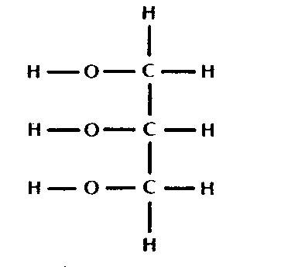
(b) use structural formulas and molecular models of glycerol and fatty acids to determine how these molecules join together to form fats and oils.

The Structure of Glycerol Glycerol

- What elements are present in glycerol? _____________________

- What is the molecular formula for glycerol? C__H__O__

- In carbohydrates there are twice as many hydrogen atoms as oxygen atoms. Are there twice as many hydrogen atoms as oxygen atoms in glycerol? _______

The Structure of Fatty Acids
Fatty acids are the other kind of molecule found in triglycerides. Saturated fatty acids have no double bonds between the carbon atoms of the fatty acid chain and are fully saturated with hydrogen atoms. Some common examples of saturated fatty acids are butyric acid (contained in butter), lauric acid (contained in coconut oil, palm oil), and palmitic acid (contained in palm oil, hence the name, and meat). Studies have found that people whose diets are high in saturated fatty acids, including butyric, lauric, and palmitic acid, have a higher prevalence of coronary heart disease.
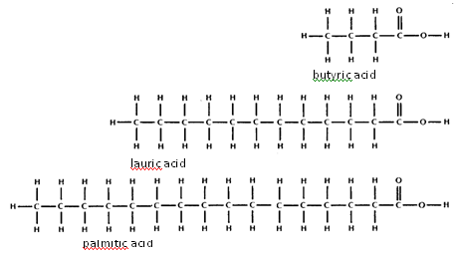
The “tail” of a fatty acid is a long hydrophobic chain. The “head” of the molecule is hydrophilic.

- What elements are present in all fatty acids? ___________________

- What is the molecular formula for butyric acid? C__H__O__

- What is the molecular formula for lauric acid? C__H__O__
What is the molecular formula for palmitic acid? C__H__O__

- How many oxygen atoms are found in each fatty acid? ____________

- List a similarity between glycerol and fatty acids. _____________________

Mini-tutorial time with Mrs. Mason! Make a model of a saturated fat in your notebook.
Using the colored paper with glycerol and fatty acid molecules and water, construct a triglyceride molecule by joining one glycerol to three fatty acid molecules through dehydration synthesis reactions.

- How many glycerol molecules are needed to form 1 molecule of fat? ______

- How many fatty acid molecules are needed to form 1 molecule of fat? _____

- Join the leftover −H and −OH ends from your models. What molecule is formed when the −H and −OH ends are joined?

- Production of a triglyceride (fat) is a chemical reaction called a dehydration synthesis reaction. In such a reaction, the elements of water are removed and the glycerol and fatty acid molecules are joined to form the triglyceride. How many water molecules are formed when one triglyceride molecule is produced? ________

An unsaturated fatty acid has one or more double bonds between carbon atoms. Double bonds may be in either a cis or trans form, depending on the orientation of the atoms surrounding the double bond. In the cis conformation hydrogens are on the same side of the double bond, whereas in the trans conformation they are on opposite sides. Most fatty acids in the trans conformation are not found in nature and are the result of human processing (eg, hydrogenation).

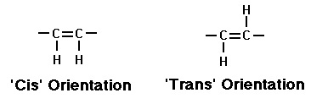
The arrangement of the cis double bond introduces a bend in the molecule. Oleic has a "kink" in it, while linoleic acid has a more pronounced bend. Linolenic acid (three double bonds), favors a hooked shape. The location of the carbon-carbon double bonds in the carbon chain of an unsaturated fatty acid makes a big difference in how the body metabolizes it.
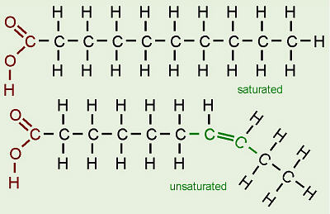
- Observe the diagram to the right. What type of orientation (cis or trans) is located in the unsaturated fat?

- What appears to happen to the unsaturated fatty acid molecule due to this double bond?

- How is that different from the saturated fatty acid molecule?

Mini-tutorial time with Mrs. Mason! Make a model of an unsaturated fat in your notebook.
Using the colored paper with glycerol and fatty acid molecules and water, construct a triglyceride molecule by joining one glycerol to three fatty acid molecules through dehydration synthesis reactions.

- How many glycerol molecules are needed to form 1 molecule of an unsaturated fat?

- How many fatty acid molecules are needed to form 1 molecule of an unsaturated fat?

- Join the leftover −H and −OH ends from your models. What molecule is formed when the −H and −OH ends are joined? _______________

Fats vs. Oils
Fats, which are mostly from animal sources, have all single bonds between the carbons in their fatty acid tails, thus all the carbons are also bonded to the maximum number of hydrogens possible. Since the fatty acids in these triglycerides contain the maximum possible amount of hydrogens, they are saturated.

Plants predominately make unsaturated cis fatty acids so these molecules are called "oils". They are liquid at room temperature. Think about why! Cis double bonds limit the ability of the fatty acids to pack closely together. Unsaturated cis fats obtained from plants (e.g., corn oil or olive oil) are preferred in the diet over saturated fats and trans unsaturated fats. Saturated fats and unsaturated trans fats allows these molecules to assume a linear shape (since they have no kinks) which leads to efficient packing and plaque formation in blood vessels. Studies have found that people whose diets are high in saturated fats and trans unsaturated fats had higher levels of blood cholesterol and plaque formation on blood vessel walls, and a higher prevalence of coronary heart disease.

We need fats in our bodies and in our diet. Animals in general use fat for long term energy storage (unlike with carbohydrates) because fat molecules store almost twice the amount of calories (energy) per gram (9 kilocalories per gram of fat vs. 4 kcal/g in both protein and carbohydrates). Plants, which don’t move around, can afford to store food for energy in a less compact but more easily accessible form, so they use starch (a carbohydrate, NOT a lipid) for energy storage. Fat is also used in our bodies to cushion vital organs like the kidneys and serve as insulation, especially just beneath the skin.

Notes:

Debrief Questions

- Why are lipids an important part of our diet?

- What chemical elements are found in all lipids?

- What two molecule types are needed to form a triglyceride or fat molecule and how many of each type of these molecules are needed?

- What chemical substance is formed when the −H ends of the fatty acids and −OH ends of the glycerol are joined during the chemical reaction to form a triglyceride or fat molecule?

- How does a saturated fatty acid differ from an unsaturated fatty acid?

- Why are unsaturated fats liquids at room temperature?

- Which types of lipids should you avoid in your diet? Why?

