

Genes R us Pre-Employment Interview

Job Title:

Transformation Specialist

Name: Applicant Group:

Please answer the following questions. If you feel you can’t answer a question, do your best and move on to the next.

- What, in simple terms, is DNA?

- Do you have any lab experience with transformation of organisms?

  - Yes

No

    - Explain what you think genetic transformation of an organism is:

- Explain what an experimental variable is:

- Explain what an experimental control is:

- How can we give organisms new phenotypes, or characteristics?
- Is it possible to insert a new gene into an organism and have that gene function correctly? If so, how do you know the gene is working?

- What do antibiotics do to bacteria?

- Can bacteria be used as factories to produce products?

  - Yes
  - No

- What is E. coli?

- What is a plasmid?

Introduction to Transformation

Some genes and their protein products have enormous commercial value. Examples include: insulin used by diabetics for lowering blood sugar, enzymes added to laundry detergent for removing stains, and restriction enzymes for cutting DNA. Scientists in the Research and Development Division of Genes-R-Us Inc. have developed a process in which enzymes (used to produce a blue dye, Indo-Blu) are produced by genetically transformed bacteria.

You have been hired to work on an extension of this Indo-Blu project. The members of your team will first learn some of the steps used to create Indo-Blu producing bacteria (using our Standard Operating Procedure). Then your team will be asked to suggest possible improvements to the bacterial transformation process, that is, successfully getting genes of interest into bacteria.

Background information:
Scientists can insert genes into bacteria. The genes inserted in the Indo-Blu (SOP #T-1) process are on a circular piece of DNA called a plasmid. (The plasmid we use is called pBLU®.) The bacteria with the inserted genes are used as factories that produce large quantities of the gene and its product. The process of giving bacteria (or another organism) a new gene is called transformation.

Our transformation process uses the bacterium Escherichia coli (or E. coli for short) as the “factory”to produce the Indo-Blu dye. We use a highly specialized, harmless strain of E. coli. We insert the pBLU® plasmid, which contains a gene that produces the enzyme beta-galactosidase (β-gal for short).

Indo-Blu is produced by the reaction between beta-galactosidase (the enzyme) and X-gal (the substrate). β-gal normally modifies lactose, the sugar in milk. X-gal chemically looks like lactose. β-gal splits a sugar group from X-gal, producing the blue dye, Indo-Blu.

Transformation is a rare event, so to make it easier to find transformants (transformed bacteria), a gene for ampicillin resistance was included on the pBLU® plasmid. Expression of this gene, which produces the enzyme beta-lactamase, allows transformed E. coli to grow in the presence of ampicillin, an antibiotic that usually prevents the growth of bacteria. The beta-lactamase enzyme dismantles ampicillin, rendering it non-functional. Hence, transformed bacteria will live in the presence of ampicillin, untransformed bacteria will not live.

Proper controls are essential in any experiment. In this experiment we will grow E. coli on agar plates which contain nutritional requirements for the bacteria. In the pBLU® transformation, our control is another sample of bacteria which is treated exactly the same as the bacteria we’re transforming, except the control does not receive the pBLU® plasmid.

Controls help you understand what happened if things go wrong and to know things work out as expected. For example, if there are no bacteria on your pBLU®-transformed plate, is this because none of them were transformed (a definite possibility) or because all the bacteria were flat-out dead already? A control plate helps answer the question. If the bacteria on the control plate are alive, you can rule out that the procedure killed the bacteria.

Controls also validate that the protocol was performed correctly when the experiment appears to have been successful. Experiments can utilize positive and negative controls.
Overview of the Transformation Process:
- Grow the bacteria on a stock plate (the head of the Molecular Biology group may have done this for you already).

- Make the bacteria “competent.” This makes them able to accept new DNA. The method we use involves coating the bacteria and the DNA with positively charged molecules, to minimize charge repulsion of the DNA by the bacteria.

- “Shock” the bacteria with heat, then chill to push the DNA into pores in the bacteria.

- Grow the bacteria on LB agar.
Bacteria on an agar plate containing the antibiotic ampicillin will only grow if they have received the plasmid.
If the agar plate also contains X-gal, the β-galactosidase gene product will convert X-gal into Indo-Blu, our dye.

E. coli colonies are usually white. Those producing Indo-Blu will be blue.

The bacteria cannot move, so they will grow and divide in the same spot on the plate. Small numbers of bacteria cannot be seen without a microscope, but colonies (millions of daughter cells from one bacterium) can be seen. This allows you to identify, count, and isolate bacterial colonies, each of which arose from a single bacterial cell.

As part of your job assignment at Genes-R-Us, your team has been given the task of increasing the efficiency of transformation. The higher the efficiency of transformation, the more Indo-Blu producing bacteria colonies will grow.

A prominent wildlife protection organization recently requested our collaboration of a project to preserve the genomes (genetic information) of endangered species. The project uses the transformation process to create “libraries” of bacteria. Each transformed bacterium carries a different small piece of the genetic material being preserved. The challenge for Genes R Us is to increase the efficiency of the transformation process so that these libraries are complete. Our scientific advisory board is keen to help with this project. Achieving higher transformation efficiency will reduce the costs and increase the success to the project.

Your first assignment is to familiarize yourself with our standard operating procedure (SOP #T-1), practicing it once using a basic protocol. You will then make a proposal to modify one aspect of the transformation protocol (using appropriate controls). If there is enough time, your team will experimentally determine whether your proposed modification improves the transformation efficiency.

pBLU® Plasmid Map

Key: | AMP = ampicillin resistance gene | EcoRV 2028= the restriction
 | Beta-galactosidase = gene coding for the β-galactosidase enzyme | enzyme EcoRV cuts at nucleotide number 2028
 | Unique sites = the restriction enzymes shown cut the plasmid in only one place

From DNA Science, Micklos & Freyer, 1995

Transformation and

Expression of pBLU

Plan
- Practice our basic transformation method by transforming E. coli with the pBLU® plasmid (which carries genes for beta-galactosidase production and ampicillin resistance).
- Assess the success of transformation by plating the bacteria on LB agar plates containing ampicillin and X-gal (LB/amp/x-gal).
- Prepare a research proposal, identifying one variable to modify in the S.O.P. to increase the number of transformant colonies producing Indo-Blu and verify with the appropriate controls.
- If R & D approves, test your proposed modification.

Materials Needed Per Team

Equipment | Reagents
microcentrifuge tubes | disinfectant (10% bleach or 70% alcohol)
rack for microcentrifuge tubes | sterile distilled water
permanent marker pen | sterile Luria Broth (LB)
sterile toothpicks | 2 LB agar plates
sterile graduated transfer pipets | 2 LB agar/amp/X-gal plates
2-20 μl micropipet + tips | pBLU® plasmid (0.01 µg/µl)
floating tube rack for waterbath | 50mM CaCl₂ (cold) 250 μl per sample
100-1000 μl micropipet + tips (shared) | container for crushed ice
2 sterile plate spreaders
(These are not disposable)

Materials Needed Per Class
42°C waterbath
37°C incubator
container for waste
E. coli stock plate
crushed ice

S.O.P. #T-1 is our standard protocol for bacterial transformation at Genes-R-Us. Take careful notes as you work through it. Write down any observations and deviations from this procedure.
- Give your team a name so that you can be identified as a group and use this name to label your samples and plates. Make sure the head of Molecular Biology knows who the members of your team are.
- As you go through the protocol, think about the procedure and what it does to the bacteria. Try imagining yourself as a bacterium, taking in new genes.

CAUTIONS
- Because we are adding DNA to living cells, all transfers should be made with sterile technique and sterile instruments. Talk with the head of Molecular Biology if you need help.
- If you spill bacterial culture, notify the head of Molecular Biology immediately.

Procedure

Step 1: Transformation

Purpose: To transform bacteria with pBLU® plasmid.

Prepare tubes:
- Remove existing bacteria from your table top and from your micropipets by cleaning with disinfectant. Wash your hands!
- Obtain two sterile 1.5 ml microfuge tubes containing cold calcium chloride solution (CaCl₂), 250 µl each.
- Label one tube “C" (for control) and the other "pBLU.”
- Label both tubes with your team name.
- Place both tubes on ice.

Add bacteria to tubes:
- Carefully remove a sterile toothpick from the aluminum can.
- Using the toothpick, pick or gently scrape up a large, single bacteria colony from the stock plate.
- Insert the toothpick into the tube labeled C and vigorously tap or twirl the toothpick against the side of the tube. Look closely to make sure the cell clump has come off.
- Suspend the cells by pipetting repeatedly with a sterile transfer pipet. After a few moments, hold the tube up to the light and check that no clumps of cells are visible.
- Return the C tube to ice.
- Place used toothpicks and pipets in waste container.
- Using a new toothpick, transfer another colony to the tube labeled pBLU just as you did for the C tube.
- Suspend the cells in the pBLU tube just as you did for the C tube.
- Return the pBLU tube to ice. Both tubes should now be on ice.
- Place used toothpicks and pipets in waste container.

Add plasmid to bacteria:
- Using a 2-20 µl micropipet and a new sterile tip, add 10 µl pBLU® plasmid to the pBLU tube ONLY.
- Mix the tube contents by tapping or flicking the tube with your fingers.
- Return the pBLU tube to ice.
- Using a new tip, add 10 µl of sterile distilled water to the C tube ONLY.
- Mix by tapping the tube with your fingers.
- Return the C tube to ice.
- Wait 15 minutes.
- This gives time for the pBLU® plasmid to settle onto the surfaces of the bacteria. While you’re waiting, think ahead about the next two steps. The timing of these steps is thought to be important in the success of the procedure.

Heat shock:
C
- When the 15 minute waiting period is over, take the ice container with the pBLU and C tubes to the 42°C water bath (check the temperature).
- Transfer the tubes into a floating tube rack.
- Place the rack with the tubes in the water bath for a heat shock of exactly 90 seconds.

IT IS ESSENTIAL THAT CELLS BE GIVEN A SHARP AND DISTINCT HEAT SHOCK
- Immediately return tubes to ice for at least 2 minutes.
- Add 250 µl of sterile Luria broth (LB) to each tube, using a new sterile tip on a 100-1000 µl micropipet for each one. Tap each tube with your finger to mix its contents.

If continuing on to next step this day:
Optional: incubate the tubes for 15-30 min. at 37°C before plating. This allows the bacteria to recover and express the ampicillin resistance gene.

If stopping at this point:
Set the tubes in a rack and store in the refrigerator until the next day (optional incubating step can be performed after removal from refrigerator).

Upon completion:
- Dispose of designated materials in the appropriate places.
- Leave equipment as you found it.
- Check that your work station is in order.
- Wipe down the table and your micropipets with disinfectant.
- Wash your hands.

Step 2: Plating Cells
Purpose: To spread individual cells evenly over the surface of the plate for overnight growth into visible colonies.

Preparing Plates:
- Eliminate existing bacteria from your work area by cleaning with disinfectant. Wash your hands.
- Label plates:
- Obtain your plates (Petri dishes).
- Handle the plates carefully so that they remain sterile while you label them.
- Using a permanent marker pen, put a pBLU and your team name and class period on the bottom of:
- an LB plate
- an LB/amp/X-gal plate.
- Put a C and your team name and class period on the bottom of:
- an LB plate
- an LB/amp/X-gal plate.

Plate the cells:
- Control sample:
- Set a 100-1000 μl micropipet to 100 μl.
- Resuspend the bacteria in the “C”tube by pipetting up and down gently.
- Draw up 100 μl and carefully drip it onto the center of the control LB plate.
- Repeat the process (use a new micropipet tip) to spread 100 μl of the control suspension on the control LB/amp/X-gal plate.
- Carefully remove a sterilized plastic spreader from the sterilization bag.
- Touch only the handle.
- Use the spreader to evenly spread the cell suspension over the surface of the control LB plate. (This may remind you of frosting a cake or spreading peanut butter.)
- Use the same spreader to spread the suspension on the control LB/amp/X-gal plate.
A spreader
- Place the used spreader in a container of disinfectant.
- pBLU sample:
- Use the above procedure to spread 100 μl of the suspension from the pBLU tube on the pBLU LB plate and the pBLU LB/amp/x-gal plate.
- Place the used spreader in a container of disinfectant.
Save the spreaders. They are not disposable!

Incubation:
- Allow 5 minutes for the plates’ surfaces to absorb the cell suspensions.
- Place your four plates, upside-down, in the 37°C incubator.
- Make predictions about what you expect to happen to each plate after overnight incubation. (See Transformation Report Form, Step 2.)

Upon completion:
- Dispose of designated materials in the appropriate places.
- Leave equipment as you found it.
- Check that your work station is in order.
- Wipe down the table and your micropipets with disinfectant.
- Wash your hands.

Step 3: Reporting
Purpose: To report results and calculate transformation efficiency.

- Examine the plates and analyze them for bacterial growth and colony color.
- Make sure your controls have performed as expected.

- Fill out a Transformation Report, including a calculation of your transformation efficiency. See Transformation Efficiency page.

- As a team, discuss the experiment you’ve done and which variable you want to try changing in order to optimize the transformation efficiency for the genome preservation project. Individually or as a team (check with the head of Molecular Biology) write your proposal on the Optimization Proposal form.

- The head of Molecular Biology will review your work and let you know whether you are to perform the experiment your team has proposed.

S.O.P. #T-1 (Indo-Blu)

Transformation Report Form

Name Team Name

Date Period

Make predictions (Step 2):
- Use the diagrams below to predict the results you expect.

Control pBLU

LB
LB/amp/X-gal
LB/amp/X-gal
LB

Record Results (Step 3):
- Use the diagrams below to record your actual results:
  - Label each circle using the same label as the plate it represents.
  - Draw your observations in the circle.

- Record the number of colonies on each plate.
- Label each circle using the label on the plate it represents.
- Record the number of colonies in the correct circle.
- If there are too many colonies to count, record “TMTC”.

- What is the evidence that cells are resistant (or not) to ampicillin?
- What is the evidence that cells are producing the enzyme β-galactosidase?

- Were the results as you expected? Explain. _________________________________________________________________

- Suppose a new employee conducts this lab and the C tube cells grow on an LB/amp/X-gal plate. What could have gone wrong? Suggest a testable hypothesis to explain this result. _______________________________________________ ___________

- What are three factors that might influence the success of this transformation procedure? _________________________________________________________________

- Why would it be good for a bacterium (and bad for us) to maintain a plasmid that carries resistance to an antibiotic? What if the antibiotic is not in that bacterium’s environment? __________________________________________________________

Transformation Efficiency (Use either method)

Calculation of Transformation Efficiency Method #1
You can calculate the efficiency of transformation to get a quantitative assessment of how successful your transformation was. Transformation efficiency is expressed as the number of antibiotic-resistant colonies per microgram of pBLU® DNA. The object is to determine exactly how much DNA (inside the E. coli) was spread on the plate and relate that to the amount of DNA (in the form of a plasmid) added to the E. coli at the beginning of the experiment. It sounds more complicated than it is.
Note: symbols connect the places where the answer for one calculation is used in the next calculation.

Determine the following:
- Mass of pBLU DNA in test tube (Step 1 #7):
♥Mass of p BLU = [concentration of pBLU (µg/µl)] [volume put in tube (µl)]
♥Mass of p BLU =
- Portion (fraction) of bacterial suspension from the tube that actually went on to the plate (Step 2 #3 & #4):
♣Fraction spread on plate = volume (µl) put on plate/ volume (µl) in tube.
♣Fraction spread on plate =
- Mass of pBLU in the portion spread on plate:
♦Fractional mass of pBLU on plate = (♥Mass of p BLU) ( ♣Fraction spread on plate)
♦Fractional mass of pBLU on plate =
- Transformation efficiency, or the number of colonies produced from each microgram of pBLU
♠Transformation Efficiency = # of colonies counted on your plate/ ♦Fractional mass of pBLU
♠Transformation Efficiency =

Calculation of Transformation Efficiency Method #2
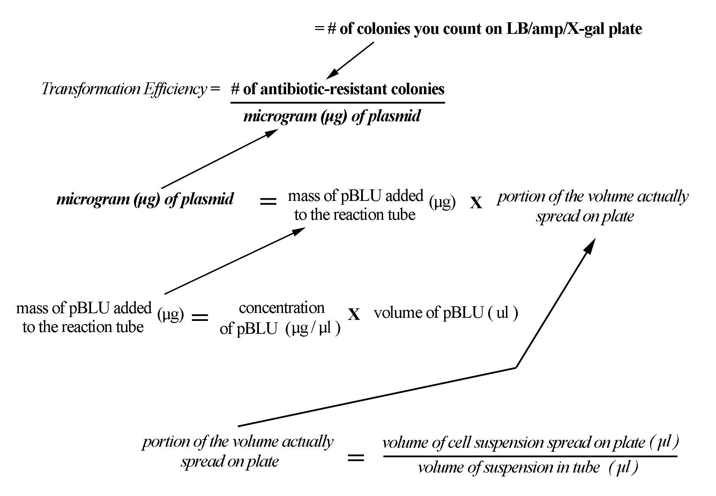

Confidential
Optimization Proposal
Name Team Name

Date Period

Now that you are familiar with S.O.P. #T-1, it is time to fine-tune, or optimize, the transformation so that you increase the number of transformants obtained.
As a team, choose a variable (something you can change) by looking at the basic protocol. Possibilities include using a different positively charged salt solution, changing its concentration, varying the amount of plasmid, changing the heat shock temperature, or changing the time of heat shock, to name just a few. (Think of the questions you had while you were working through the basic procedure.) Discuss your proposal with the Head of Molecular Biology.

- What variable do you propose to change?

- Why do you think changing this variable will improve the transformation efficiency?

- What controls will you use to make sure that any effect you see is truly due to changing one variable?

- How will you know if your experiment has improved the transformation efficiency?

- Discuss any potential problems: (continue on back if necessary)

Genes-R-Us

pBLU® Technical Information Sheet

X-Gal/β-galactosidase Information

- Some strains of E. coli, a common bacterium, are incapable of hydrolyzing (splitting the molecule using water) the sugar lactose, found in milk. This is, in part, because they lack the gene for the enzyme beta-galactosidase (β-gal). The pBLU® plasmid contains the β-gal gene. If E. coli acquires this plasmid, it acquires the ability to digest lactose. However, if we feed the bacteria not lactose, but a lactose analog -- a substance that is chemically similar to lactose called X-gal, we’ll make Indo-Blu.

⬅Lactose

- X-gal is just a convenient way to say a complicated chemical name. X-gal’s real name is 5-bromo-4-chloro-3-indolyl-β-D-galactoside. The structure is shown below. Galactose is the large ring-shaped structure; it’s the sugar group. The dye color is generated when the sugar is clipped off from the 5-bromo-4-chloro-3-indolyl group. The β indicates where on the sugar the two groups are connected. Do you think the galactose or the rest is responsible for the color?

X-gal

Reference:
Sambrook, et al. Molecular Cloning: A Laboratory Manual, Cold Spring Harbor Laboratory, B. 14, p186 (1989).

