How Does An Electrical Generator Work?
http://www.actewagl.com.au/Education/energy/electricity/MakingElectricity/HowGeneratorsWork.aspx

An electrical generator is a simple device that moves a huge magnet near a wire to create a steady flow of electrons, known as an electric current. In large power generators, the coils remain stationary, and the magnetic field rotates. This produces the same effect. The magnet rotates with the turbine, to which it is attached.
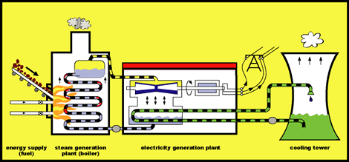
Fossil fuels provide energy that can be changed into electricity, as in the diagram. In the steam generating plant, heat from the burning fossil fuel turns water into steam. The steam, moving under high pressure, makes the turbine blades spin. The turbine is connected to the generator, which produces electricity.

The electricity generated is then sent to the electricity grid for transmission to where it is needed.The turbine in an electricity generator needs energy to work. This energy may come from moving water, wind, steam created by heat from the sun (solar energy) or by burning coal, oil or gas.

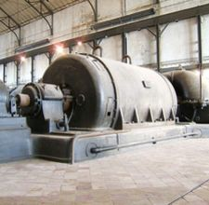
Some of these forms of energy will never run out. They are known as renewable energy sources. Other forms of energy are in limited supply, they are known as non-renewable energy sources.

How Does a Generator Work?
http://www.ehow.com/how-does_4564043_generator-work_.html July 28, 2010

An electric generator converts mechanical energy into electrical energy. It is based on the principle of electromagnetic induction, a scientific law that was discovered by British scientist Michael Faraday and American scientist Joseph Henry in 1831. The principle states that when an electric conductor, such as a copper wire, is moved through a magnetic field, electric current will flow through the conductor. The mechanical energy of the moving wire is converted into the electric energy. Faraday and Henry found that when you move a magnet in a coil of wire, electric current is generated.
Faraday's law of induction shows that a moving magnetic field will cause electrons to move. Generators create electron movement in the copper wire coils contained within by moving them through a magnetic field. Faraday built the first electromagnetic generator, called the Faraday disc, which was a simple copper disc rotating between the poles of a horseshoe magnet.
Generator magnets apply pressure to the electrons to push them and create a flow or current of electricity. The number of moving electrons is called the amperage or the current and is measured in amps. The pressure pushing the electrons is called the voltage and is measured in volts.
A generator is basically created by a mechanical force that turns a conductive wire or bar within a magnetic field. The force used to spin the conductive object can be provided by many sources, such as moving water, steam, wind, gas engine or even hand-cranked levers. The electricity then flows into an electric motor or other electric-powered device, which reverses the process and the electricity makes it move. Small generators create a magnetic field with permanent magnets. Larger generators create a magnetic field with a set of metal coils with electric current flowing through them; this is an electromagnet.
How Electrical Generators Work
Name _____________________________________ Date ____________

Article 1, “How Does An Electrical Generator Work?”
Read and mark the article:
- Underline important concepts.
- Write a √ next to or over items you already know.
- Write a ? next to or over items you are unsure about or have a question about.
- Add any thoughts you have about the topic in the margin.

Article 2, “How Does A Generator Work?”
- In paragraph 1, what moves? What isn’t moving?

- In paragraph 2, what moves? What isn’t moving?

- In both cases what happens as a result of the copper wire and magnetic field moving in relation to each other?

- Explain the difference between amperage (amps) and voltage (volts).

- Draw a diagram, picture or graphic to illustrate the steps in paragraph four.

Go back and experiment again with the materials you used earlier in class. Explain how your use of these materials models what is described in the two Electrical Generator articles.

Bonus questions

- What are amps?

Most household circuits are 110 amp. Some appliances like clothes dryers run on 220 amp circuits. What’s the difference?

- What is voltage?

What’s the difference between a 1.5V and a 6V battery?

