Chapter 5 Review

1) Calculate the kinetic energy in J of an electron moving at 6.00 × m/s. The mass of an
electron is 9.11 × g. Answer: 1.64 × Sec. 5.1

2) The value of ΔE for a system that performs 213 kJ of work on its surroundings and loses 79 kJ of heat is __________ kJ. Answer: -292 Sec. 5.2

3) The change in the internal energy of a system that releases 2,500 J of heat and that does 7,655 J of work on the surroundings is __________ J. Answer: -10,155 Sec. 5.2

4) The value of ΔH° for the reaction below is -126 kJ. _________kJ are released when 2.00 mol of NaOH is formed in the reaction?

Answer: 63 Sec. 5.4

5) The value of ΔH° for the reaction below is -126 kJ. The amount of heat that is released by the reaction
of 25.0 g of with water is __________ kJ.

Answer: 20.2 Sec. 5.4

6) The value of ΔH° for the reaction below is -790 kJ. The enthalpy change accompanying the reaction
of 0.95 g of S is __________ kJ.

Answer: -12 Sec. 5.4

7) The value of ΔH° for the reaction below is +128.1 kJ:

How many kJ of heat are consumed when 5.10 g of CO (g) is formed as shown in the equation?
Answer: 23.3 Sec. 5.4

8) The molar heat capacity of a compound with the formula is 88.0 J/mol-K. The specific heat of this substance is __________ J/g-K. Answer: 1.13 Sec. 5.5

9) The ΔH for the solution process when solid sodium hydroxide dissolves in water is 44.4 kJ/mol. When a 13.9-g sample of NaOH dissolves in 250.0 g of water in a coffee-cup calorimeter, the temperature increases from 23.0°C to ________°C. Assume that the solution has the same specific heat as liquid water, i.e., 4.18 J/g-K.
Answer: 37.0°C Sec. 5.5

10) The temperature of a 15-g sample of lead metal increases from 22°C to 37°C upon the addition of 29.0 J of heat. The specific heat capacity of the lead is __________ J/g-K. Answer: 0.13 Sec. 5.5

11) ΔH for the reaction

is __________ kJ, give the data below.

Answer: +355 Sec. 5.6

12) The value of ΔH° for the following reaction is -3351 kJ:

The value of for (s) is __________ kJ. Answer: -1676 Sec. 5.7

13) Given appendix C, for the reaction is __________ kJ.
Answer: -140 Sec. 5.7

14) Given appendix C, ΔH° for the reaction is __________ kJ.
Answer: -566.4 Sec. 5.7

15) The value of ΔH° for the following reaction is 177.8 kJ. The value of ΔH°f for CaO(s) is __________ kJ/mol.
See appendix C.
Answer: -635.5 Sec. 5.7

16) Given appendix C, for the reaction is __________ kJ.
Answer: -198 Sec. 5.7

17) Given appendix C, for the reaction is __________ kJ.
Answer: -132 Sec. 5.7

18) Given appendix C, for the reaction is __________ kJ.
Answer: -570.37 Sec. 5.7

19) Given appendix C, for the reaction is __________ kJ.
Answer: 570.37 Sec. 5.7

20) A 25.5-g piece of cheddar cheese contains 37% fat, 28% protein, and 4% carbohydrate. The respective fuel values for protein, fat, and carbohydrate are 17, 38, and 17 kJ/g, respectively. The fuel value for this piece of cheese is __________ kJ. Answer: 500 Sec. 5.8

21) Which one of the following conditions would always result in an increase in the internal energy of a system?
A) The system loses heat and does work on the surroundings.
B) The system gains heat and does work on the surroundings.
C) The system loses heat and has work done on it by the surroundings.
D) The system gains heat and has work done on it by the surroundings.
E) None of the above is correct. Answer: D Sec. 5.2

22) Which one of the following is an exothermic process?
A) ice melting B) water evaporating C) boiling soup D) condensation of water vapor
E) Ammonium thiocyanate and barium hydroxide are mixed at 25°C: the temperature drops. Answer: D Sec. 5.2

23) The internal energy can be increased by __________.

(a) transferring heat from the surroundings to the system
(b) transferring heat from the system to the surroundings
(c) doing work on the system

A) a only B) b only C) c only D) a and c E) b and c Answer: D Sec. 5.2

24) A chemical reaction that absorbs heat from the surroundings is said to be __________ and has a __________ ΔH at constant pressure.
A) endothermic, positive B) endothermic, negative C) exothermic, negative
D) exothermic, positive E) exothermic, neutral Answer: A Sec. 5.4

25) The units of of specific heat are __________.
A) K/J or °C/J B) J/K or J/°C C) J/g-K or J/g-°C D) J/mol E) g-K/J or g-°C/J Answer: C Sec. 5.5

26) For which one of the following equations is equal to for the product?
A) B)
C) D)
E) Answer: A Sec. 5.7

27) Of the following, is not zero for __________.
A) B) C (graphite) C) D) E) Answer: D Sec. 5.7

28) For which one of the following reactions is equal to the heat of formation of the product?
A) B)
C) D)
E) Answer: B Sec. 5.7

29) For which one of the following reactions is the value of equal to ΔH°f for the product?
A) B)
C) D)
E) Answer: A Sec. 5.7

30) For which one of the following reactions is the value of equal to ΔH°f for the product?
A) B)
C) D)
E) none of the above Answer: E Sec. 5.7

31) For which one of the following reactions is the value of equal to ΔH°f for the product?
A) B)
C) D)
E) all of the above Answer: E Sec. 5.7

32) A 50.0-g sample of liquid water at 25.0 C is mixed with 29.0 g of water at 45.0°C. The final temperature of the water is ________°C. The specific heat capacity of liquid water is 4.18 J/g-K.
Answer: 32.3 Sec. 5.5

33) Given the equation H2O (l) → H2O (g) △Hrxn = 40.7 kJ at 100oC
Calculate the heat required to convert 3.00 grams of liquid water at 100oC to vapor.
Answer: 6.78 kJ Sec. 5.5
5 • Energy and Chemical Reactions
Station 1 – EXOTHERMIC AND ENDOTHERMIC

Classify each statement as talking about an [EXO]thermic or [ENDO]thermic reaction:

_____ surroundings get hot  _____ PE diagram is uphill  _____ energy is a product  _____ ΔH is positive  _____ reactants have more energy | _____ ΔH is negative  _____ PE diagram is downhill  _____ surroundings get cold  _____ products have more energy  _____ energy is a reactant

5 • Energy and Chemical Reactions
Station 2 – HEAT CALCULATIONS

A 45.0 mL sample of water is heated from 15.0°C to 35.0°C. How many joules of energy have been absorbed by the water? (Show work)

If 5430 J of energy is used to heat 1.25 L of room temperature water (23.0°C), what is the final temperature of the water?

5 • Energy and Chemical Reactions
Station 3 – HOT AND COLD OBJECTS

A 100. gram sample of aluminum (specific heat = 0.900 J·g⁻¹·°C⁻¹) in boiling water is added to an insulated cup containing 50.0 grams of water at 5.00°C. What will the final temperature of the mixture be? The specific heat of water is 4.184 J·g⁻¹·°C⁻¹.

5 • Energy and Chemical Reactions
Station 4 – WORK, HEAT, AND ENERGY

Determine the change in energy, ΔE, for each system:

A system gives off 25.0 kJ of heat and has 15.0 kJ of work done on it. _____

A system takes in 75.0 kJ of heat and has 25.0 kJ of work done on it. _____

A system does 45.0 kJ of work and loses 80.0 kJ of heat. _____

5 • Energy and Chemical Reactions
Station 5 – HEATS OF FUSION & VAPORIZATION
Knowing that the ΔH_{fus} for water is 6.02 kJ·mol⁻¹, calculate the following:

How much energy (in kJ) is absorbed by 45.0 g of ice as it melts?

What mass of ice can be melted with 75.0 kJ of energy?

5 • Energy and Chemical Reactions
Station 6 – ΔH FROM DATA

When 10.0 grams of C₅H₁₂ is burned, 453 kJ of energy is released.
What is the ΔH_{combustion} for C₅H₁₂?

When 10.0 grams of aluminum melts, 3.929 kJ of energy is required. What is the ΔH_{fus} of Al?

5 • Energy and Chemical Reactions
Station 7 – HESS’S LAW—LONG VERSION
Iron ore can be converted to iron metal with CO gas.

$\begin{aligned}\text{FeO }(s) +\text{ CO }(g) →\text{ Fe }(s) +\text{ CO}2(g) \\ \text{ Calculate the standard enthalpy change for this reaction from these reactions} \\ \text{of iron oxides with CO:} \\ (1)\text{ 3 Fe}2O3(s) +\text{ CO }(g) →\text{ 2 Fe}3O4(s) +\text{ CO}2(g) ΔH° =\text{ - 47 kJ} \\ (2)\text{ Fe}2O3(s) +\text{ 3 CO }(g) →\text{ 2 Fe }(s) +\text{ 3 CO}2(g) ΔH° =\text{ -25 kJ} \\ (3)\text{ Fe}3O4(s) +\text{ CO }(g) →\text{ 3 FeO }(s) +\text{ CO}2(g) ΔH° =\text{ 19 kJ}\end{aligned}$

5 • Energy and Chemical Reactions
Station 8 – HESS’S LAW--SHORTCUT

chemical | CO₂(g) | H₂O(g) | C₅H₁₂(l) | C₂H₅OH(l)
ΔH_{f} | -393.5 kJ·mol⁻¹ | -241.8 kJ·mol⁻¹ | -173.1 kJ·mol⁻¹ | -277.6 kJ·mol⁻¹

Given the above ΔH_{f}°’s, calculate the ΔH_{combustion} of pentane, C₅H₁₂.

Calculate the ΔH_{combustion} of ethyl alcohol, C₂H₅OH(l)

5 • Energy and Chemical Reactions
Station 9 – MORE HESS’S LAW

chemical | CO₂(g) | H₂O(g) | C₈H₁₈(l)
ΔH_{f} | -393.5 kJ·mol⁻¹ | -241.8 kJ·mol⁻¹ | ??? kJ·mol⁻¹

Knowing that the ΔH_{combusion} of octane, C₈H₁₈, is -5508.9 kJ·mol⁻¹ calculate the ΔH_{f} of octane.

5 • Energy and Chemical Reactions
Station 9 – MORE HESS’S LAW

chemical | CO₂(g) | H₂O(g) | C₈H₁₈(l)
ΔH_{f} | -393.5 kJ·mol⁻¹ | -241.8 kJ·mol⁻¹ | ??? kJ·mol⁻¹

Knowing that the ΔH_{combusion} of octane, C₈H₁₈, is -5508.9 kJ·mol⁻¹ calculate the ΔH_{f} of octane.

AP Chemistry
5 • Energy and Chemical Reactions
Station 1 – EXOTHERMIC AND ENDOTHERMIC

Classify each statement as talking about an [EXO]thermic or [ENDO]thermic reaction:

_EXO__ surroundings get hot  _ENDO_ PE diagram is uphill  _EXO__ energy is a product  _ENDO_ ΔH is positive  _EXO__ reactants have more energy | _EXO__ ΔH is negative  _EXO__ PE diagram is downhill  _ENDO_ surroundings get cold  _ENDO_ products have more energy  _ENDO_ energy is a reactant

AP Chemistry
5 • Energy and Chemical Reactions
Station 2 – HEAT CALCULATIONS
45.0 mL = 45.0 g (density of water is 1 g/mL)
A 45.0 mL sample of water is heated from 15.0°C to 35.0°C. How many joules of energy have been absorbed by the water? (Show work)

q = mcΔT = (45.0 g)(4.184 J·g⁻¹·°C⁻¹)(20.0°C) = 3770 J = 3.77 kJ

If 5430 J of energy is used to heat 1.25 L of room temperature water (23.0°C), what is the final temperature of the water?
q = mcΔT
5430 J = (1,250 g)(4.184 J·g⁻¹·°C⁻¹)(x)
x = 1.0°C
T_{final} = 24.0°C
AP Chemistry
5 • Energy and Chemical Reactions
Station 3 – HOT AND COLD OBJECTS

A 100. gram sample of aluminum (specific heat = 0.900 J·g⁻¹·°C⁻¹) in boiling water is added to an insulated cup containing 50.0 grams of water at 5.00°C. What will the final temperature of the mixture be? The specific heat of water is 4.184 J·g⁻¹·°C⁻¹. Let x = final temp
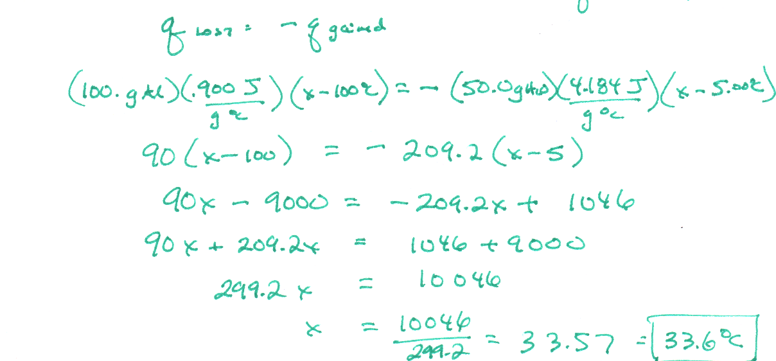

AP Chemistry
5• Energy and Chemical Reactions
Station 4 – WORK, HEAT, AND ENERGY

Determine the change in energy, ΔE, for each system:

A system gives off 25.0 kJ of heat and has 15.0 kJ of work done on it. -10.0 kJ
lose 25 gain 15

A system takes in 75.0 kJ of heat and has 25.0 kJ of work done on it. +100.0 kJ
Gain75 gain 25

A system does 45.0 kJ of work and loses 80.0 kJ of heat. -125 kJ
lose 45 lose 80
AP Chemistry
5 • Energy and Chemical Reactions
Station 5 – HEATS OF FUSION & VAPORIZATION
Knowing that the ΔH_{fus} for water is 6.02 kJ·mol⁻¹, calculate the following:

How much energy (in kJ) is absorbed by 45.0 g of ice as it melts?

45.0 g H₂O x 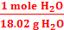 x 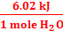 = 15.0 kJ absorbed

What mass of ice can be melted with 75.0 kJ of energy?

75.0 kJ x 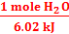 x 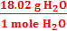 = 224.5 g = 225 g H₂O

AP Chemistry
5 • Energy and Chemical Reactions
Station 6 – ΔH FROM DATA

When 10.0 grams of C₅H₁₂ is burned, 453 kJ of energy is released.
What is the ΔH_{combustion} for C₅H₁₂?
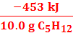 = 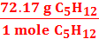 = -3269.3 = -3270 kJ·mol⁻¹

When 10.0 grams of aluminum melts, 3.929 kJ of energy is required. What is the ΔH_{fus} of Al?

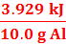 = 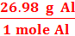 = 10.6 kJ·mol⁻¹
AP Chemistry
5 • Energy and Chemical Reactions
Station 7 – HESS’S LAW—LONG VERSION
Iron ore can be converted to iron metal with CO gas.

$\begin{aligned}\text{FeO }(s) +\text{ CO }(g) →\text{ Fe }(s) +\text{ CO}2(g) \\ \text{ Calculate the standard enthalpy change for this reaction from these reactions} \\ \text{of iron oxides with CO:} \\ (1)\text{ 3 Fe}2O3(s) +\text{ CO }(g) →\text{ 2 Fe}3O4(s) +\text{ CO}2(g) ΔH° =\text{ - 47 kJ} \\ (2)\text{ Fe}2O3(s) +\text{ 3 CO }(g) →\text{ 2 Fe }(s) +\text{ 3 CO}2(g) ΔH° =\text{ -25 kJ} \\ (3)\text{ Fe}3O4(s) +\text{ CO }(g) →\text{ 3 FeO }(s) +\text{ CO}2(g) ΔH° =\text{ 19 kJ}\end{aligned}$

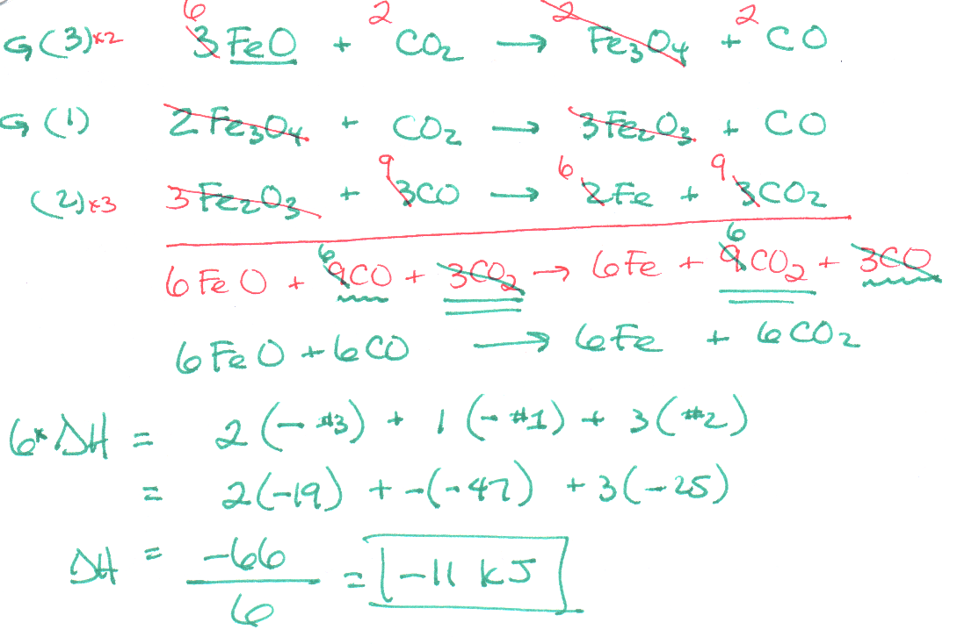

South Pasadena • AP Chemistry
6 • Energy and Chemical Reactions
Station 8 – HESS’S LAW--SHORTCUT

chemical | CO₂(g) | H₂O(g) | C₅H₁₂(l) | C₂H₅OH(l)
ΔH_{f} | -393.5 kJ·mol⁻¹ | -241.8 kJ·mol⁻¹ | -173.1 kJ·mol⁻¹ | -277.6 kJ·mol⁻¹

Given the above ΔH_{f}°’s, calculate the ΔH_{combustion} of pentane, C₅H₁₂.

C₅H₁₂ + 8O₂ → 5CO₂ + 6H₂O(g)

ΔH_{combustion} = 5(ΔH_{f} CO₂) + 6(ΔH_{f} H₂O) - ΔH_{f} C₅H₁₂
= 5(-393.5) + 6(-241.8) – (-173.1)
= -3245.2 kJ·mol⁻¹

Calculate the ΔH_{combustion} of ethyl alcohol, C₂H₅OH(l)

C₂H₅OH + 3O₂ → 2CO₂ + 3H₂O(g)

ΔH_{combustion} = 2(ΔH_{f} CO₂) + 3(ΔH_{f} H₂O) - ΔH_{f} C₂H₅OH
= 2(-393.5) + 3(-241.8) – (-277.6)
= -1234.8 kJ·mol⁻¹

South Pasadena • AP Chemistry
6 • Energy and Chemical Reactions
Station 9 – MORE HESS’S LAW

chemical | CO₂(g) | H₂O(g) | C₈H₁₈(l)
ΔH_{f} | -393.5 kJ·mol⁻¹ | -241.8 kJ·mol⁻¹ | ??? kJ·mol⁻¹

Knowing that the ΔH_{combusion} of octane, C₈H₁₈, is -5508.9 kJ·mol⁻¹ calculate the ΔH_{f} of octane.

C₈H₁₈ + ²⁵/₂O₂ → 8CO₂ + 9H₂O(g)

ΔH_{combustion} = 8(ΔH_{f} CO₂) + 9(ΔH_{f} H₂O) - ΔH_{f} C₈H₁₈
-5508.9 = 8(-393.5) + 9(-241.8) – (x)
x = +184.7 kJ·mol⁻¹

Thermochemistry: More Practice!!!

1) Use a standard enthalpies of formation table to determine the change in enthalpy for each of these reactions.
a) 2 CO(g) + O₂(g) ---> 2 CO₂(g)
b) CH₄(g) + 2 O₂(g) ---> CO₂(g) + 2 H₂O(l)
c) 2 H₂S(g) + 3 O₂(g) ---> 2 H₂O(l) + 2 SO₂(g)

2) Calculate ΔH for these reactions. In each case, state whether the reaction is exothermic or endothermic, rewrite the equation as a thermochemical equation to include the heat term, and indicate whether the products have a greater or smaller enthalpy than the reactants. H_{f} of NH₄Cl = 314.4 kJ/mol.
a) SO₂(g) + ½ O₂(g) ---> SO₃(g)
b) CaO(s) + H₂O(l) ---> Ca(OH)₂(s)
c) N₂(g) + 3 H₂(g) ---> 2 NH₃(g)
d) C₆H₆(l) + 1½ O₂(g) ---> 6 C(s) + 3 H₂O(l)
e) NH₃(g) + HCl(g) ---> NH₄Cl(s)

3) The standard heat of formation, ΔHº_{f}, for sulfur dioxide (SO₂) is -297 kJ/mol. How many kJ of energy are given off when 25.0 g of SO_{2 (g)} is produced from its elements?
4) The heat of reaction for the combustion of 1 mol of ethyl alcohol is -9.50 × 10² kJ:
C₂H₅OH _{(l)} + 3 O_{2 (g)} → 2 CO_{2 (g)} + 3 H₂O _{(l)} + 9.5 × 10² kJ
How much heat is produced when 11.5 g of alcohol is burned?

5) ΔH for the complete combustion of 1 mol of propane is -2.22 × 10³ kJ:
C₃H_{8 (g)} + 5 O_{2 (g)} → 3 CO_{2 (g)} + 4 H₂O _{(l)}
Calculate the heat of reaction for the combustion of 33.0 g of propane.

6) A 15.0 gram sample of nickel metal is heated to 100.0 °C and dropped into 55.0 grams of water, initially at 23.0 °C. Assuming that all the heat lost by the nickel is absorbed by the water, calculate the final temperature of the nickel and water. (The specific heat of nickel is 0.444 J/g •°C)

7) Diborane (B₂H₆) is a highly reactive boron hydride, which was once considered as a possible rocket fuel for the U.S. space program. Calculate ΔH for the synthesis of diborane from it elements, according to the equation:
2B(s) + 3 H₂(g) B₂H₆(g)
using the following data:
Reaction ΔH (kJ)
(a) 2B(s) + 3/2 O₂(g) → B₂O₃(s) ΔH (kJ) = –1273
(b) B₂H₆(g) + 3 O₂(g) → B₂O₃(s) + 3 H₂O(g) ΔH (kJ) = –2035
(c) H₂(g) + 1/2 O₂(g) → H₂O (l) ΔH (kJ) = –286
(d) H₂O(l) → H₂O(g) ΔH (kJ) = 44
8) It takes 78.2 J to raise the temperature of 45.6 grams of lead by 13.3 °C. Calculate the specific heat capacity and molar heat capacity of lead.

9) The complete combustion of acetic acid (HC2H3O2) in oxygen gas to form water and carbon
dioxide at constant pressure releases 871.7 kJ of heat per mole of acetic acid.
a. Write a balanced chemical equation for this reaction.
b. How much heat (kJ) would be released if you burned 2.00 moles of acetic acid?
c. Draw an enthalpy diagram for the reaction.

10) Consider the following reaction: 2 Mg(s) + O2(g) → 2 MgO(s) ΔH = -1204 kJ
a. Is this reaction exothermic or endothermic?
b. Calculate the amount of heat transferred when 2.4 g of Mg reacts at constant pressure.
c. How many grams of MgO are produced during an enthalpy change of -96.0 kJ?
d. How many kJ of heat are absorbed when 7.50 g of MgO is decomposed into Mg and O2 at constant pressure?

11) From the enthalpies of reaction, calculate the heat of the reaction: 3H2(g) + O3(g) →3H2O(g)
2H2(g) + O2(g) → 2H2O(g) ΔH = -483.6 kJ
3O2(g) → 2O3(g) ΔH = +284.6 kJ

12) Use Hess’s Law and the given data to calculate ΔH for the reaction:
N2O(g) + NO2(g) → 3NO(g)
N2(g) + O2(g) → 2NO(g) ΔH = +180.7 kJ
2NO(g) + O2(g) →2NO2(g) ΔH = -113.1 kJ
2N2O(g) → 2N2(g) + O2(g) ΔH = -163.2 kJ

13) Calcium carbide reacts with water to form acetylene and calcium hydroxide. Give the
following enthalpy of reaction and data in Appendix C, calculate ΔH_{f} for CaC2(s).
CaC2(s) + 2H2O(l) → Ca(OH)2(s) + C2H2(g) ΔH = -127.2 kJ

14) Many cigarette lighters contain liquid butane, C4H10. Using enthalpies of formation,
calculate the quantity of heat produced when 1.0 g of butane is completely combusted in air.

Ch. 19 Practice

Use the table below to answer the questions that follow.

Thermodynamic Quantities for Selected Substances at 298.15 K (25°C)

Substance ΔH°f (kJ/mol) ΔG°f (kJ/mol) S (J/K-mol)

Carbon
C (s, diamond) 1.88 2.84 2.43
C (s, graphite) 0 0 5.69
C2H2 (g) 226.7 209.2 200.8
C2H4 (g) 52.30 68.11 219.4
C2H6 (g) -84.68 -32.89 229.5
CO (g) -110.5 -137.2 197.9
CO2 (g) -393.5 -394.4 213.6

Hydrogen
H2( g) 0 0 130.58

Oxygen
O2 (g) 0 0 205.0
H2O (l) -285.83 -237.13 69.91

1) The value of ΔS° for the catalytic hydrogenation of acetylene to ethene is __________ J/K.

C2H2 (g) + H2 (g) → C2H4 (g)

A) +18.6 B) +550.8 C) +112.0 D) -112.0 E) -18.6 Answer: D Sec. 19.4

2) The combustion of acetylene in the presence of excess oxygen yields carbon dioxide and water:

2C2H2 (g) + 5O2 (g) → 4CO2 (g) + 2H2O (l)

The value of ΔS° for this reaction is __________ J/K.
A) +689.3 B) +122.3 C) +432.4 D) -122.3 E) -432.4 Answer: E Sec. 19.4

Use the table below to answer the questions that follow.

Thermodynamic Quantities for Selected Substances at 298.15 K (25°C)

Substance ΔH°f (kJ/mol) ΔG°f (kJ/mol) S (J/K-mol)

Calcium
Ca (s) 0 0 41.4
CaCl2 (s) -795.8 -748.1 104.6
Ca2+ (aq) 226.7 209.2 200.8

Chlorine
Cl2 (g) 0 0 222.96
Cl- (aq) -167.2 -131.2 56.5

Oxygen
O2 (g) 0 0 205.0
H2O (l) -285.83 -237.13 69.91

Phosphorus
P2 (g) 144.3 103.7 218.1
PCl3 (g) -288.1 -269.6 311.7
POCl3 (g) -542.2 -502.5 325

Sulfur
S (s, rhombic) 0 0 31.88
SO2 (g) -269.9 -300.4 248.5
SO3 (g) -395.2 -370.4 256.2

3) The value of ΔH° for the oxidation of solid elemental sulfur to gaseous sulfur trioxide is __________ kJ/mol.

2S (s, rhombic) + 3O2 (g) → 2SO3 (g)

A) +790.4 B) -790.4 C) +395.2 D) -395.2 E) +105.1 Answer: B Sec. 19.5

4) The value of ΔH° for the formation of POCl3 from its constituent elements is __________ kJ/mol.

P2 (g) + O2 (g) + 3Cl2 (g) → 2POCl3 (g)

A) -1228.7 B) -397.7 C) -686.5 D) +1228.7 E) +686.5 Answer: A Sec. 19.5

5) The value of ΔG° at 25 °C for the oxidation of solid elemental sulfur to gaseous sulfur trioxide is ________ kJ/mol.

2S (s, rhombic) + 3O2 (g) → 2SO3 (g)

A) +740.8 B) -370.4 C) +370.4 D) -740.8 E) +185.2 Answer: D Sec. 19.5

6) The value of ΔG° at 25 °C for the decomposition of gaseous sulfur dioxide to solid elemental sulfur and gaseous oxygen is __________ kJ/mol.

SO2 (g) → S (s, rhombic) + O2 (g)

A) +395.2 B) +269.9 C) -269.9 D) +300.4 E) -300.4 Answer: D Sec. 19.5

7) The value of ΔG° at 25 °C for the decomposition of POCl3 into its constituent elements is __________ kJ/mol.

2POCl3 (g) → P2 (g) + O2 (g) + 3Cl2 (g)

A) -1,109 B) +1,109 C) -606.2 D) +606.2 E) -1,005 Answer: B Sec. 19.5

8) The value of ΔG° at 25 °C for the decomposition of calcium chloride into its constituent elements is _____ kJ/mol.

CaCl2 (s) → Ca (s) + Cl2 (g)

A) -795.8 B) +795.8 C) +763.7 D) +748.1 E) -748.1 Answer: D Sec. 19.5

9) The value of ΔG° at 373 °K for the oxidation of solid elemental sulfur to gaseous sulfur dioxide is _______ kJ/mol.
At 298K, ΔH° for this reaction is -269.9 kJ/mol, and ΔS° is +11.6 J/K.

S (s, rhombic) + O2 (g) → SO2 (g)

A) -300.4 B) +300.4 C) -4,597 D) +4,597 E) -274.2 Answer: E Sec. 19.5 Use the table below to answer the questions that follow.

Thermodynamic Quantities for Selected Substances at 298.15 K (25°C)

Substance ΔH°f (kJ/mol) ΔG°f (kJ/mol) S (J/K-mol)

Calcium
Ca (s) 0 0 41.4
CaCl2 (s) -795.8 -748.1 104.6
Ca2+ (aq) 226.7 209.2 200.8

Chlorine
Cl2 (g) 0 0 222.96
Cl- (aq) -167.2 -131.2 56.5

Oxygen
O2 (g) 0 0 205.0
H2O (l) -285.83 -237.13 69.91

Phosphorus
P2 (g) 144.3 103.7 218.1
PCl3 (g) -288.1 -269.6 311.7
POCl3 (g) -542.2 -502.5 325

Sulfur
S (s, rhombic) 0 0 31.88
SO2 (g) -269.9 -300.4 248.5
SO3 (g) -395.2 -370.4 256.2

11) The equilibrium constant for a reaction is 0.48 at 25 °C. What is the value of ΔG° (kJ/mol) at this temperature?
A) 1.8 B) -4.2 C) 1.5 × 10² D) 4.2 E) More information is needed. Answer: A Sec. 19.7

13) The thermodynamic quantity that expresses the degree of disorder in a system is __________.
A) enthalpy B) internal energy C) bond energy D) entropy E) heat flow Answer: D Sec. 19.2

14) The entropy of the universe is __________.
A) constant B) continually decreasing C) continually increasing D) zero E) the same as the energy, E

Answer: C Sec. 19.2
15) ΔS is positive for the reaction __________.
A) 2H₂ (g) + O₂ (g) → 2H₂O (g) B) 2NO₂ (g) → N₂O₄ (g) C) CO₂ (g) → CO₂ (s)
D) BaF₂ (s) → Ba²⁺ (aq) + 2F⁻ (aq) E) 2Hg (l) + O₂ (g) → 2HgO (s)
Answer: D Sec. 19.3
16) ΔS is positive for the reaction __________.
A) CaO (s) + CO₂ (g) → CaCO₃ (s) B) N₂ (g) + 3H₂ (g) → 2NH₃ (g)
C) 2SO₃ (g) → 2SO₂ (g) + O₂ (g) D) Ag+ (aq) + Cl⁻ (aq) → AgCl (s)
E) H₂O (l) → H₂O (s) Answer: C Sec. 19.3

17) Which reaction produces a decrease in the entropy of the system?
A) CaCO₃ (s) → CaO (s) + CO₂ (g) B) 2C (s) + O₂ (g) → 2CO (g)
C) CO₂ (s) → CO₂ (g) D) 2H₂ (g) + O₂ (g) → 2H₂O (l)
E) H₂O (l) → H₂O (g) Answer: D Sec. 19.3

18) Which reaction produces an increase in the entropy of the system?
A) Ag⁺ (aq) + Cl⁻ (aq) → AgCl (s) B) CO₂ (s) → CO₂ (g)
C) H₂ (g) + Cl₂ (g) → 2 HCl (g) D) N₂ (g) + 3 H₂ (g) → 2 NH₃ (g)
E) H₂O (l) → H₂O (s) Answer: B Sec. 19.3

19) Which one of the following processes produces a decrease of the entropy of the system?
A) dissolving sodium chloride in water B) sublimation of naphthalene
C) dissolving oxygen in water D) boiling of alcohol
E) explosion of nitroglycerine Answer: C Sec. 19.3

20) Consider a pure crystalline solid that is heated from absolute zero to a temperature above the boiling point of the liquid. Which of the following processes produces the greatest increase in the entropy of the substance?
A) melting the solid B) heating the liquid C) heating the gas
D) heating the solid E) vaporizing the liquid Answer: E Sec. 19.3

21) Which one of the following correctly indicates the relationship between the entropy of a system and the number of different arrangements, W, in the system?
A) S = kW B) S = C) S = D) S = k lnW E) S = Wk Answer: D Sec. 19.3
22) Of the following, the entropy of __________ is the largest.
A) HCl (l) B) HCl (s) C) HCl (g) D) HBr (g) E) HI (g) Answer: E Sec. 19.4

23) The standard Gibbs free energy of formation of __________ is zero.

(a) H₂O (l) (b) O (g) (c) H₂ (g)

A) (a) only B) (b) only C) (c) only D) (b) and (c) E) (a), (b), and (c) Answer: C Sec. 19.5

24) The equilibrium position corresponds to which letter on the graph of G vs. f (course of reaction) below?

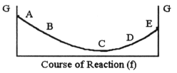

A) A B) B C) C D) D E) E Answer: C Sec. 19.5

25) For the reaction C(s) + H₂O (g) → CO(g) + H₂ (g)

ΔH° = 131.3 kJ/mol and ΔS° = 133.6 J/K · mol at 298 K. At temperatures greater than __________°C this reaction is spontaneous under standard conditions.
A) 273 B) 325 C) 552 D) 710 E) 983 Answer: D Sec. 19.6

26) For the reaction C₂H₆ (g) → C₂H₄ (g) + H₂ (g)

ΔH° is +137 kJ/mol and ΔS° is +120 J/ K · mol. This reaction is __________.
A) spontaneous at all temperatures B) spontaneous only at high temperature
C) spontaneous only at low temperature D) nonspontaneous at all temperatures Answer: B Sec. 19.6

27) A reaction that is not spontaneous at low temperature can become spontaneous at high temperature if ΔH is __________ and ΔS is __________.
A) +, + B) -, - C) +, - D) -, + E) +, 0 Answer: A Sec. 19.6

28) If ΔG° for a reaction is greater than zero, then __________.
A) K = 0 B) K = 1 C) K > 1 D) K < 1 E) More information is needed. Answer: D Sec. 19.7

29) Which one of the following statements is true about the equilibrium constant for a reaction if ΔG° for the reaction is negative?
A) K = 0 B) K = 1 C) K > 1 D) K < 1 E) More information is needed. Answer: C Sec. 19.7

30) Find the temperature above which a reaction with a ΔH of 123 .0 kJ/mol and a ΔS of 90.00 J/K·mol becomes spontaneous.
Answer: 1367 K Sec. 19.6

31) In the Haber process, ammonia is synthesized from nitrogen and hydrogen: N₂ (g) + 3H₂ (g) → 2NH₃ (g)
△G° at 298 oK for this reaction is -33.3 kJ/mol. The value of △G at 298 K for a reaction mixture that consists
of 1.9 atm N₂, 1.6 atm H₂, and 0.65 atm NH₃ is __________.
A) -1.8 B) -3.86 × 10³ C) -7.25 × 10³ D) -104.5 E) -40.5 Answer: E Sec. 19.7

