Principal’s message

## Jefferson Elementary School

## 2022-2023

## STUDENT HANDBOOK

**Steve Hopkins, Principal**

2500 Cadet Way

Everett, WA 98208

Telephone: 425-385-7400

E-mail for reporting absences: [JFEAttendance@everettsd.org](mailto:JFEAttendance@everettsd.org)

Fax: 425-385-7402

Visit us on the web:

[*http://www.everettsd.org/jeffersones*](http://www.everettsd.org/jeffersones)

*Please refer to the Everett Public Schools Student Responsibilities and Rights handbook for a complete publication of policies and rules at* [*http://www.everettsd.org/domain/1493*](http://www.everettsd.org/domain/1493)*.*

***Our Mission Statement***

*“At Jefferson Elementary School, we achieve to high standards  
by providing a meaningful and relevant education, preparing   
each of our students to be healthy, well-rounded lifelong learners   
and responsible citizens in a changing society.”*

Welcome to the 2022-23 school year! Whether you are new to Jefferson or returning this year, our staff is excited to have you! You are joining a strong learning community, one where staff members, students, and family members all come together to ensure that students have a high-quality and engaging experience at school each day. Working with families as partners is very important to us, so please reach out if you have questions or concerns.

Our goal at Jefferson is expressed in our mission statement, which is printed on the cover of this handbook. The focus at Jefferson is on the whole child – and on *each* child as a unique individual whose achievement and development will be supported by a reflective, responsive staff. Families play an essential role as partners in the education of their children, so please consider volunteering to help in your child’s classroom and/or with other activities around the school, as current COVID guidelines allow. A strong home-school connection is a great way to support your child’s learning.

Please take the time to read through this handbook carefully, and to discuss the relevant sections with your child. It contains key phone numbers, policies, and procedures.

Thank you for your support of your child, and of Jefferson Elementary School. It’s going to be a great year!

***Steve Hopkins, Principal***

Telephone Directory

Please call lines directly using the numbers below.

Main Office 425-385-7400

Attendance Line 425-385-7405

Fax 425-385-7402

Health Room 425-385-7406

Counselor 425-385-7410

School Psychologist 425-385-7412

Kitchen 425-385-7407

Transportation 425-385-4144

safety tip line: 855-637-2095

Anyone with a concern about safety in Everett Public Schools or who knows something about a possible threat to safety is urged to call or text the safety tip line. Or you can e-mail a tip to [1350@alert1.us](mailto:1350@alert1.us) or enter a tip online at <https://everett-wa.safeschoolsalert.com/>. Reporters can choose to remain anonymous.

Bell Schedule

* Regular school days: 9:10 a.m. to 3:30 p.m.
* **Learning Improvement days:** 9:10 a.m. to   
  2:15 p.m.
* **Early dismissal days:** 9:10 a.m. to 1:00 p.m.

Arriving AT and leaving school

Arrival times and locations for students are:

* 8:45 a.m. for Safety Patrol students
* 8:45 a.m. to the cafeteria for students eating breakfast at school
* 8:55 a.m. to the covered play area (grades 1-5) or kindergarten corral. Wait in line with the class. Quiet conversations are appropriate. Children are not allowed to play on the playground or fields.

There is no adult supervision provided before 8:55 a.m. except for breakfast or Safety Patrol, so it is not safe for students to be dropped off before then.

After school:

* Students who ride the bus are to go directly to the kindergarten corral and line up by bus route.
* Students who are picked up by car are to go directly to the parent pick-up area and wait in lines by grade level. Students are to be picked up by 3:40 p.m.
* Students who walk are to go directly home, and are not allowed to play on the playground or fields until they have been home to get permission, and then only after 4:00 p.m.

There is no adult supervision provided after 3:40 p.m., so it is not safe for students to be picked up later. If your child chooses to stay after dismissal and play at the playground, parents must stay to supervise their child.

Parents/guardians will be notified if students are repeatedly arriving too early or staying too late.

Students who are eligible to ride the bus are not allowed to walk. Bus transportation is provided on the assumption that there are long distances to walk, or that the area is unsafe for walking as determined by the transportation office. Bus riders getting off at a different stop than usual must bring a parent note to the school office, as must students going home with friends.

School behavior standards and expectations apply at bus stops and while riding the bus. Students may not bring toys, games, or electronics to the bus stop or on the bus. Cell phones are to be off and in backpacks while waiting for and riding the bus.

Students receiving three or more bus conduct write-ups may be suspended from the bus.

Student Drop-Off and Pick-Up

Families are to use the main parking lot (El Capitan) entrance only. The Cadet Way entrance is for buses, day care vans, and deliveries. Please respect Safety Patrol students, adult supervisors and signs. In addition, follow these guidelines to keep everyone safe, and traffic flowing:

* Use the designated crosswalks.
* Park in designated parking spaces.
* Park in handicapped spaces only if you have a placard or proper license plate.
* Do not leave your vehicle at the curb unattended.
* Students enter/exit vehicles on the curb side only.
* Drive cautiously, and follow the posted speed limit.

Changes in Transportation

When a student needs to go home with another child or to any place that is out of their ordinary routine, they must have a note from the parent/guardian. Teachers will send students home the usual way if there is no note. Students will not be allowed to use school phones to arrange playdates. For unplanned/unexpected changes, call the office by 3:00 p.m. so the change can be relayed.

**BICYCLES, SCOOTERS, ETC.**

Per Everett Public Schools policy, students in grades three and above may ride bicycles to and from school. Students must walk their bicycles on campus, wear a helmet, and lock the bike to the rack behind the cafeteria. Skateboards, scooters, roller blades, roller shoes, etc., may not be ridden on district property. The district is not responsible for loss or theft of student property.

Attendance

Daily attendance is a major contributor to a student’s academic success. District policy, in alignment with state law, requires written documentation of absences in order to excuse them. Not all absences are excused, and reporting an absence does not automatically excuse it. Per district policy, there are eight valid excusal reasons:

1. District or school-approved activity
2. Illness, health condition, or medical appointment
3. Family emergency
4. Religious purposes (holiday/religious instruction)
5. Judicial proceeding or jury duty
6. Post-secondary, technical school or apprentice-ship program visit or interview
7. State-recognized search and rescue activities
8. Absence directly related to the student’s homeless status

**The preferred way** to report your child’s absence is to send an e-mail to **JFEAttendance@everettsd.org** from an address that is in your student’s records so that it can be verified. In the e-mail, please include:

1. Student name and ID number
2. Absence date(s)
3. Reason for the absence
4. Parent/guardian name

Parents/guardians may contact the school by phone to provide an explanation for a student absence. Such parent/guardian contact will be recorded in writing by school office staff to excuse the absence.

In order for vacation/travel to be excused, they must be approved in advance. The district policy states: “Families should not schedule vacations or travel while school is in session. If a family vacation or travel must occur while school is in session, it must be prearranged prior to the absence and approved by the principal (or designee). ... The principal (or designee) may excuse up to five (5) school days for a prearranged absence per student each school year.” To pre-arrange an absence, please contact the office for a form.

**Tardies:** The first bell rings at 9:10, and this is the latest students should arrive on campus. Students who arrive after the 9:15 tardy bell will be marked tardy and must come to the office to receive a slip to enter class. Tardies are excused or unexcused based on the same reasons as absences. Students who are chronically late miss many learning opportunities, and their arrival disrupts the classroom. Students who arrive 30 minutes or more after the beginning of school will be marked absent for a half-day. When signing your child in late, please say goodbye at the front desk rather than escorting the student to class.

**Early release:** Please schedule appointments during non-student days when possible. If an appointment requires that a student be released early, parents/guardians must come to the office to sign the student out and have the student called to the office. Students who leave school more than two hours prior to the scheduled dismissal time will be marked absent for a half-day. Leaving within a half-hour of dismissal counts as a tardy. Early releases are excused or unexcused based on the same reasons as absences.

**Attendance conferences:** Frequent absences, tardies, or early releases will result in a conference with the parent/guardian and a school administrator.

Keep us informed

It is imperative that you keep the office informed of any changes in your contact information. In case of emergencies, it is crucial that we have accurate contact information for relatives or friends if we cannot reach you.

Emergencies

Jefferson has emergency procedures in place for earthquake, fire, and lockdown situations. Whole-school practice drills are conducted monthly. In the event of a true emergency, please be patient. Our first priority will be to ensure student safety. Office personnel will be busy helping students, directing emergency crews, etc., and may not be able to answer your calls promptly. Our staff is trained to deal with emergencies and will not release any child until an authorized person arrives.

School Breakfast/Lunch Program

During the 2021-22 school year, both breakfast and lunch will be available free to all students without any free/reduced application required. However, we encourage families to complete the annual application found on the district website, as some funding sources are based on the percentage of students who qualify for free/reduced price meals.

ANIMALS on campus

The following restrictions apply to dogs and other animals on district property:

No dogs or other animals shall be allowed on district grass and/or synthetic athletic fields (e.g., soccer, football, baseball, softball, etc.) at any time.

No dogs or other animals are allowed on other district property between the hours of 7:00 a.m. and 5:00 p.m. Monday through Friday, except for bona fide service animals governed by Policy 2030 and Procedure 2030P, or those animals approved for schools as governed by Policy 3418 and Procedure 3418P. At all other times, dogs or other large animals that can be leashed must be leashed and controlled by their owners. Small animals that cannot be leashed must be controlled by their owners at all times through other appropriate means. Dogs and other animals are also not allowed on campus during evening school or PTA/Lighthouse events.

Animal owners must clean up after their animals and remove waste from district premises.

If district personnel determine that a person with an animal should be ordered to leave district property or have their future access restricted, such personnel shall attempt to communicate that information to the person. Following an attempt at oral communication, if the person does not comply with personnel directives, and if the situation warrants assistance, personnel may call law enforcement. If the person can be identified, the appropriate regional assistant superintendent may also issue a no trespass notice in written form.

Pursuant to Washington State law (RCW 16.08.040), the owner of any dog that bites a person while that person is in a public place is liable for any damages suffered by the person bitten, regardless of the former viciousness of such dog or the owner’s knowledge of such viciousness. The dog owner is personally held strictly liable for the damage inflicted on any persons injured or harmed by the dog physically or emotionally in any manner.

CLOSED CAMPUS DURING THE DAY

The Jefferson campus is closed to community use from 8:45 a.m. to 3:45 p.m. on days that school is in session. This includes paths through campus, fields, playgrounds, and blacktop areas.

Evening events

Students attending evening school or PTA/Lighthouse events must have an adult with them at all times. They may not be dropped off on their own and picked up later.

Harassment, Intimidation, Bullying

In our continuing effort to maintain a safe and positive learning environment, Jefferson staff strictly follow and enforce district policy on anti-harassment, intimidation and bullying. The policy outlines specific procedures for responding to bullying reports. All staff members have received training about how to respond effectively to bullying problems. Students are encouraged to recognize, refuse, and report bullying when it happens to them or someone else. Please refer to Everett Public Schools policy 3204 regarding the definition, prohibition, and consequences of harassment, intimidation, and bullying.

FOOD/celebrations IN CLASSROOMS

Information about snacks and celebrations (including birthdays) will be shared with families in the fall, and will be based on COVID health and safety guidelines at that time.

Flower and balloon deliveries will not be accepted.

Gum is not to be chewed on campus or on buses.

behavior Expectations

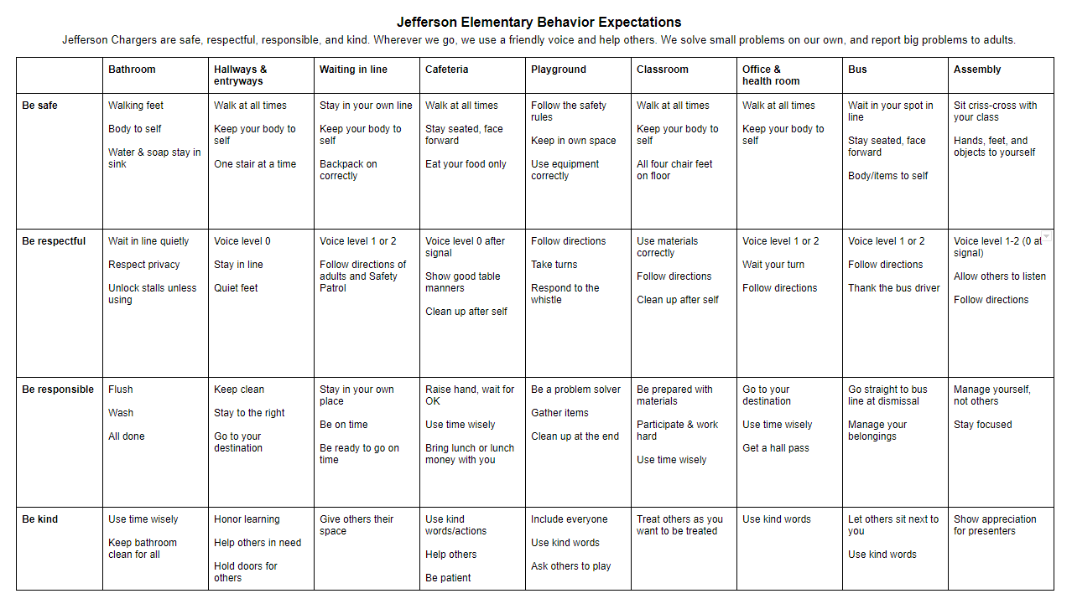All Jefferson students learn and review schoolwide behavior expectations each year as part of our approach to behavior, Positive Behavior Interventions & Supports (PBIS). They learn to follow the Charger Code: “Jefferson Chargers are safe, respectful, responsible, and kind. Wherever we go, we use a friendly voice and help others. We solve small problems on our own, and report big problems to adults.” Please see the accompanying chart with behavior expectations.

Here are some additional playground rules:

* No tag, or tackle football.
* No climbing on top of the blue bar.
* The slide is one-way – down and seated.
* Students are not allowed into the building unless they need to use the restroom, so must remember their jackets before going out.
* Students need to be in sight of playground staff and away from fences and wooded areas.
* Students may not bring any recess/play equipment from home.

Dress and Appearance

Children should be prepared to participate in the day’s activities, including gym and recess, with appropriate footwear. Clothing should allow for normal play such as running and kneeling. Students should be appropriately dressed for the weather, with water-resistant jackets. Hats, bandannas, etc., are not to be worn inside school buildings.

Student dress will be regulated to preserve a beneficial learning environment and to assure the safety and well-being of all students. Dress that presents a health or safety hazard, damages school property, or creates a material and substantial disruption of the educational process is prohibited per district policy 3224. Students will wear appropriate school attire, including shoes. Appropriate attire shall exclude any type of dress or manner of grooming that school officials reasonably believe would disrupt or interfere with the school environment, activities and/or educational process. The following are not permitted:

1. Attire that shows undergarments; inadequately covers breasts, midriff, buttocks, or thighs; displays obscene, sexual, drug or alcohol related messages; or displays gang-related symbolism.
2. Any clothing that would create, in fact, an atmosphere in which a student, staff member, or other person’s well-being is hindered by undue pressure, behavior, intimidation, overt gesture or threat of violence.

Students dressed inappropriately will be asked to call home or to wear clothes from our Health Room.

ITEMS FROM HOME & CELL PHONES

Children are to leave their own playthings at home unless the teacher has given permission otherwise. This includes all recess equipment (basketballs, soccer balls, etc.).

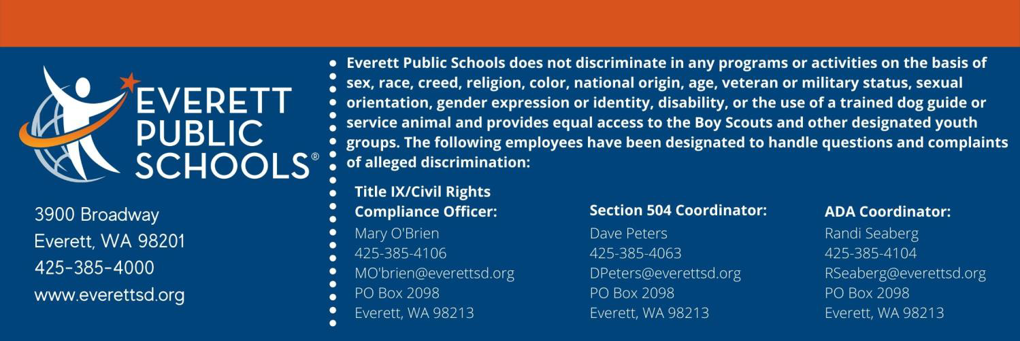Personal belongings not permitted include but are not limited to: toys, games, skateboards, skates/rollerblades,  
  
  
  
  
 skate shoes, scooters, electronics, laser pens, trading cards/collections, and any other items that pose a safety risk or are a distraction.

Cell phones are to be left off and in backpacks between 8:45 a.m. and 3:45 p.m., as well as on school buses. Cell phones may not be taken on field trips. Smart watches and other “wearable technology” items are heavily discouraged due to the potential for loss and distraction. If any teacher deems such items too distracting for students, they will not be allowed at school. Items of value taken from a student will be held in the office until a parent picks them up (maximum of one month). The school is not responsible for lost or damaged items.

Parents/Volunteers/visitors

Visiting and volunteering will be done in accordance with COVID safety and security guidelines, which may change throughout the year. All visitors and volunteers must sign in at the office and wear a visitor sticker before proceeding to other areas of the campus. As safety allows, we welcome volunteers! Please connect with your child’s teacher about how you can help. All volunteers must fill out a district volunteer application and be approved before working. Visiting occasionally does not require volunteer clearance. Parents and guardians are welcome to visit classrooms, but visits must be scheduled in advance with the child’s teacher. Volunteers may not bring younger siblings. Visitors for special events must clear bringing younger siblings with the classroom teacher.

Homework Policy

Teachers will communicate homework routines during the first weeks of school. Expect your child to work for 30 to 45 minutes each day, including reading. Parents are encouraged to check backpacks (and planners for grades 3-5) for teacher and school communication. Parents can assist students with homework by providing a specific time and place to work, as well as praise and encouragement.