March 31, US History Period 4, Vocab and Concepts Review

CIVIL
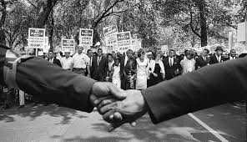Civil Rights
What do you think “Civil” means in this phrase above?
I think “Civil” is referring to________________________________________.

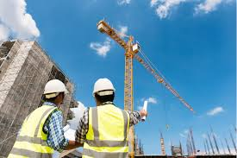Civil Engineering
What do you think “Civil” means in this phrase above?
I think “Civil” is referring to________________________________________.
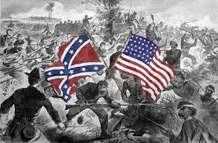Civil War
What do you think “Civil” means in this phrase above?
I think “Civil” is referring to________________________________________.
WORDS TO KNOW, THAT MAY CHALLENGE YOU SIMPLIFIED, OTHER WORDS
Refer

Rights

Engineering

War

Argued

decide

____________________________________________________________________________________
What was the Civil War about in American history??

Southern and Northern states argued over ______________________________________________.

They fought a war to decide______________________________________________________________

