#1: Listen with the intent to understand

I took 3 years of French and I remember nothing

Comprehensible Input

CLASSROOM RULES



**The name of the game is proficiency!**

**Comprehensible Input = All language learned must be comprehensible to all learners**

**🡪 Growth Based Classroom -** We celebrate mistakes and take responsibility for our learning

**🡪 Physical Classroom -** We move our bodies every day. We have fun

**🡪 Student Centered Classroom -** Every student has a job. We are a community

#3: Support the flow of the class

There will be NO:

* Memorizing vocab lists
* Practicing verb conjugations
* Learning French in English

#2: One person speaks while the others listen

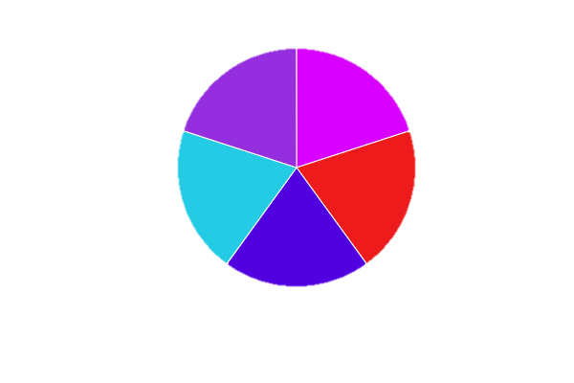\

* This course qualifies for EvCC’s College in the High School Program (CHS). Students seeking to earn college credit must enroll in the EvCC CHS program.
* Program processes and deadlines can be found at [www.everettcc.edu/chs](http://www.everettcc.edu/chs).
* Course costs for **5 credits** : $220.00
* **Step 1**: Apply for Admission by Friday, October 12, 2018
* **Step 2**: Complete Program Application by Monday, November 5, 2018
* **Step 3**: Registration and Payment by Monday, November 19, 2018

Interpersonal and Presentational Writing

* Emails & stories

Interpretive Listening

* Story recall & audio/video analyses

Interpretive Reading

* Multiple choice/short answer quizzes & text analysis

Interpersonal and Presentational Speaking

* Skits & presentations

**Participation**

**20%**

**listening**

**Listening**

**listening**

**Speaking**

**Reading**

**Writing**

**20%**

**listening**

**20%**

**listening**

**20%**

**listening**

**20%**

**listening**

GRADING

Bienvenue à la Classe de Français 3!

Mme Wendy Organ

Portable 6

Soyez courageux d'essayer

[](http://images.clipartpanda.com/cell-phone-clipart-black-and-white-xTgoqAnTA.jpeg)[](http://www.clipartbest.com/cliparts/dT8/6oL/dT86oLrjc.jpg)[](http://i0.kym-cdn.com/photos/images/original/001/107/727/232.png)

425.385.7084  
I'm available after 2:05 pm

[worgan@everettsd.org](mailto:worgan@everettsd.org)  
I usually respond within 24-hours

https://www.everettsd.org/jhs-worgan