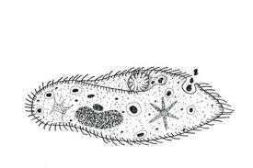
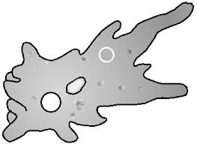
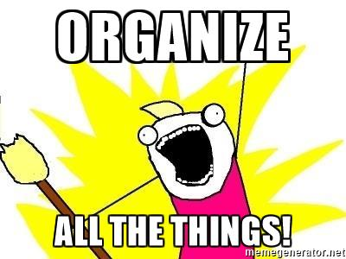
How do I Succeed in this Class? (Part 1) Be organized!

ORGANIZATION: Students need to have the following items for science every day:

- One 1 or 1 ½ inch three-ring binder to be kept in class for daily work and activities
- Pencils and erasers for everyday work and colored pencils for labs
- Lined paper

What’s going on?
COMMUNICATION: Check my blog daily.**

I keep a daily blog which can be found on my web page. Teacher web pages are on the Heatherwood Middle School web site. At the end of each school day, I write a reflection of what we did in class with attachments for lab sheets or other work, links to videos we may have watched and the daily warm ups. This is the best way for you, and your child, to keep up with what we’re doing in science. If you are absent, my blog is the best way for you to find out what you’ve missed. You may print out whatever sheets you missed while you’re at home if you want to. If you have any questions that the blog can’t answer, the best way to reach me is through email (blanigan@everettsd.org)

**If you do not have internet access at home and need a hard copy of anything I post on my blog, please let me know on the checklist sheet at the end of this packet.

Blog?
HOW DO I GET THERE?
Go to the Heatherwood Middle School home page. Click on “Our Staff” and click on “Teachers”. Click on “Lanigan, Billie” (That’s me!) and it will take you to my web page. On the left side of the page, click on “Ms. Lanigan’s Blog” and you’re at my blog!
**If you do not have internet access at home and need a hard copy of anything I post on my blog, please let me know on the checklist sheet at the end of this packet.

Dear Students and Families,

Welcome to 6th grade science! I hope you enjoyed your summer and you’re ready for a new school year. My name is Billie Lanigan and I am excited to be here to help foster curiosity and enthusiasm for science.

Look for the circled items and make sure you read and understand them. There will be a quiz at the end of this letter!

Ms. Lanigan’s

Class

How do I Succeed in Class? (Part 2) Do the work!

HOMEWORK
I do not give homework. (Yes, you read that right – except for returning the checklist attached to this information sheet, I do not give homework! Yay, Ms. Lanigan! Don’t high-5 just yet. You have plenty of work to do in class.)

ABSENT? Well, you’ve just made yourself some homework.
If you are absent, it is your responsibility to find out what you’ve missed and to make up the work. We have an in-class procedure that we will practice. Everything we do in class will be posted on my daily blog. There will also be links to labs, lab sheets, other assignments, and videos we’ve watched in class.

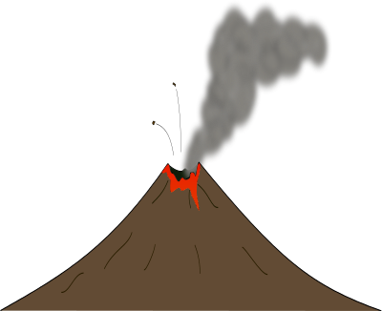
More Success Tips!
For group labs, you must hand in your own lab sheet. You will not get credit for adding your name to someone else’s lab sheet. Science labs are designed for group exploration and discovery. You are expected to help and support each other; however, when answering questions, each individual is expected to provide his or her own original responses.

Group Work
Although labs, warm-ups, and other assignments do not count toward final grades it is imperative that they are complete. Students will need to complete work or redo missing class work before they are allowed to take tests or quizzes.

Keep all of your work! Not only do you need it to study for tests and quizzes, it is your insurance in case there is an error in recording your grade. Check each posting of grades and if at any time we do not agree, you can use your graded, returned assignment as proof of completion. Believe it, or not, I do make mistakes! I will gladly correct the errors if you show me your graded, returned paper.

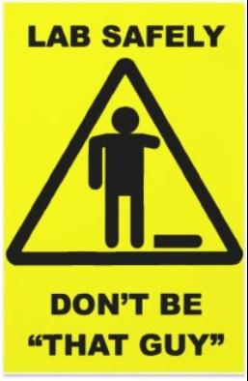
How to Act? Be Cool. Be Nice. Treat Others the Way You Want Them To Treat You!

CONDUCT: Students will be given the student handbook which will have all the information about school expectations. These apply in the classroom as well. Please refer to it for more information.

LAB SAFETY: Read the attached lab safety rules. If you have questions about any of them, let me know. We will go over them thoroughly in class.

One more thing…
This is a cool way to get reminders from me if you’re not able to check the blog regularly. I can send you reminders about tests and important stuff without me having your phone number or you having mine! See the attached sheet for more information and sign up!
Rating your Success:

GRADING: All labs and projects will be corrected and entered in the grade book, but not be included in the overall grade. Final grades will be from test and quiz scores only. The warm ups, labs, and projects are perfect to use as study guides for the tests. We will have at least one full class period for review before each test and have collaborative study groups when possible. It is important that all work is completed because the work directly influence test scores. If any work is missing or incomplete it will need to be done and graded before the next test. Any test with a score below 70% may be retaken on request.

Grades will be based on test scores. The letter grades correspond to the following scores:
- A = 90-100% B = 80-89% C = 70-79% D = 60-69% F = 0-59%

Grades are updated regularly on-line and can be accessed through the Heatherwood Web Site (https://lms.everettsd.org/secure/HomePage.aspx). This web page will be available mid September.

This Quiz (only this page) needs to be turned in to be graded by
Wednesday, September 13, 2017
Circle  T for True, F for False | If you’re not sure if the answer is true or false, write me a note somewhere on this page.
T F | My child has the proper supplies needed for success in Ms. Lanigan’s class (pencils, binder, colored pencils, lined paper, pencils, erasers, pencils).
T F | My child and I know that Heatherwood recommends using a planner, but that Ms. Lanigan will post everything on her blog if the planner isn’t used in science class.
T F | All returned graded papers should be saved in my science binder and kept in class to keep track of grades, have proof of grades, and to use to study for tests and quizzes.
T F | We understand the grading scale and that, even though only tests and quizzes count for overall grades, the other work is super important to prepare me for tests and quizzes. Also, I can retake any tests I receive a score of less than 70%.
T F | We have read and understand the necessity of the lab safety rules and the consequences for breaking them. We understand that the rules need to be followed to ensure the safety of all students in the class.
T F | We understand that it is the student’s responsibility to find out about missed work if an absence occurs and this might require the work to be done outside of school (homework!).
T F | We have signed up for Remind.com for another way to be kept up to date on upcoming quizzes, tests, or important information.
T F | We were able to access Ms. Lanigan’s blog and know that all of this important information and much more will be there whenever we need it.
T F | We are unable to access Ms. Lanigan’s blog because we don’t have internet access and understand that our child will need to get a hard copy of necessary information.
Multiple choice – circle the best answer choice |  | I often take photos of students while they are participating in labs during class to post on my blog and for use in the yearbook.  - I give permission to use any photos my child appears in.  - DO NOT take photos of my child to post on your blog or in the yearbook.
Student Name: _____________________________________________________________________________________

Parent(s) Name(s): ________________________________________________________________________________

Student Signature: _________________________________________________________ Date: __________________

Parent Signature: ___________________________________________________________ Date: _________________

Preferred method of contact? (Circle one) email phone

Best email address to reach a parent: ________________________________________________________________

Best phone number to reach a parent: _______________________________________________________________
Science Lab Safety Rules

Lab Procedures:
- Always get your teacher’s permission before beginning an experiment.
- Be sure you read and understand the directions and procedures before beginning your investigation/inquiry.

- Return all materials to their proper places.
- Dispose of chemicals and broken glassware as directed by your teacher.
- Be sure your work area is clean during and after the lab.
Remember:
No lab can be 100% safe, but most accidents can be avoided by carefully following the rules and by acting responsibly.

Students are expected to:
- Be on-task, safe and respectful at all times.
- Follow lab directions carefully. Watch for hazards.
- Keep all objects out of your mouths.
- Tie back long hair and avoid wearing loose fitting clothing.
- Shoes should cover feet completely.
- Wash hands before and after lab activities.
- Wear lab goggles and aprons when directed.
- Report spills and injuries immediately!
- Dump chemicals in appropriate containers, NOT down the drain.
- Treat unknown chemicals with caution. Clear liquids may not be water!
- Handle all chemicals with care. Avoid skin contact.
- Avoid contamination. Do not pour chemicals back into original containers.

