Step 1: Go to the Everett District Website <https://www.everettsd.org/>

Step 2: The click on students

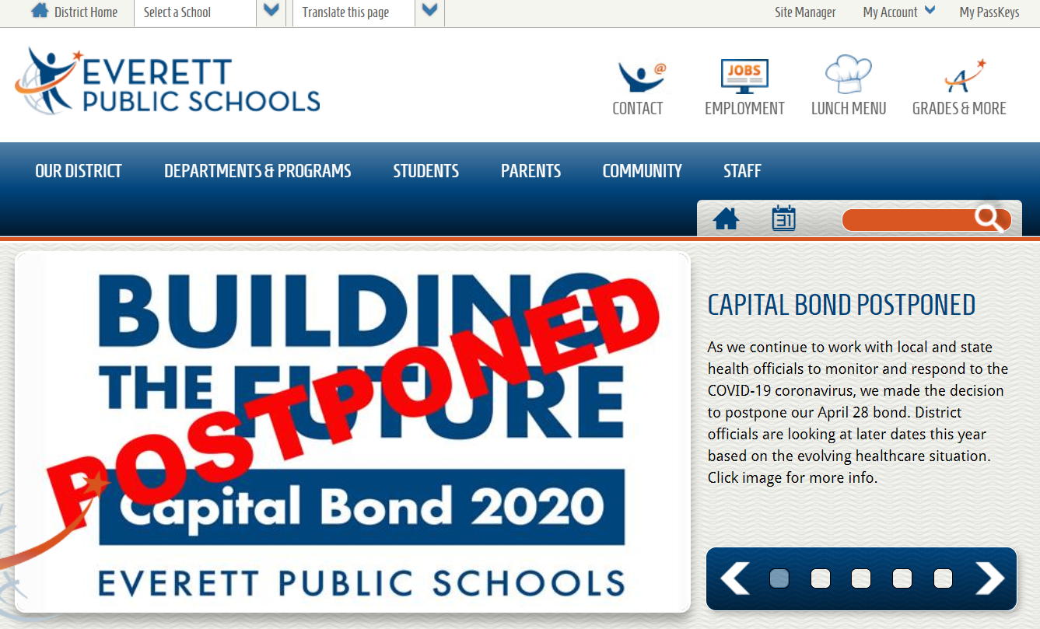

Step 3: Once on the student tools page, look for the iReady symbol and click on it.

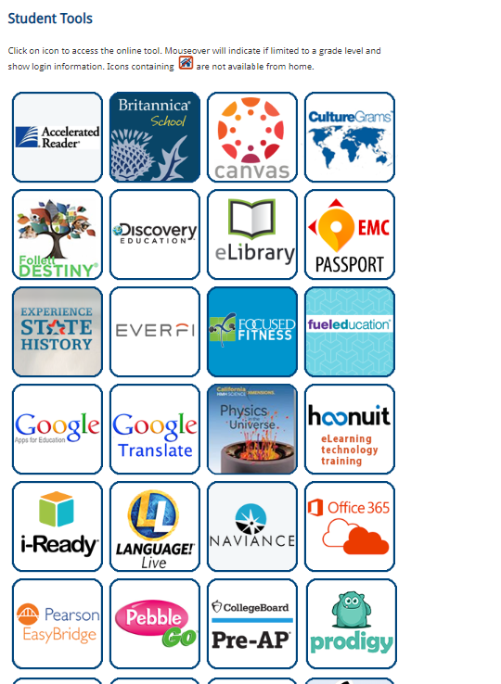

Step 4: You will be redirected to a log in page, you will next click on “Sign in with your district id and password”

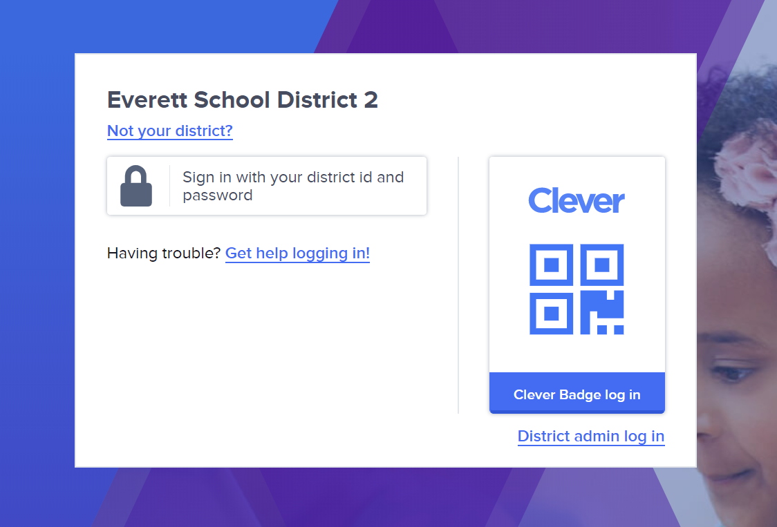

**Step** 5: Log in with your student ID number. Their ID number is both their username and password. I will email all parents their student individual ID numbers.

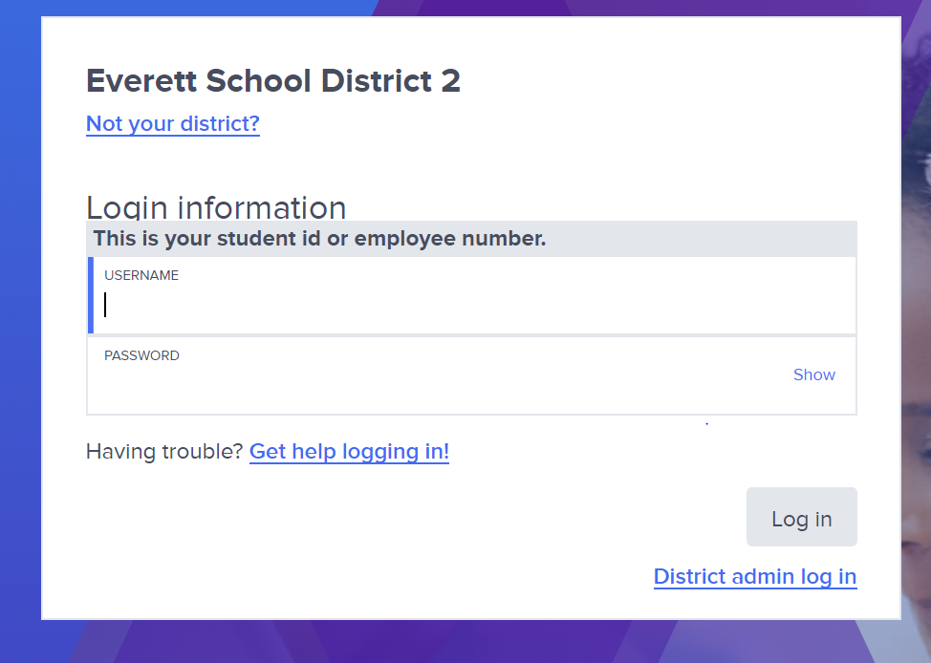

Step 6: Once on student dashboard, click on the iReady symbol

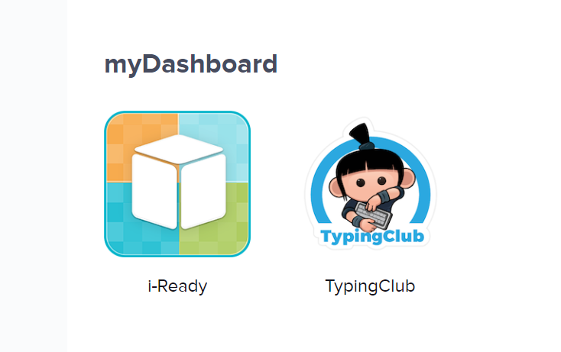

Step 7: Set a timer for 20 minutes and have your child choose either reading or math

