LESSON 10

Breaking the Code

The Periodic Table

|  |
| --- |
| [**Delete**](Javascript:top.EditNoteDelete()) |

**Think About It**

The elements copper, Cu, and gold, Au, share many similarities. Both are relatively unreactive elements. They are soft so it is easy to bend and shape them. They are called *coinage metals* because they have been made into coins by many cultures. Copper and gold have high values as jewelry because they remain shiny for many years. Is the similarity in their properties related to their locations on the periodic table?

**What information does the periodic table reveal about the elements**

To answer this question, you will explore

* icon green1.jpgThe Modern Periodic Table
* icon green2.jpgTrends in Properties

**Exploring the Topic**

icon green1.jpgThe Modern Periodic Table

Scientists have detected around 114 different elements on the planet. Each is unique. Yet, groups of elements have similar properties. Recall from Lesson 9: Create a Table that Dmitri Mendeleyev constructed a table based on patterns in the properties of the elements. His table has been replaced over the decades with many updated versions, such as the one shown below. The modern periodic table is a storehouse of valuable information about the elements. Over time you will learn how to make use of the information that is contained there.

**Element Squares**

Each element has a square on the periodic table. Within each square is information about that element including its name and symbol. The whole number in each square is called the [**atomic number**](JavaScript:top.Define('atomicnumber')). Hydrogen is the first element in the table and has the atomic number 1. Helium is the second element and has the atomic number 2. Each atomic number corresponds to a different element.

The decimal number in each square on the periodic table square is the average atomic mass in amu.

Here is a square from the periodic table.

[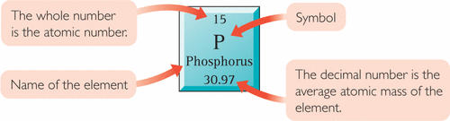](javascript:top.OpenSupp('figure','2','UN431','FIGURE'))

[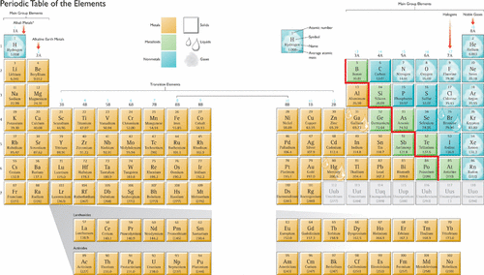](javascript:top.OpenSupp('figure','2','UN441','FIGURE'))

* Group 1A, except for hydrogen, H  
The values in parentheses are the average atomic mass of the longest lasting isotope of the element at the time of writing.

HEALTH

CONNECTION

Transition metals are important to human health. For example, iron is a central component of the protein hemoglobin, which helps to transport oxygen in the blood. Chromium helps our bodies metabolize glucose, and zinc helps to protect our immune systems.

[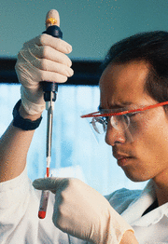](javascript:top.OpenSupp('figure','2','UN461','FIGURE'))

**Parts of the Periodic Table**

Most modern periodic tables have 18 vertical columns and 7 horizontal rows. The vertical columns are also called [**groups**](JavaScript:top.Define('group')), or families. Hydrogen, H, is in Group 1A, along with lithium, Li, and five other elements in that column. Some of the groups have specific names as shown below.

[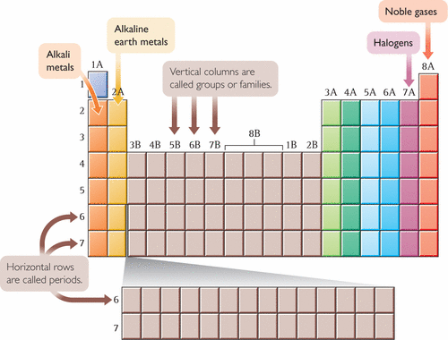](javascript:top.OpenSupp('figure','2','UN462','FIGURE'))

The horizontal rows of the table are called [**periods**](JavaScript:top.Define('period')) because patterns repeat periodically, or over and over again, in each row. There are only two elements in Period 1, hydrogen and helium. However, there are eight elements in Periods 2 and 3, and 18 elements in Period 4.

Chemists also have names for sections of the periodic table. Between Group 2A and Group 3A, for example, is where the transition elements fit in.

[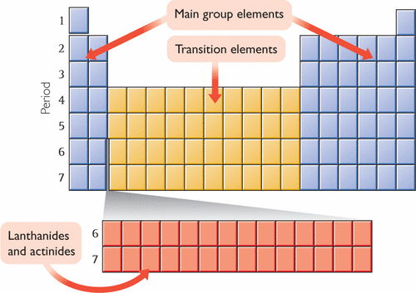](javascript:top.OpenSupp('figure','2','UN463','FIGURE'))

CAREER

CONNECTION

Silicon Valley is a region in northern California that is known for its many high-technology and computer-based businesses. Silicon is a Group 4A element and a metalloid. It is the main component of semiconductor devices such as the microchips used in computers and electronic equipment.

[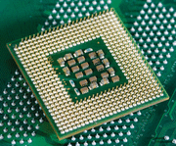](javascript:top.OpenSupp('figure','2','UN471','FIGURE'))

In addition, there are two rows of elements usually shown at the bottom of the table. These elements are called the lanthanides and actinides. If you examine the atomic numbers of these elements, you’ll see that they belong in the sixth and seventh rows. If they were included where they belong, the table would look like this.

[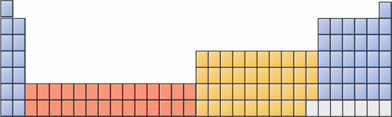](javascript:top.OpenSupp('figure','2','UN472','FIGURE'))

Most periodic tables show them at the bottom so everything will fit onto one page.

icon green2.jpgTrends in Properties

Once the elements are arranged according to their general properties, many other patterns or trends can be found. These three drawings illustrate some of the trends contained within the periodic table.

**Solids, Liquids, and Gases**

Most of the elements are solids at room temperature. There are several elements that are gases at room temperature, and only a few that are liquids at or near room temperature.

[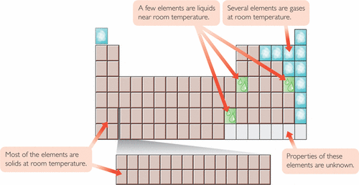](javascript:top.OpenSupp('figure','2','UN473','FIGURE'))

**Metals, Metalloids, and Nonmetals**

The majority of the elements are [**metals**](JavaScript:top.Define('metal')). On most periodic tables there is a stair-step line that divides the table. Metals are found to the left and [**nonmetals**](JavaScript:top.Define('nonmetal')) are found to the right of the stair-step line. The elements found along the stair-step line are called [**metalloids**](JavaScript:top.Define('metalloid')). Metalloids have properties similar to those of both metals and nonmetals.

[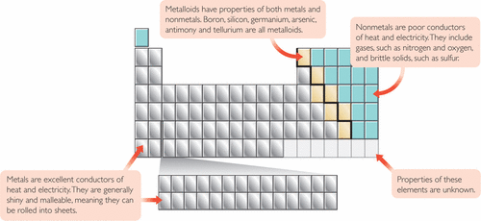](javascript:top.OpenSupp('figure','2','UN481','FIGURE'))

[**Reactivity**](JavaScript:top.Define('reactivity'))

Elements in the lower left and upper right of the periodic table are the most reactive, with the exception of the noble gases in Group 8A, which are very unreactive. Copper, Cu, silver, Ag, and gold, Au, are metals that are in the middle of the periodic table and are not very reactive.

[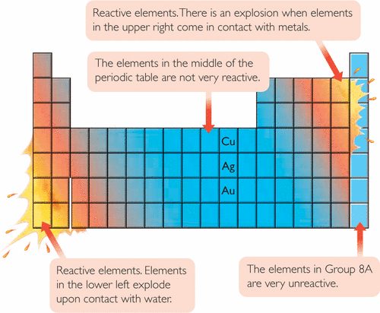](javascript:top.OpenSupp('figure','2','UN482','FIGURE'))

Example 1

Iodine, I

Find iodine, I, on the periodic table.

* **a.** Find iodine’s atomic number, average atomic mass, period, and group.
* **b.** Would you expect iodine to be a solid, liquid, or gas at room temperature?
* **c.** Is iodine a metal, metalloid, or nonmetal? How can you tell?
* **d.** Do you expect iodine to be reactive? Explain.

***Solution***

Iodine is in the lower-right area of the main group elements.

* **a.** The atomic number is 53. Average atomic mass is 126.9 amu. Iodine is in Period 5 and Group 7A, halogens.
* **b.** Iodine is a gas at room temperature.
* **c.** Iodine is a nonmetal, because it is to the right of the stair-step line.
* **d.** Yes, you can expect it to be reactive, though not as reactive as elements above it in Group 7A.

Example 2

Coinage Metals

Which element would make the best coin: phosphorus, P, silver, Ag, potassium, K, or xenon, Xe? Explain your thinking.

***Solution***

Xenon, Xe, is a gas, so it is definitely not a candidate for making a coin. Phosphorus, P, is a nonmetal that is dull and brittle. It would be difficult to shape into a coin. Silver, Ag, is a shiny, malleable metal, so it would make the best coin. Potassium, K, is also a metal, but it is too soft and reactive, so it would not make a good coin. A good coin should not react with other substances.

**Lesson Summary**

**What information does the periodic table reveal about the elements**

The periodic table is an organized chart of the elements. Each element square contains valuable information, including the element name, symbol, atomic number, and average atomic mass. These elements are arranged in vertical columns called groups, or families, and horizontal rows called periods. Most elements are solids and metals, except for those in the upper right of the table. The most reactive elements are located in the lower left and upper right of the table, excluding the noble gases in the last column on the right, which are unreactive.

Key Terms

[**atomic number**](JavaScript:top.Define('atomicnumber'))

[**group**](JavaScript:top.Define('group'))

[**alkali metals**](JavaScript:top.Define('alkalimetals'))

[**alkaline earth metals**](JavaScript:top.Define('alkalineearthmetals'))

[**halogens**](JavaScript:top.Define('halogens'))

[**noble gases**](JavaScript:top.Define('noblegases'))

[**periods**](JavaScript:top.Define('period'))

[**main group elements**](JavaScript:top.Define('maingroupelements'))

[**transition elements**](JavaScript:top.Define('transitionelements'))

[**lanthanides**](JavaScript:top.Define('lanthanides'))

[**actinides**](JavaScript:top.Define('actinides'))

[**metals**](JavaScript:top.Define('metal'))

[**nonmetals**](JavaScript:top.Define('nonmetal'))

[**metalloids**](JavaScript:top.Define('metalloid'))

**Exercises**

**Reading Questions**

**1.**

Describe how reactivity changes as you go down Group 1A.

[http://ebooks.bfwpub.com/livingbychemistry1e/pics/show_answer.gif](javascript:top.ToggleSolution('pq1',this.document))

**Answer:**

Within Group 1A, the elements tend to get more reactive as you move from the top of the column to the bottom.

**2.**

Choose two different properties and describe how they vary across a period.

**Reason and Apply**

**3.**

You will need a handout of the periodic table.

* **a.** On your periodic table, clearly label the alkali metals, the alkaline earth metals, the halogens, and the noble gases (if you wish, you may color them and provide a color key at the top).
* **b.** Label the main group elements, the transition metals, and the lanthanides and actinides.

**4.**

Name two elements that have properties similar to those of beryllium, Be, and have average atomic masses higher than 130.

**5.**

Which of these elements are solids?

* **A.** fluorine, F
* **B.** titanium, Ti
* **C.** lead, Pb
* **D.** oxygen, O
* **E.** potassium, K
* **F.** silicon, Si

[http://ebooks.bfwpub.com/livingbychemistry1e/pics/show_answer.gif](javascript:top.ToggleSolution('pq5',this.document))

**Answer:**

**b**. titanium **c**. lead **e**. potassium **f**. silicon

**6.**

Which of these elements are nonmetals?

* **A.** bromine, Br
* **B.** carbon, C
* **C.** boron, B
* **D.** thallium, Tl
* **E.** phosphorus, P
* **F.** aluminum, Al

[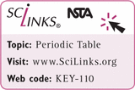](http://ebooks.bfwpub.com/livingbychemistry1e/boxes/scilink.php?term=Periodic%20Table&code=KEY-110)

**7.**

Which two of these elements are the least reactive? Explain your thinking.

* **A.** chlorine, Cl
* **B.** barium, Ba
* **C.** copper, Cu
* **D.** rubidium, Rb
* **E.** potassium, K
* **F.** mercury, Hg

[http://ebooks.bfwpub.com/livingbychemistry1e/pics/show_answer.gif](javascript:top.ToggleSolution('pq7',this.document))

**Answer:**

Elements c, copper, and f, mercury, are the least reactive. On the periodic table the least reactive elements (aside from the noble gases) are the transition metals that are located in the center of the table. The other elements listed are from more reactive groups near the edge of the table: alkali metals (potassium and rubidium), alkaline earth metals (barium), and halogens (chlorine).

**8.**

Can you make jewelry out of each of the elements listed below? Explain your thinking.

* **a.** copper, Cu
* **b.** neon, Ne
* **c.** sodium, Na
* **d.** platinum, Pt