**Mixtures and Solutions (from Chem 4 Kids)**

**Mixture Basics**

**Mixtures** are absolutely everywhere you look. Most things in nature are mixtures. Look at rocks, the ocean, or even the atmosphere. They are all mixtures, and mixtures are about **physical properties**, not chemical ones. That statement means the individual molecules enjoy being near each other, but their fundamental chemical structure does not change when they enter the mixture. If the chemical structure changed, it would be called a [reaction](http://www.chem4kids.com/files/react_intro.html).   
  
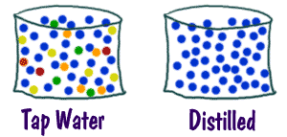When you see distilled water (H2O), it's a pure substance. That means that there are only water molecules in the liquid. A mixture would be a glass of water with other things dissolved inside, maybe one of those powders you take if you get sick. Each of the substances in that glass keeps its own chemical properties. So, if you have some **dissolved** substances in water, you can boil off the water and still have those dissolved substances left over. If you have some salt (NaCl) in water and then boil off the water, the salt remains in the pan. The salt is left because it takes very high temperatures to [melt](http://www.chem4kids.com/files/matter_changes.html) salt (even more to boil it).

**Mixtures are Everywhere**

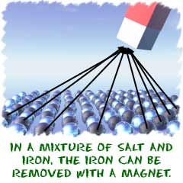There are an **infinite number of mixtures**. Anything you can combine is a mixture. Think of everything you eat. Just think about how many cakes there are. Each of those cakes is made up of a different mixture of ingredients. Even the wood in your pencil is considered a mixture. There is the basic cellulose of the wood, but there are also thousands of other compounds in that pencil. [Solutions](http://www.chem4kids.com/files/matter_solution.html) are also mixtures, but all of the molecules are evenly spread out through the system. They are called **homogenous mixtures**.   
  
If you put sand into a glass of water, it is considered to be a mixture. You can always tell a mixture, because each of the substances can be separated from the group in different physical ways. You can always get the sand out of the water by **filtering** the water away. If you were busy, you could just leave the sand and water mixture alone for a few minutes. Sometimes mixtures separate on their own. When you come back, you will find that all of the sand has sunk to the bottom. **Gravity** was helping you with the separation. Don't forget that a mixture can also be made of two liquids. Even something as simple as oil and water is a mixture.

<http://www.chem4kids.com/files/matter_mixture.html>

**Solutions and Mixtures**

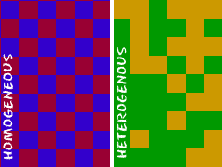Before we dive into **solutions**, let's separate solutions from other types of [mixtures](http://www.chem4kids.com/files/matter_mixture.html). Solutions are groups of molecules that are mixed and evenly distributed in a system. Scientists say that solutions are **homogenous systems**. Everything in a solution is evenly spread out and thoroughly mixed. **Heterogeneous mixtures** have a little more of one thing (higher concentration) in one part of the system when compared to another.   
  
Let's compare sugar in water (H2O) to sand in water. Sugar dissolves and is spread throughout the glass of water. The sand sinks to the bottom. The sugar-water is a homogenous mixture while the sand-water is a heterogeneous mixture. Both are mixtures, but only the sugar-water can also be called a solution.

**Can anything be in a Solution?**

Pretty much. Solutions can be solids **dissolved** in [liquids](http://www.chem4kids.com/files/matter_liquid.html). When you work with chemistry or even cook in your kitchen, you will usually be dissolving solids into liquids. Solutions can also be [gases](http://www.chem4kids.com/files/matter_gas.html) dissolved in liquids, such as carbonated water. There can also be gases in other gases and liquids in liquids. If you mix things up and they stay at an even distribution, it is a solution. You probably won't find people making solid-solid solutions. They usually start off as solid/gas/liquid-liquid solutions and then harden at room temperature. [Alloys](http://www.chem4kids.com/files/matter_mixture2.html) with all types of metals are good examples of solid solutions at room temperature.

|  |  |
| --- | --- |
| **SOLUTION** | **EXAMPLE** |
| Gas-Gas Gas-Liquid Gas-Solid Liquid-Liquid Liquid-Solid Solid-Solid | Air Carbon Dioxide (CO2) in Soda Hydrogen (H2) in Palladium (Pd) Metal Gasoline Dental Fillings Metal Alloys Such as Sterling Silver |

**Making Solutions**

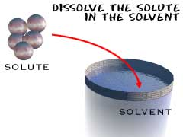A simple solution is basically two substances that are evenly mixed together. One of them is called the solute and the other is the solvent. A **solute** is the substance to be dissolved (sugar). The **solvent** is the one doing the dissolving (water). As a rule of thumb, there is usually more solvent than solute. Be patient with the next sentence as we put it all together. The amount of solute that can be dissolved by the solvent is defined as **solubility**. That's a lot of "sol" words.

**Colloids**

Science has special names for everything. They also have names for the different types of homogenous mixtures. Solution is the general term used to describe homogenous mixtures with small particles. **Colloids** are solutions with bigger particles. Colloids are usually foggy or milky when you look at them. In fact, milk is an **emulsified colloid**.   
  
You may also hear about colloids if you study soil. While milk is an **organic** colloid, soils can be made up of **inorganic** colloids, such as clay.

<http://www.chem4kids.com/files/matter_solution.html>

**Making Solutions**

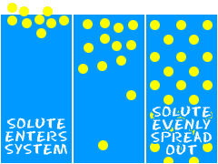So, what happens? How do you make that **solution**? Mix the two [liquids](http://www.chem4kids.com/files/matter_liquid.html) and stir. It's that simple. Science breaks it into three steps. When you read the steps, remember...   
Solute=Sugar  
Solvent=Water  
System=Glass.   
  
1. The **solute** is placed in the **solvent** and the concentrated solute slowly breaks into pieces. If you start to stir the liquid, the mixing process happens much faster.  
  
2. The molecules of the solvent begin to move out of the way and they make room for the molecules of the solute. Example: The water has to make room for the sugar molecules to spread out.   
  
3. The solute and solvent interact with each other until the concentration of the two substances is equal throughout the system. The concentration of sugar in the water would be the same from a sample at the top, bottom, or middle of the glass.

<http://www.chem4kids.com/files/matter_solution2.html>