**Informational / Informative Writing**

Name __________________________________________________________ Date _____________________

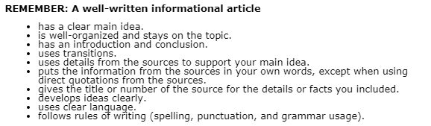**Informational writing means reporting on a topic by giving facts and details. You can include some of your opinions about those facts to make your writing interesting, but it is not trying to convince people of something as much as an opinion essay.**

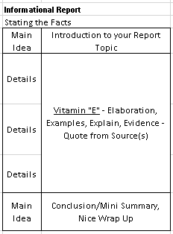

**Use the writing process as you write your article/report. Be sure to:**

* Create a plan for your informational article
* Write a rough draft
* Edit and revise your writing
* Write a final draft