Name ___________________________________ Date _______________ Period __________

Fence Post Problem
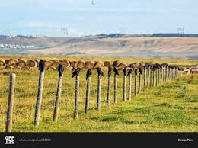
With a new partner solve this problem. Post on both web sites.

The problem:
You need to build one side of a fence that is 12 yards long. This fence will be built with fence posts and rails that connect one fence post to another. If each fence post is 1 yard away from the next fence post, how many fence posts will be needed for this side of the fence.

How many connecting rails do you need?

How many fence posts will be needed for a side of a fence that is N yards long (N > 0).

How many connecting rails do you need?

Understanding the problem:
What data is known?
What is unknown?
What are the conditions?

Plan the solution:
Show your plan for solving this problem.

Carry out the plan:
Using your plan, show your work and your solution.

Review and discuss your solution:
Did you solve it correctly? If not, what was wrong?

