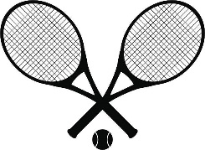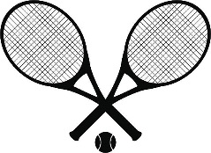2022 Junior Tennis Camp

Harbor Square Athletic Club

Our goal is to provide a camp that is fun, safe, instructional and informative. We integrate a series of competitive drills, strategy drills, work stroke production and mechanics, and match play everyday, as well as cardio and footwork workouts. This camp is great for kids of all ability levels. We are committed to providing a POSITIVE and FUN learning experience for all campers.

Who: Kids levels 1-3 ages 10-19

Where: Harbor Square Athletic Club at the Tennis Center

160 W Dayton St.

Edmonds, Wa 98020

SESSION 1: JUNE 27-30 2:00-5:00 PM

SESSION 2: JULY 11-14 2:00-5:00 PM

SESSION 3: JULY 18-21 2:00-5:00 PM

SESSION 4: JULY 25-28 2:00-5:00 PM

SESSION 5: AUGUST 1-4 2:00-5:00 PM

SESSION 6: AUGUST 8-11 2:00-5:00 PM

SESSION 7: AUGUST 15-18 2:00-5:00 PM

SESSION 8: AUGUST 22-25 2:00-5:00 PM

SESSION 9: AUGUST 29-SEPT 1 2:00-5:00 PM

Cost: 4 day session $180

Daily Drop in $45

Email: [perrontennis@gmail.com](mailto:perrontennis@gmail.com) or text (360) 480-5414

Club Phone: **(425) 778-3546**