From the Principal

Celia O’Connor-Weaver
Principal
Monique Beane
Assistant Principal

Tambark Creek Elementary School
4419 180th St. SE,
Bothell, WA 98012
425-302-9200
www.everettsd.org/tambarkcreek

Feb. 7
Learning Improvement Friday
2:15 Dismissal

Feb. 14
Learning Improvement Friday
2:15 Dismissal

Feb. 17-18
No School Mid-Winter Break

Feb. 21
Learning Improvement Friday 2:15 Dismissal

Feb. 28
Learning Improvement Friday 2:15 Dismissal

Tambark Creek News
TAMBARK CREEK ELEMENTARY SCHOOL NEWSLETTER

VOLUME 1, ISSUE 10

February 2020

Hello Tambark Creek Families! I hope the snowy weather is behind us now. We appreciate your patience and understanding around safety. Safety is our number one focus at school. Safety protocals are embedded in our arrival and dismissal procedures, recess, school-wide student expectations, and our PTSA events. As I mentioned in last month’s newletter, we have student safety concerns at our PTSA evening events. Students and their siblings are not allowed in any of our hallways or on the stairs. We lock the cooridoors and block off the stairs to prevent students from entering those areas. Also, no children should ever be climbing on the cafeteria tables or going up on the stage behind the curtains. Mrs. Beane and I will be reminding all parents and students of our safety expectations at the beginning of
each PTSA event.

Morning drop off
Beginning on Monday, February 3, students may be dropped off all along the east side of the car lane. This is a change from our current drop off procedures located directly in front of the school. It is our plan to have one adult on this side of the walkway to monitor the safety of students. Students will be required to exit cars independently. Students should not exit cars on the drivers side without the assistance of an adult. If your child needs assistance, we ask that you park and walk your child. The passing lane will remain close and we ask for your continued patience. A friendly reminder: No students should be dropped off in the parking lot. This area is unsafe. Also, students are not permitted on campus before 8:50AM. There is no supervision.

Bus Lane and the road on the east side of our school
It has come to our attention that families are dropping students off on the east side of our school in the bus lane and at the stop sign. Students need to be dropped off in front of the school in the designated area for student safety. The district facilities and planning will be constructing speedbumps on the road that runs along the east side of the school by the bus loop. We have witnessed several vehicles going over the 20MPH speed limit. This is a school zone and speed limits are strickly enforced. Please drive slow for the safety of our students.

The Educational Effectiveness Survey (EES) is given each year to parents, students in grades 3-5 and staff members across the district. The survey will open on February 19 and close on April 3. It will be available online and we will post the link on our websight. The information we receive from the survey provides the district with feedback and suggestions on ways in which we can improve our practices. Thank you for taking the time to complete the survey.

February 3 through the 7 is National School Counseling Week. We are so thankful for all of our district counselors. Please show them your appreciation by sending them a card or e-mail.

From the Counselor

Our Second Step work by grade level is below. If you are interested in seeing this curriculum please let me know!
Here are some of the focus areas we have explored this month:
Kindergarten – We have continued our work on our calming down skills – 1. Put your hands on your tummy 2. Say “Stop”. 3. Name your feeling. 4. Take belly breaths/ Count/Use self-Talk. We have focused on Calming Down Strong Feeling; Handling Waiting; Managing Anger.
1st Grade – We have continued to work on Emotional Management. Calming down anger and using Self-Talk with our Calm Down Strategies – 1. Stop-Use your signal. 2. Name your feeling. 3. Calm down: Breathe, Count, Use positive self-talk.
2nd Grade – We continued working on Problem Solving. Our Focus was on taking responsibility and applying our problem solving skills to playground problems. Problem Solving Steps – 1. “S” Say the problem 2. “T” Think of solutions 3. “E” Explore consequences 4. “P” Pick the best solution. Second grade is finishing our Second Step lessons this month.
3rd Grade – Using our Problem Solving Steps to propose several solutions for a given problem in response to scenarios. Problem Solving Steps – 1. “S” Say the problem 2. “T” Think of solutions 3. “E” Explore consequences 4. “P” Pick the best solution.
4th Grade – We worked on generating safe and respectful solutions to a problem, identifying consequences of potential solutions, and selecting an appropriate solution to a problem. We also worked on acknowledging mistakes, making an apology, and offering to make amends.
5th Grade – We worked on generating safe and respectful solutions to a problem, identifying consequences of potential solutions, and selecting an appropriate solution to a problem. We also worked on using assertiveness skills and problem solving steps to resist peer pressure.
New Friendship groups will be coming soon!
3rd through 5th grades will have the opportunity to learn how to crochet during lunch recess on Tuesdays and Wednesdays starting soon. Rather than going outside for recess they will have the opportunity to sit in the Commons area with the counselor, developing friendships, along with learning to crochet.
Please ask your student(s) what they are learning about in Second Step. Let me know if you have any questions!

Ms. Hehn & Mango
From the Office
If your student is absent or will be leaving early for an appointment and you email the teacher please remember to also include the attendance email at tceattendance@everettsd.org This provides a written response for your childs absence and ensures the office gets this important information. If your child attends an outside daycare please make sure you notify them when you’re child is absent from school so they aren’t looking for your student in the line after school.
Reminder:
If your child will be attending any after school activity that is not a school sponsored you need to email the teacher to let them know which program they’re enrolled in and the dates.
From the PTSA
Mark your calendars for our first PTSA free family movie night on Friday, February 21st at 6:15pm in the cafeteria! We will watch The Secret Life of Pets 2! PTSA concessions will be available for purchase. Wear your pajamas, bring your favorite blanket to sit on, and enjoy the movie on the big screen! Please note that this is not a drop-off event. Children must be accompanied by an adult.

We will also be having a skate night at Skate Deck on February 27th! Stay tuned for more information!

Tambark Creek PTSA is now officially a 501(c)(3) which means that we can accept company matches! If you donated to our Orange Ruler fundraiser in the fall and work for a company that matches donations, please go ahead and submit your donation to your company. Contact treasurer@tambarkcreekptsa.org with any questions.

We now are a part of AmazonSmile! This is a simple and automatic way for you to support Tambark Creek PTSA every time you shop at Amazon! The first time you visit smile.amazon.com, you will need to search for and select Tambark Creek PTSA 7 3 12 as your charitable organization. Then go to smile.amazon.com for future shopping and Amazon donates a portion of the price of your eligible purchases to Tambark Creek PTSA!

Do you shop at Fred Meyer? You can support Tambark Creek PTSA just by doing your regular Fred Meyer shopping! Register your rewards card and remember to use it each time you shop at Fred Meyer! Go to fredmeyer.com/communityrewards to link you rewards card to Tambark Creek PTSA. You can search by our name or our Fred Meyer non-profit number WW733.

If you have any questions regarding PTSA, please contact us at president@tambarkcreekptsa.org.
Music News
Tambark Creek Kindergarten through 5th grade Concert
Theme: Children of the World
Date: Thursday, February 13, 2020
Time: 6:30 PM (The doors will open at 6 PM. Students should arrive no later than 6:15 PM)
Location: Everett Civic Auditorium (2416 Colby Ave.)
Dress Code: Traditional cultural clothing (for example, sari, sherwani, kimono, etc.) or simply dress your best. No jeans, please.
Attention kindergarten parents: You can take your student home after the kindergarteners perform. If you plan to stay for the entire concert, please save a seat for your student. S/he must stay with you in the audience.
From the PTSA
Spirit Wear is now available! Order forms and payments are due by December 18th and can be found at our website tambarkcreekptsa.org. You can also order online for an additional fee at https://my.cheddarup.com/c/spirit-wear-28905
From the Kitchen
February’s Harvest of the Month is truly magical! Although fondly referred to as a fruit – this harvest is best described as a seed or a legume, but it goes by the name - beans! This magical food is high in protein and provides 9-13 grams of fiber per serving! That is almost ½ the daily amount of recommended fiber intake! Fiber is the true superfood – high intake of fiber is associated with good heart health, decreased risk of cardiac arrest and stroke and decreased incidence of certain cancers, such as colon cancer. Exposing students to beans NOW increases the likelihood that beans will remain in their diet through adulthood. Which means, in summary, serving our students beans impacts their future health and longevity.
Upcoming Menu items
*February 14th Be Mine Celebration Cups
*February 21st Black Bean Burgers
See you in the Café

Everett School Board Welcomes Two New Members
This November voters elected two new members to the Everett School District Board. April Berg will fill position 2, the seat vacated by the retirement of longtime school board director Carol Andrews. Berg lives in Mill Creek and is a planning commissioner for the city. She has six children, two university graduates, one at Henry M. Jackson High School and one at Heatherwood Middle School

Andrew J. Nicholls will fill position 1, the seat held by Jamyang Dorjee Nhangkar who was appointed to the board in September 2018. Nicholls is a research social worker with the VA Puget Sound Medical Center and has two children who will soon be entering school in the district’s north end.


Lunch payments are easy with the app

Want to see your student's lunch balance and pay a balance from your phone? If you're logged into the district’s mobile app, you can find and pay your student's lunch balance under your student's info. An icon inside the app also gives a shortcut to deposit funds for your student's lunch account. To make a payment, look for the green chef's hat icon.

The latest school news and information in Everett Public Schools is available on smartphones and mobile devices with a mobile app. The free mobile app is available in the online iTunes® and Google Play® app stores. Once you’ve downloaded the app, log in to “student info” with your LMS password to see student-specific information for each of your children.
Parent safety tip
Six ways your student can protect their online identities:

- Share carefully – don’t give out any personal information to unknown sites or strangers
- Go private – keep privacy settings high and limit location services when possible
- Log out – especially after using shared computers
- Mix up passwords – use different passwords for different apps and websites
- Avoid clickbait – avoid quizzes and random questionnaires
- Choose wisely – pick an appropriate username
Learn more about online safety, digital wellness, cell phones and learning with technology with age-specific tips and tools on www.commonsensemedia.org.
Kindergarten registration begins in March
Do you have a child who will be 5 years old by Aug. 31, 2019? Registration begins on March 2, 2020, at all district elementary schools.
Did you know?
Every year OSPI publishes a report card for each district and each school within the district. This year OSPI is using a new application to do this and will require a little more effort to find the data available for Everett Public Schools. You can access the 2017-18 data on the OSPI website.

To review the data for the school district or a school start typing in the name and a drop box will appear with choices. Click on your choice to view the report card.
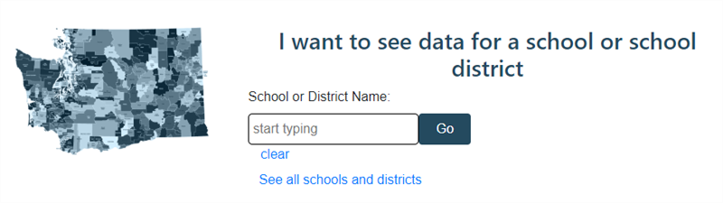
Optionally you can click on See all schools and districts and navigate the to the district or school you want to select.

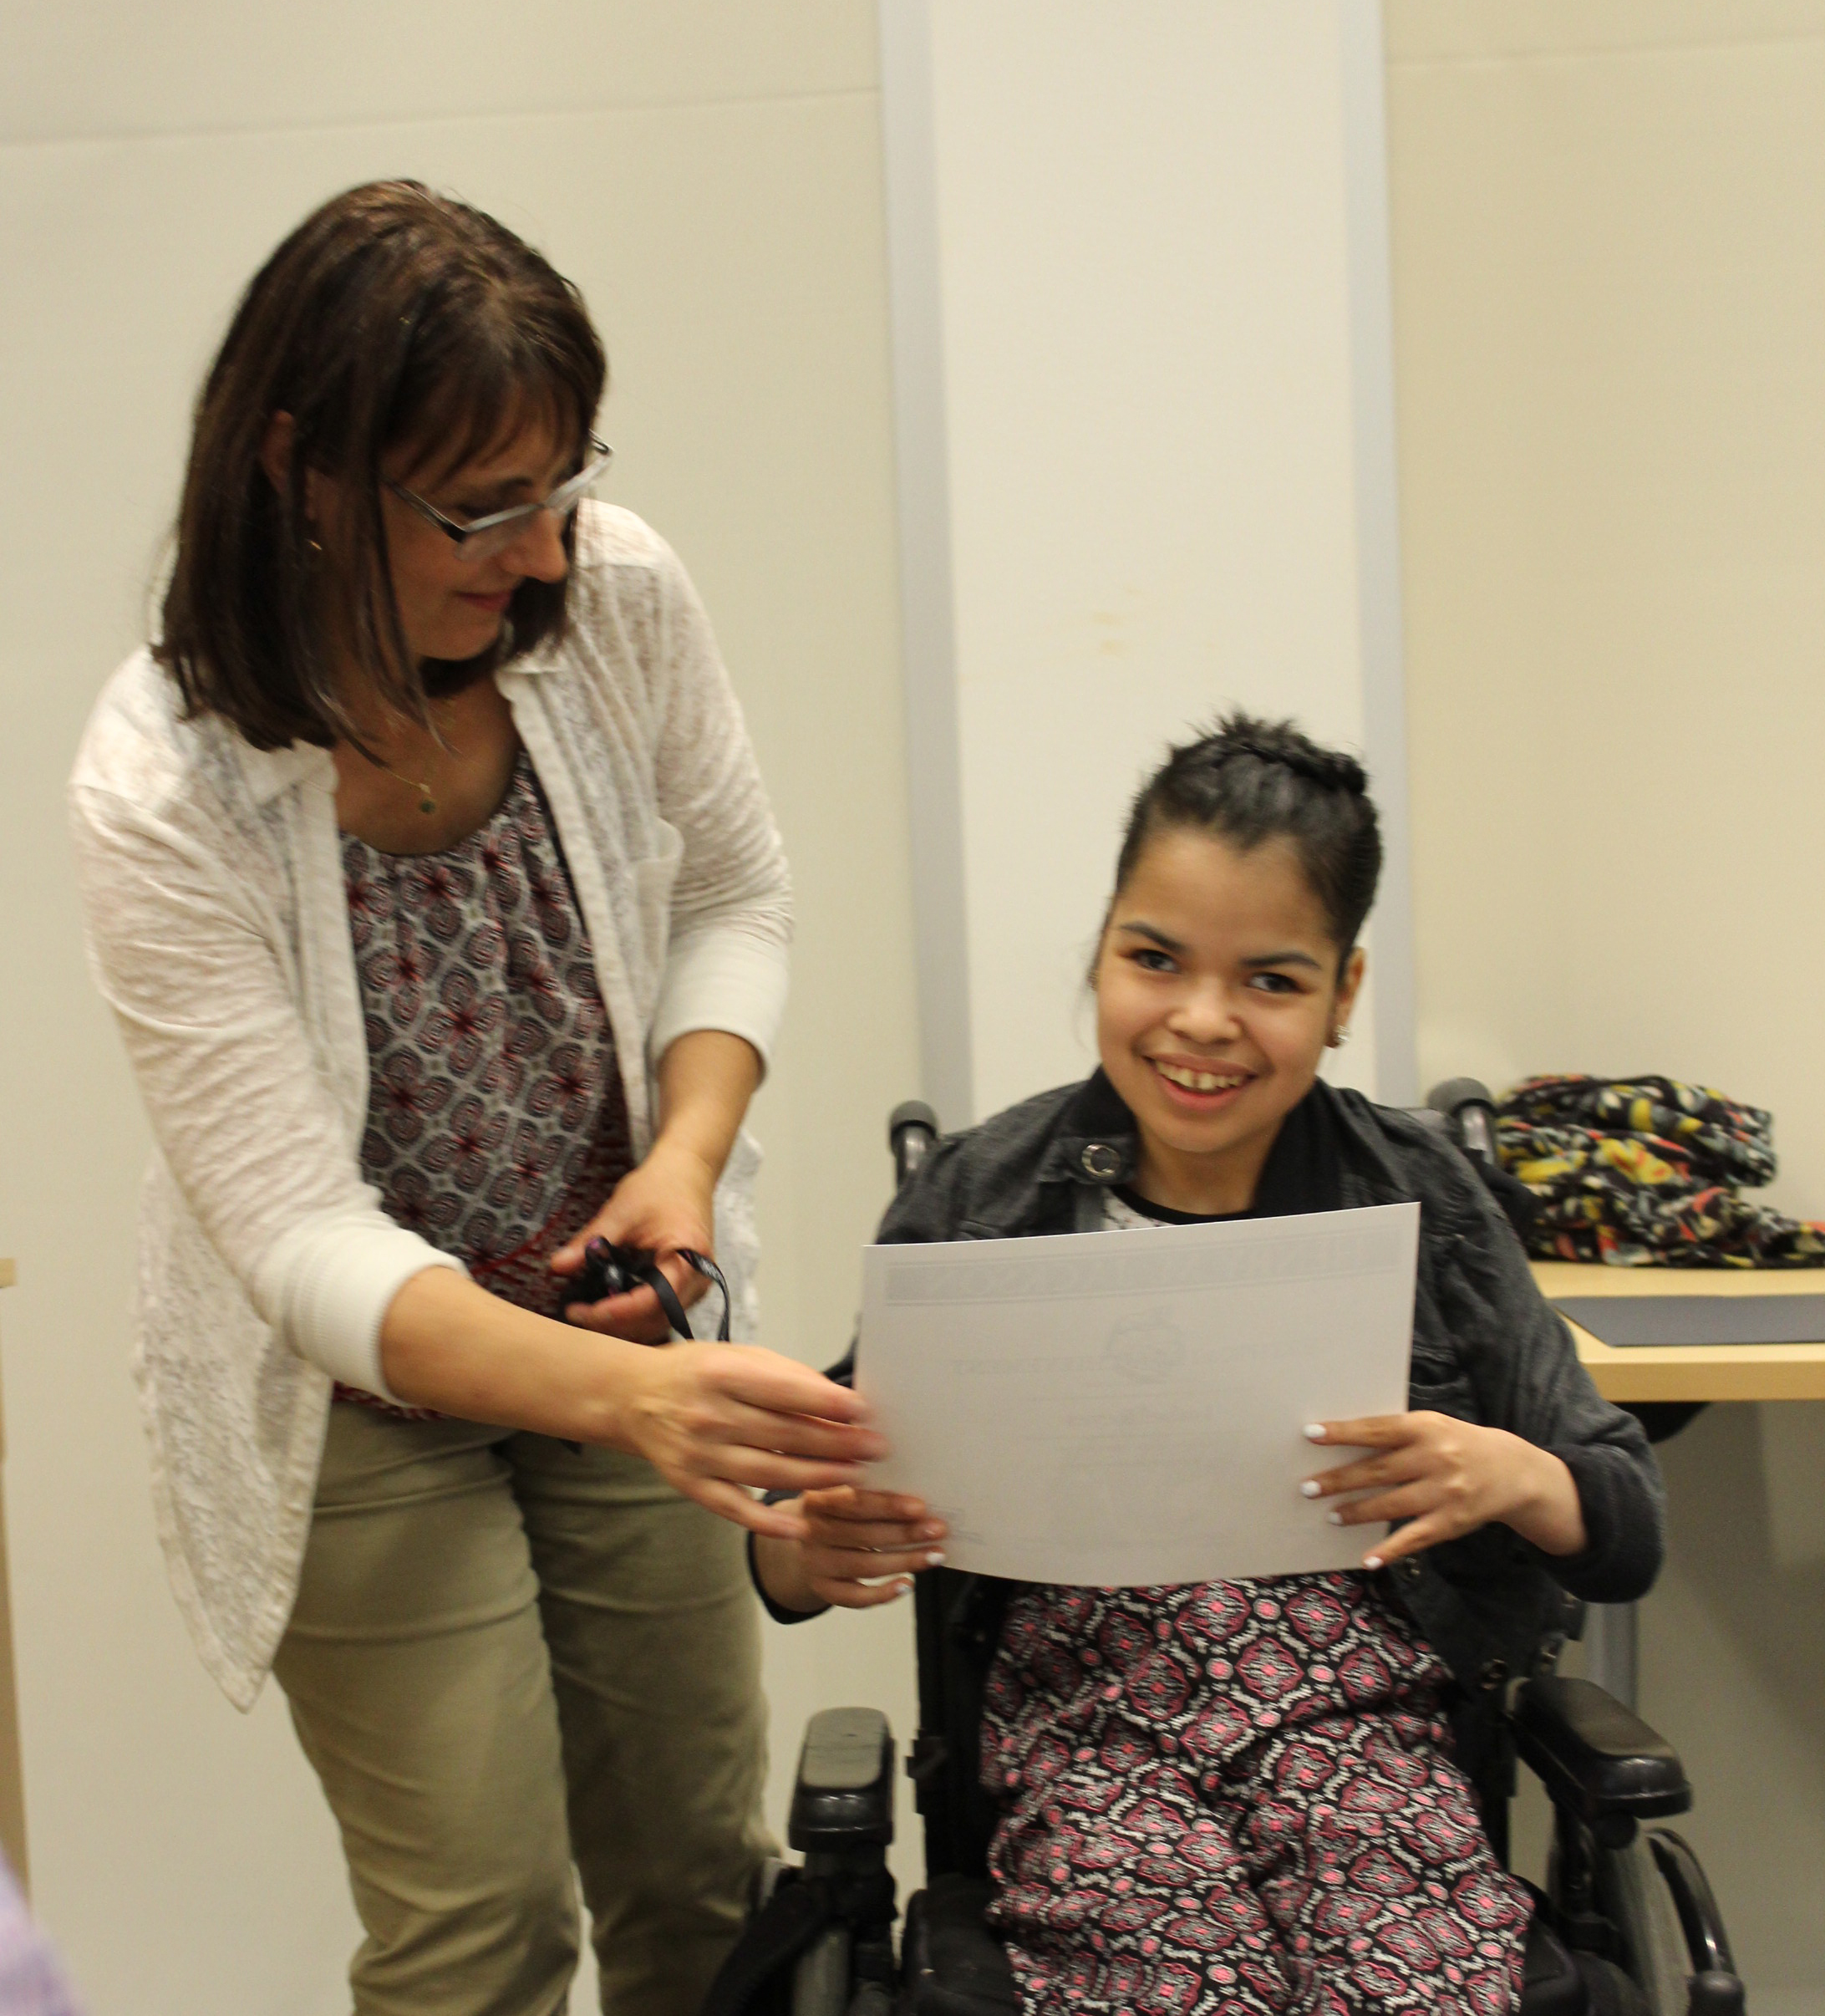
Do you have a student in special education?
Did you know there is a Special Education PTSA in the district? The Special Education PTSA serves students, families, and educators involved in Special Education. They encourage students, families, educators and community members to work collaboratively to provide programs and activities recognizing each student's potential and enhancing the educational opportunities of children receiving and/or seeking special services in our district. Connect with the SEPTSA on their Facebook page.

Harvest of the month

This month, the Food and Nutrition Department brings you beans! Be sure to give them a try this month in our homemade hummus, black bean burger or vegetarian chili!

Did you know that there are over 40,000 different varieties of beans and are an excellent of protein and fiber? Find out more by checking out the Harvest of the Month flyer on our website at https://www.everettsd.org

I’ve bean thinking about you…
2020 capital projects bond - community open house meetings
Everett Public Schools is placing a $317.4 million bond on the April 2020 ballot. This measure will provide crucial funding to build permanent classroom space to accommodate growth, improve safety and security and make necessary school improvements.

Upcoming Community Open House meetings are scheduled, and we encourage everyone to attend one:

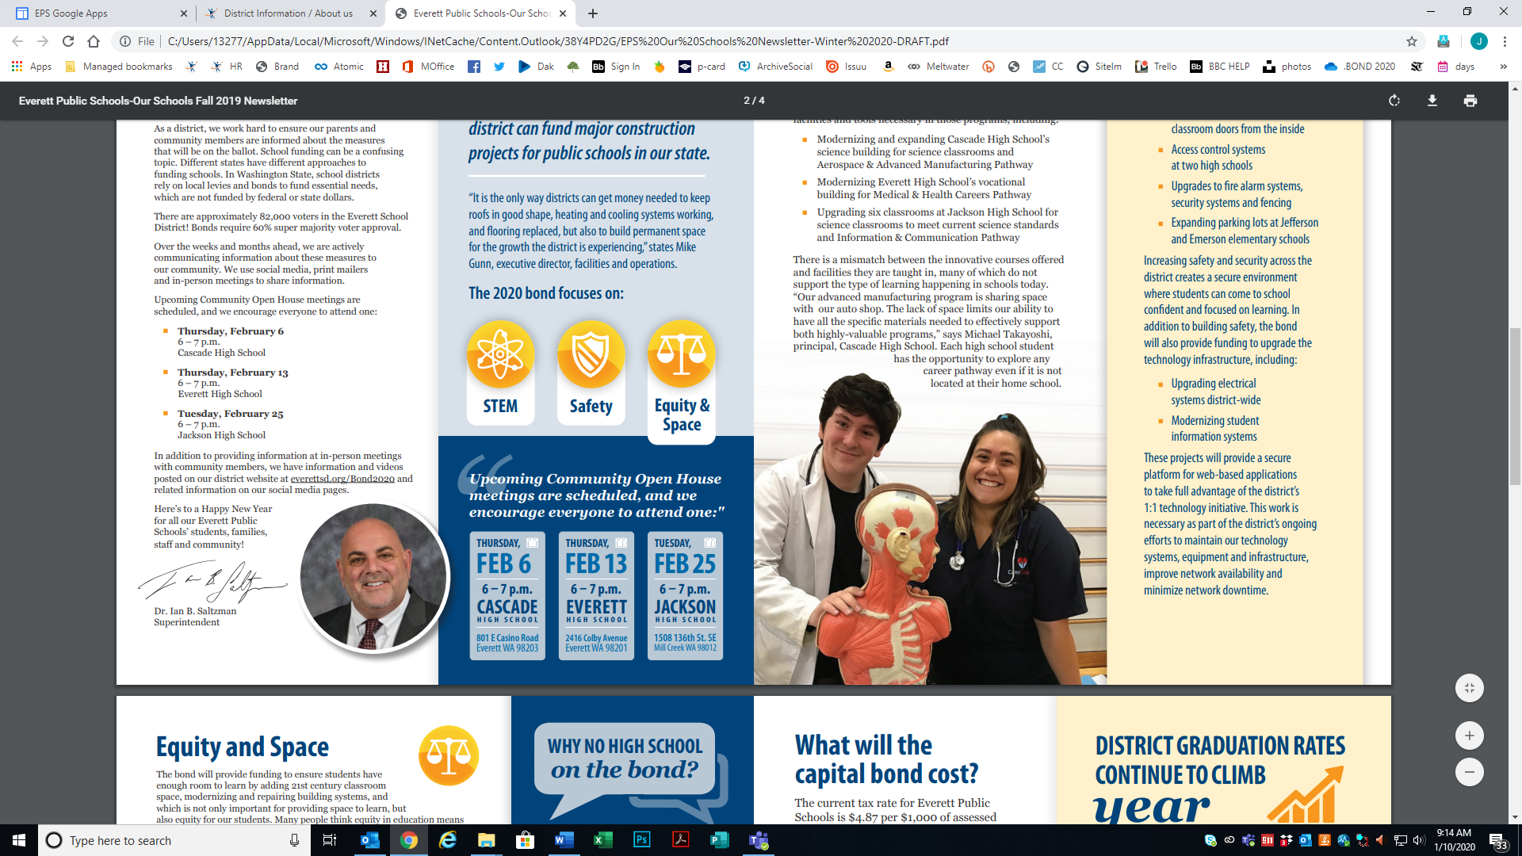

What the 2020 capital projects bond will fund at our school.

