From the Principal

Tambark Creek News
TAMBARK CREEK ELEMENTARY SCHOOL NEWSLETTER

VOLUME 1, ISSUE 15

September 2020

Hello Tambark Creek Families! I hope you had a wonderful summer and are enjoying our beautiful weather. I am pleased to welcome you back to the 2020-21 school year and a special welcome goes out to our newest families to Tambark Creek. The start of the 2020 school year is not your typical start to a school year. We will not be able to have our face to face meet and greet, no in person events, and no students in the building for quite some time. However, we are going to make it the best start to the school year by providing a consistent schedule, parent conferences the first five days of school, and on-going support with technology. Student success is attributed to the partnership and relationships we build within our school community. Although this year looks different than any other year, we are dedicated to providing each student with the best interactive, engaging distance learning opportunity. We are here to support students and families.
Celia O’Connor-Weaver
Principal
Shelby Leising
Assistant Principal

Tambark Creek Elementary School
4419 180th St. SE,
Bothell, WA 98012
425-302-9200
www.everettsd.org/tambarkcreek

September 9
First day of school grades 1-5
September 14
First day of school for kindergarteners

I look forward to seeing you on September 8th in the drop-off/pick-up lanes as our modified meet and greet. We will be providing Chromebooks and materials to students. Throughout the school year, I will send out reminders to all families via phone, emails and text messages as well as my monthly parent newsletters. Please let the office staff know if you are not receiving them.

Our Tambark Creek PTSA is working closely with the administrators to provide extracurricular Zoom student events, fundraisers and more. We are excited to announce our mascot naming contest for our TCE Mountain Lion. More information regarding the contest will be out in mid-September. We will post all future events as well as information about ordering our TCE spirit wear on the Tambark Creek website and Facebook page.

Important information:
- September 8th -grade level drive up “Meet and Greet” You will receive a Chromebook and materials.
- A special guest appearance from TCE’s mascot. (see attached schedule)
- September 8th-expect a schedule for the first few weeks of school from your child’s teacher
- September 9th first day of school

Warm Regards,
Mrs. O’Connor-Weaver

From the Assistant Principal
My name is Shelby Leising and I am so honored to become a part of the TCE family. I have a passion to lead and equip the children in becoming world changers. I love all things Disney, having my nose deep in a book, nestled next to a fire and traveling to new places. Thank you for welcoming me into the TCE community with open arms. I cannot wait to see all that this school year brings!

From the Counselor
Hello, I’m Ms. Hehn, Tambark Creek Elementary School Counselor. I will be sharing a variety of information to support the students and families at Tambark Creek Elementary over this school year. I will divide my time among many tasks in support of our students. Primarily, these include individual and small group counseling, teaching developmental guidance and social emotional lessons, and collaborating with parents, staff, and community members. This makes me both a counselor and a teacher.

Because I serve a school of many students, my concern is always whether I am meeting everyone’s needs. When I am not in meetings or working with students, I will be available to meet with you.

I will work closely with parents, as needed, to support their child's ability to learn and be successful at school. I will also consult with school psychologists, social workers, mental health agencies, and other individuals and organizations which are available in the community to support our students.

I am here to help, please contact me with any questions or concerns.

Julia Hehn,
Tambark Creek School Counselor - Along with Mango, the Service Dog
(425)302-9200 jhehn@everettsd.org
Counselor Corner

Please be aware of my sincere respect for confidentiality. In all my consultation, collaboration, and counseling activities, I follow and adhere to the ASCA ethical guidelines for confidentiality.

The times they are a-changin’ . . . Truer words have never been said, or in this case sung. These words are the work of poet and song writer Bob Dylan.
We are all dealing with so many changes and life itself isn’t what it has been in the past. With change comes stress and often anxiety. Moving to a remote/online system of teaching for Everett Public Schools is no small feat and with it come many questions and adjustments. We are in this together. I am here to help.
Each month I will be adding interesting articles, thoughts and support in this newsletter to help you navigate this school year. Below are some ideas to help your student in remote learning. Take what works for you and leave the rest. You will know what is best for your student and your family.
• Keep the routine you have had for a traditional school year.
Take your photos outside for the start of school, pick out a special outfit to wear, celebrate the start of school with a family dinner to discuss what you are excited about this year!
• Set up a workstation for your student. This is a BIG ONE!
Get the supplies ready and easily accessible for your student when s/he sits down to work. This should be a work area that is special to come to during school.
• Write out your student’s schedule and post it so it can be seen and used.
A white board or bulletin board is helpful. When a student doesn’t know what to do next this tool can be the guide. For younger students using pictures can be helpful instead of words to help them to follow along with the schedule.
• Stand-up and stretch OFTEN.
This is SO important! Work this into your student’s school schedule! We teachers always put this in our daily plan as we know that students need to move around. There are some great movement videos you can use or just do jumping jacks or dance for a couple minutes to get their bodies moving and ready to focus again!
• Dress for the school day -NO pajamas please.
Get dressed and ready for school every day. This helps both you and your student to feel it is school time. Time to get to work. (It always makes me feel more productive and ready to go when I get dressed for my day!)
• Pack a lunch.
This is something that will make your student feel like s/he is really at school. It is a creative activity that makes lunch time more seamless. (Also, if you are working from home it will help with your daily schedule to have this already done!)
From the Office
If you need to reach the office staff for any reason you can email Mrs. Patty the office manager at ttetrault@everettsd.org or Mrs. Angie the office assistant at ajames2@everettsd.org If you are not receiving connect ed calls from Mrs. O’Connor-Weaver please call the office to update your telephone number and email address at 425-302-9200.
Please report all absences to the attendance email at: tceattendance@everettsd.org

From the PTSA
Welcome to the 2020-2021 school year from the Tambark Creek PTSA (Parent Teacher Student Association)! We are excited for the school year to begin! Our theme this year is that we are in this together!
The mission of our PTSA is to support our diverse school community by providing meaningful and enriching programs for our children, financial support for our school, and an approachable and enthusiastic volunteer force. All of this will look different this year as we navigate the pandemic.
One of the best ways to support the students, staff, and the school is to join the PTSA! Anyone can join – parents, students, staff, families, and community members! Membership fees are tax deductible. Confidential scholarships to join PTSA are also available. Please note that joining the PTSA does NOT meant that you need to attend meetings or volunteer (although you are always welcome to do so). We hope that you will join our PTSA at membership.tambarkcreekptsa.org. Please note that we are only accepting online payments this year, but there are no extra fees for paying online.
Because we are not able to have a fall Fun Run this year, our primary fundraising effort this year will be general donations to the PTSA. Your donations will go to things like teacher grants, student enrichment, staff appreciation efforts, the Reflections art contest, events and programs (virtual and then hopefully in-person later in the year), and more! You can make a donation at the same link as above (with no additional fees for doing so online): membership.tambarkcreekptsa.org. Note that you do not need to join PTSA in order to donate. All donations are tax deductible and can be matched if your company offers a corporate match!
We are not sure exactly what volunteering will look like this year, but if you are interested in being added to our general volunteers list, please email vicepresident@tambarkcreekptsa.org and let us know! We will email volunteers from the list when we figure out how volunteer opportunities will work this year!
We hope that you will be able to attend our first PTSA meeting. It will be held virtually via zoom on Thursday, September 17th at 7:30pm. All are welcome! Here is the link: lwtech.zoom.us/j/5362703670
For more information on all things PTSA, check out our website tambarkcreekptsa.org, our Facebook page facebook.com/TambarkCreekPTSA, or you can email us at anytime with questions, comments, concerns, or just to say hi! We can be reached at president@tambarkcreekptsa.org. We hope you have a great year!
Alisha Crawley-Davis & Heather Morgan
co-Presidents, Tambark Creek PTSA 7.3.12

Adventure Together
Our theme to kick off the school year is Adventure Together. We chose “Adventure” because this school year is kicking off remotely, but not like it was in the spring. This year will look and feel much different and will be a new, exciting and challenging adventure for students, teachers and families. And, “Together” because we are all in this together. Although this start to school will feel different to everyone, we encourage taking on this challenge with courage, knowing we will all learn and grow as we navigate new and unexpected situations. We are here for every student, every family, every teacher, every staff member. We are a team! Let’s Adventure Together!

Parent University
Starting September 2, Everett Public Schools will have a Parent University available 24/7 online and mobile, for you to access important resources to help support your student’s remote learning. You can find details on how to access and log in to Canvas, how to view your student’s schedule, where to get meals, and much more. Resources will continue to be added throughout the year. You will find Parent University, and all other information related to remote learning, at www.everettsd.org/COVID2020-21
Learning model status
Everett Public Schools will begin the 2020-21 school year with 100% remote learning using our staged approach to reopening. As the numbers of positive COVID-19 cases and deaths continue to rise across our state and in our region, it has become clear at this time that our more robust remote learning model will be the safest way to form the foundation for student learning this fall.

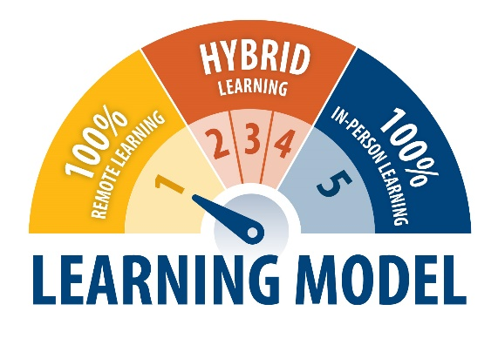
Staged reentry to schools will be determined by the impacts of a changing COVID-19 pandemic, available resources, direction from Snohomish Health District, OSPI and our Governor. Having the flexibility and agility to move to different models will enable Everett Public Schools to provide the best education possible in whatever scenario presents itself.

The current status is 100% remote learning. Visit the learning model status webpage to get to know the five stages.

Attendance procedures

We look forward to teaching your child every day. Regular attendance is important, and we will work with you to ensure your child is engaged in learning to benefit from an excellent education. If your child will miss remote learning, please email the school at their attendance email address, which you can find on the school website.

If email is not possible, and even if you leave a message with the school attendance line, please send a written note to the school office within 30 days. Teachers will use digital Gradebook attendance to log student attendance daily. K-5 students will have attendance taken daily at the beginning of the day during their morning meeting. Grades 6-12 will have attendance taken in every class period.

2020-21 Immunization Changes

The way schools collect immunization records and comply with immunization rules has changed for the 2020-21 school year. As of August 1, 2020, a change in state immunization rules has affected three areas of immunization compliance:
- The definition of “conditional status” has been clarified. Students must turn in their immunization
paperwork on or before the first day of in-person learning.
- All new immunization records from students need to be medically verified.
- The Tdap vaccine requirement for 6th through 12th graders has been changed to a 7th through 12th grade requirement.

A medically verified record includes one or more of the following and can be submitted by email to EPS.BuildingRN.MailList@everettsd.org:
- A Certificate of Immunization Status (CIS) printed from the Immunization Information System
- A physical copy of the CIS with a healthcare provider signature
- A physical copy of the CIS accompanying medical immunization records from a healthcare provider verified and signed by school staff
- A CIS printed from your MyIR account.

Access your family’s immunization information
To access your family's immunization information from the Washington State registry visit, sign up for MyIR to view, download and print your student's immunization records securely online. Once you register, you can access the records anytime you need them. You can print your child's Certificate of Immunization Status for school, childcare and camp programs.

Ways to stay in touch



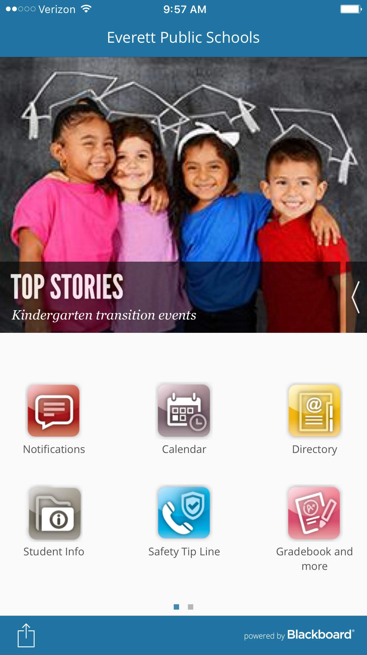
On the communications department webpage, you can sign up for InTouch announcements and school board meeting agendas highlights delivered to your email box twice monthly. You can also follow us on Facebook, Twitter and Instagram.

Mobile app
Families can download the district mobile app to easily access student information, grades, attendance, lunch balances, borrowed library books, calendars and more! Translate notifications and app functions into the language you prefer.

Social & emotional health
The outbreak of COVID-19 may be stressful for people and communities. Fear and anxiety about a disease can be overwhelming and cause strong emotions in adults and children.

Everyone reacts differently to stressful situations. The emotional impact of an emergency on a person can depend on the person’s characteristics and experiences, the social and economic circumstances of the person and their community, and the availability of local resources. People can become more distressed if they see repeated images or hear repeated reports about the outbreak in the media.
Children react, in part, on what they see from the adults around them. When parents and caregivers deal with the COVID-19 calmly and confidently, they can provide the best support for their children. Parents can be more reassuring to others around them, especially children, if they are better prepared. Please visit the district’s social & emotional health webpage for more information.


ECEAP preschool is now enrolling for 2020-21
Everett Public Schools Early Childhood Education & Assistance Program (ECEAP) is a FREE preschool program for three- and four-year-old children from families with limited income. ECEAP prepares children for kindergarten and includes family support and health and nutrition services. It is funded in partnership with Snohomish County Human Services and Washington State Department of Children, Youth and Families.

ECEAP will be providing remote preschool services this fall including virtual circle times and small groups, video libraries of fun, engaging activities, and learning materials for home-based activities. Additionally, ECEAP will support parents as their child’s first and most important teacher through regular parent-teacher check-ins, family support coaching, resources, and online family support groups and informational classes.

The ECEAP preschool program is located at Cedar Wood (new for 2020-21), Garfield, Hawthorne, Lowell, Madison and Silver Lake elementary schools. ECEAP will be providing remote preschool services this fall including virtual circle times and small groups, video libraries of fun, engaging activities, and learning materials for home-based activities. Additionally, ECEAP will support parents as their child’s first and most important teacher through regular parent-teacher check-ins, family support coaching, resources, and online family support groups and informational classes. Space is limited – apply early! For an application or more information, please call 425-385-4628, email eceap@everettsd.org or visit our website.

Kids in Transition program
Kids in Transition (KIT) program supports students who qualify as homeless under the federal McKinney-Vento Homeless Act. Students without a fixed, regular, and adequate nighttime residence may qualify. The KIT program works to eliminate barriers to students’ academic success and extra-curricular involvement. We ensure students experiencing homelessness have access to free school meals, school supplies, and uniforms. KIT can help students access extended day or summer school classes and provide access to tutoring when needed. The KIT Program can also cover fees required to take part in activities such as school-sponsored sports, clubs, and required class fees. KIT transports eligible students to maintain school stability, as long as the commute is​ in the best interest of the student.
Last year, Everett Public Schools served over 1,100 homeless students at some time during the school year. For more information, visit the KIT website or contact the KIT Program at 425-385-4032.

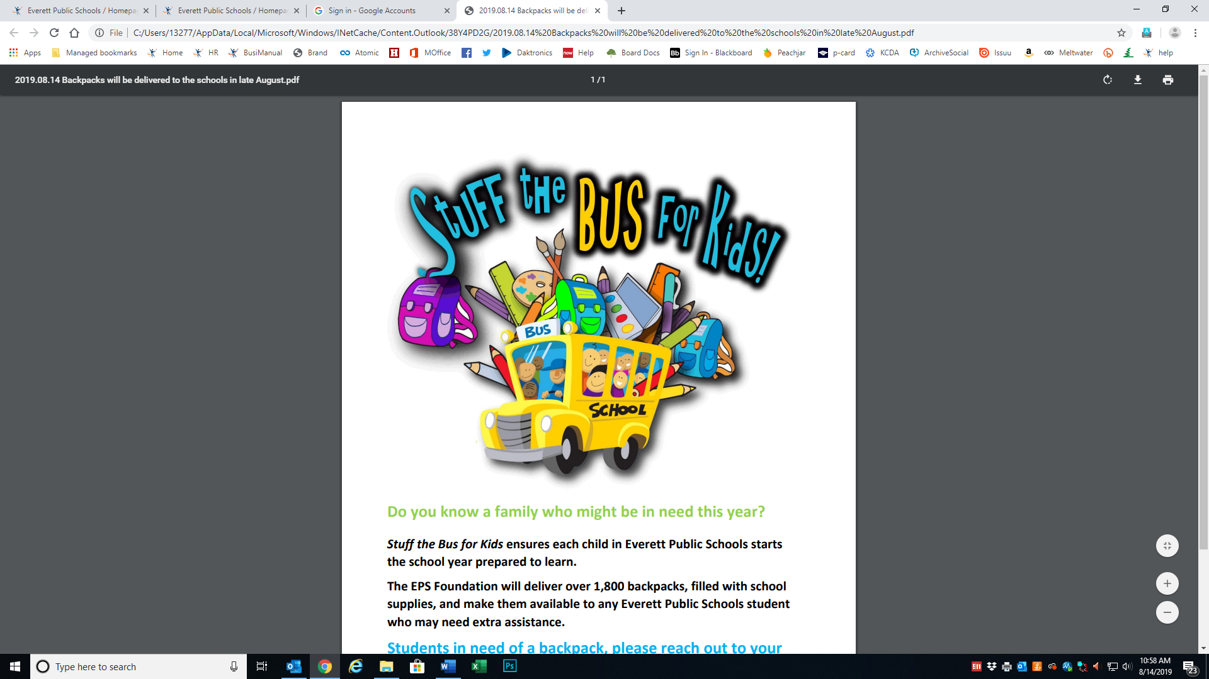
Backpacks for students in need
Do you know a family who might be in need this year? Stuff the Bus for Kids ensures each child in Everett Public Schools starts the school year prepared to learn. The EPS Foundation will deliver over 1,900 backpacks, filled with school supplies, and make them available to any Everett Public School student who may need extra assistance.

Students in need of a backpack, please reach out to your school to receive your supplies. Backpacks will be available for pick up at each school beginning August 31, the week before school.


Student opportunities and activities eflyers
We use Peachjar to email approved flyers from community organizations to parents and guardians. Schools also post those flyers on their websites. Look for the Peachjar button in the Quicklinks section of your school home page to see those flyers. You can also register there to have those flyers delivered to your email address if you aren’t already receiving them.

Safety tip line
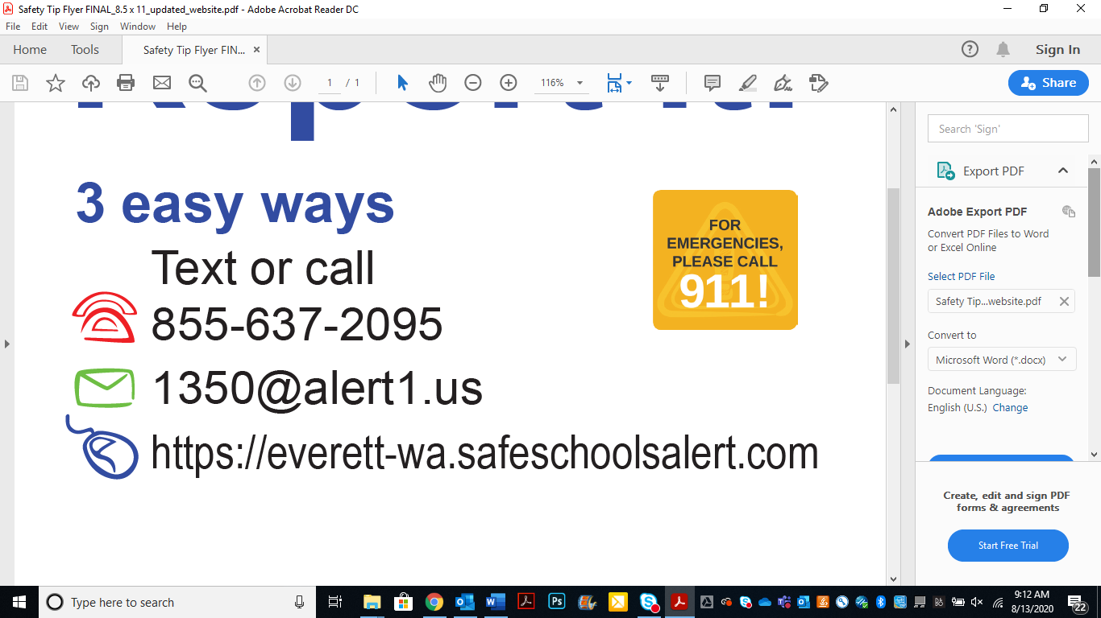
Do you or your student have a concern about someone experiencing bullying or harassment? Report it! You can talk directly with your school’s office or you can call, text or email your concern.

If there is reason for concern about safety on a designated walkway to school, call 9-1-1 immediately for authorized, quick help. We have strong partnerships with local law enforcement who share our interest in safe schools and neighborhoods. Student safety is a priority for all of us. Working together, we can help make our neighborhoods and schools nurturing places for students to safely learn and grow.

Access to public records
District records are public records. Parents and other citizens have the right to ask to view or have copies of records defined as “public” under state and federal laws. These include parents’ and legal guardians’ student’s records and records about discipline of school employees.

The district’s general counsel office handles public records requests. Request records by writing to that office at PO Box 2098, Everett, WA 98213, sending an email request to publicrecords@everettsd.org, or calling 425-385-4150.

Your student’s records are confidential
Everett Public Schools is serious about protecting student records and privacy. The district uses multiple security measures to safeguard student transcripts and other education-related records. Only those teachers, administrators and other staff members who work directly with students (and have an educational need to know) have access to individual student records. Staff members are required to maintain confidentiality of all information in a student’s records.

Register to vote!
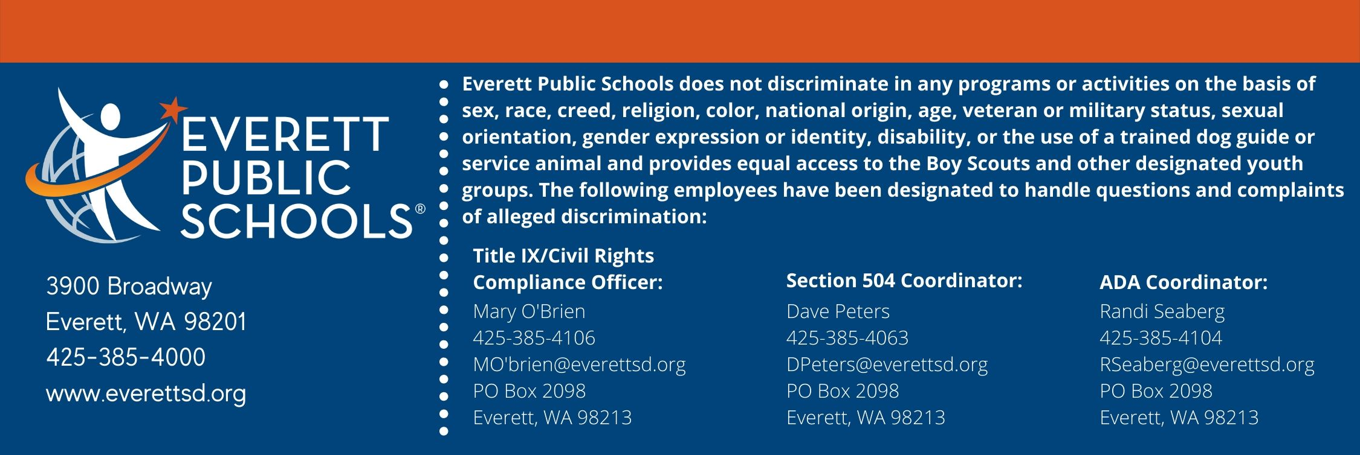
It’s easy! You can register online at http://bit.ly/VoteRegistration or stop by your schoo

