# From the Principal

**Celia O’Connor-Weaver**Principal

**Monique Beane**

Assistant Principal

**Tambark Creek Elementary School**   
4419 180th St. SE,   
Bothell, WA 98012

425-302-9200

*www.everettsd.org/tambarkcreek*

**March 6**Learning Improvement Friday

2:15 Dismissal

**March 13**Learning Improvement Friday

2:15 Dismissal

**March 20**Learning Improvement Friday 2:15 Dismissal

**March 27**

Early Release

1:00 Dismissal

March 30-April 3

Conference Week

Early Release

1:00 Dismissal

**Tambark Creek News**

TAMBARK CREEK ELEMENTARY SCHOOL NEWSLETTER

VOLUME 1, ISSUE 11

**March 2020**

Hello Tambark Creek Families! March has arrived and so far, it’s come in like a lamb-not a lion. Spring is right around the corner and we will welcome it with open arms. With the warmer weather and sunshine approaching, students desire to stay outside and play or go to a friend’s house after school. It’s important that all students follow their dismissal plans such as, bus, walk home, parent pick up etc. Please discuss this with your child.

We have begun our Smarter Balanced Assessment (SBA) countdown at Tambark Creek. Students in grades 3, 4, & 5 are practicing their skills in ELA and math by taking the practice Balanced Interim Assessment (BIA) for the SBA. The SBA will be given to all 3rd, 4th and 5th graders beginning the end of April and will run through May. We will be sending out additional information next month. If you have any questions about the State assessments, please visit the Office of Superintendent of Public Instruction (OSPI) website at

<https://www.k12.wa.us/student-success/testing/state-testing-overview/washington-state-smarter-balanced-assessment-consortium>

The Educational Effectiveness Survey (EES) is given each year to parents and students in grades 3-5, as well as staff members across the district. The survey is currently available online at [https://www.research.net/r/eps-parent](https://nam01.safelinks.protection.outlook.com/?url=https%3A%2F%2Fwww.research.net%2Fr%2Feps-parent&data=02%7C01%7CAJames2%40everettsd.org%7C08968505b4264c215f8408d7bbc563e8%7Ca6158ef04f854b0da599925097f77b3d%7C0%7C0%7C637184328781879852&sdata=LwtUSIXh5OCfrnKxv8sCECVuZn64W7Q7S%2FAp%2FHB%2BXLM%3D&reserved=0) through April 3. We will also post the link on our website. The information we receive from the survey provides the district with feedback and suggestions on ways in which we can improve our practices. Thank you for taking the time to complete the survey.

Beginning today, Jo Boaler, a distinguished math professor at Stanford University is offering a FREE online math course called, How to Learn Math.  She helped develop YouCubed and has written multiple books about math mindset and learning.  It is a free self-paced class for learners of all levels of mathematics. It combines really important information on the brain and learning with new evidence on the best ways to approach and learn math effectively targeted for students AND families.

Please see the link below for topics covered and additional information.  We hope you can take advantage of this amazing learning opportunity!

[https://www.edx.org/course/how-to-learn-math-for-students-2](https://nam01.safelinks.protection.outlook.com/?url=https%3A%2F%2Fwww.edx.org%2Fcourse%2Fhow-to-learn-math-for-students-2&data=02%7C01%7Ccoconnor%40everettsd.org%7C8637841c64814592ea4608d7ba2e8224%7Ca6158ef04f854b0da599925097f77b3d%7C0%7C0%7C637182581225689832&sdata=1rRRiuSglqQnwNzD9xhnt%2BWJl0da%2FTCNbro2WXmL7vs%3D&reserved=0)

|  |  |
| --- | --- |
|  | [How to Learn Math: For Students](https://nam01.safelinks.protection.outlook.com/?url=https%3A%2F%2Fwww.edx.org%2Fcourse%2Fhow-to-learn-math-for-students-2&data=02%7C01%7Ccoconnor%40everettsd.org%7C8637841c64814592ea4608d7ba2e8224%7Ca6158ef04f854b0da599925097f77b3d%7C0%7C0%7C637182581225709823&sdata=iBSEmrChmdYDJTr63ZGqAdD2iTwAbImPMz6O1SJN788%3D&reserved=0)  <p>How to Learn Math is a free self-paced class for learners of all levels of mathematics. It combines important information on the brain with new evidence on the best ways to approach math effectively. Many people have had negative experiences with math. This class will give learners of math the information to become powerful math learners, correct any misconceptions about what math is, and will teach them about their own potential to succeed.</p>  www.edx.org |

Mrs. O’Connor-Weaver

**From the Counselor**

Our Second Step work by grade level is below. If you are interested in seeing this curriculum please let me know!

Here are some of the focus areas we have explored this month in Second Step for Kindergarten and 1st grade:

Kindergarten – We have continued our work on our calming down skills – 1. Put your hands on your tummy 2. Say “Stop”. 3. Name your feeling. 4. Take belly breaths/ Count/Use self-Talk. We have focused on Calming Down Strong Feeling; Managing Anger, Disappointment. We have started to learn about “STEP” our Problem Solving plan.

1st Grade – We have continued to work on Emotional Management. Calming down anger and using Self-Talk with our Calm Down Strategies – 1. Stop-Use your signal. 2. Name your feeling. 3. Calm down: Breathe, Count, Use positive self-talk. We have focused on Managing Worry, and Fair Ways to Play.

Second Step has grade level lessons on Bullying Prevention that I will be teaching to each grade level. I have started with 4th and 5th grade and will be doing 2nd and 3rd grade next and then moving on to 1st and kindergarten.

4th Grade & 5th Grade – The students are learning that bullying is different than a conflict. They are learning how to recognize different types of bullying behaviors; understanding you can refuse bullying in different ways; learning how to be assertive in reporting and refusing bullying. They understand what a bystander is and how a bystander can help to stop bullying and support someone being bullied.

We have started to do our Crocheting for 3rd through 5th grades during our lunch recess on Tuesdays and Wednesdays. Rather than going outside for recess, students have the opportunity to sit in the Commons Area with the counselor, developing friendships, along with learning to crochet.

Please ask your student(s) what they are learning about in Second Step. Let me know if you have any questions!

Ms. Hehn & Mango

**Personal Devices**

Elementary students may not use personal devises during the school day. This includes cell phones, smart watches or other electronic devices. You may find this policy in the Student Rights and Responsibilities Handbook, under Procedure 3246P, page 35. Students will be advised at the beginning of the school year as to proper use of Personal Electronic Devices (PED) on district property. Elementary and middle school students Elementary and middle school students who choose to bring cell phones and other PEDs to school may only use them before or after the school day. During the school day, all cell phones and other PEDs must be powered off and stored (e.g., in the student’s backpack, locker, other district provided storage).

**From the Office**

If your student is absent or will be leaving early for an appointment and you email the teacher please remember to also include the attendance email at [tceattendance@everettsd.org](mailto:tceattendance@everettsd.org) as this provides a written response for your child’s absence and ensures the office gets this important information. Also please remember if your child attends an outside daycare you need to notify them when your child is absent from school, so they aren’t looking for your student in the line after school.

**Just a reminder that students should arrive no earlier than 8:50A.M. unless they are attending a before school class as there is no supervision outside or in the building until then.**

If you are dropping off lunch for your child on a regular basis please let them know before school that you will be leaving it in the office so they know to come and get it.

**From the PTSA**

You are invited to come to our next membership meeting at 6:30pm on Monday, March 16th in the library! In addition to PTSA business, we will hear a presentation about the bond from Citizens for Everett Public Schools and then vote on whether or not Tambark Creek PTSA will endorse the bond. We will also hear about the Everett School District Special Education PTSA! We hope to see you there!

The PTSA is excited to bring a free Family Science Night on Thursday, March 20th at 6:30pm in the cafeteria. Come with your family to do fun science activities! We will also have concessions available for sale!

Get ready for another Book Fair during conference week (3/30 – 4/3)! More details will be coming soon!

If you are interested in volunteering for these or any PTSA programs or events, please contact our Vice Presidents of Volunteers Christian Guzman and Maria Reyes at [vicepresident@tambarkcreekptsa.org](mailto:vicepresident@tambarkcreekptsa.org).

This is a friendly reminder to submit a company match if you participated in our Fall Orange Ruler Fundraiser. We have received our 501(c)(3) approval and can now accept company matches! Here is some information you might need for your matching donation request:

Name of Organization: Tambark Creek Elementary PTSA 7.3.12  
EIN: 84-2261857  
Contact Name: Hai Evans, Treasurer  
Email: [treasurer@tambarkcreekptsa.org](mailto:treasurer@tambarkcreekptsa.org)  
Website: [www.tambarkcreekptsa.org](https://nam01.safelinks.protection.outlook.com/?url=http%3A%2F%2Fwww.tambarkcreekptsa.org%2F&data=02%7C01%7CAJames2%40everettsd.org%7C9a83c79acfd040c3b21d08d7bb1f9ad3%7Ca6158ef04f854b0da599925097f77b3d%7C0%7C0%7C637183616737699515&sdata=4ngSwMw3RZwoVQ6L4zC535kcPdUCun6W0ha9oPK5WAM%3D&reserved=0)

Remember that you can stay up to date with all things PTSA on our website: [www.tambarkcreekptsa.org](https://nam01.safelinks.protection.outlook.com/?url=http%3A%2F%2Fwww.tambarkcreekptsa.org%2F&data=02%7C01%7CAJames2%40everettsd.org%7C9a83c79acfd040c3b21d08d7bb1f9ad3%7Ca6158ef04f854b0da599925097f77b3d%7C0%7C0%7C637183616737699515&sdata=4ngSwMw3RZwoVQ6L4zC535kcPdUCun6W0ha9oPK5WAM%3D&reserved=0) and our Facebook page: [www.facebook.com/TambarkCreekPTSA](https://nam01.safelinks.protection.outlook.com/?url=http%3A%2F%2Fwww.facebook.com%2FTambarkCreekPTSA&data=02%7C01%7CAJames2%40everettsd.org%7C9a83c79acfd040c3b21d08d7bb1f9ad3%7Ca6158ef04f854b0da599925097f77b3d%7C0%7C0%7C637183616737699515&sdata=dyYpKfYMMPkb%2FjMa1a9vDOFpgtWUmDga3fMZT7KrE90%3D&reserved=0)

If you have any questions, comments, or other feedback about PTSA, please contact us at [president@tambarkcreekptsa.org](mailto:president@tambarkcreekptsa.org)

Thank you,  
Alisha Crawley-Davis & Heather Morgan  
co-Presidents, Tambark Creek PTSA 7.3.12

**From the Kitchen**

In **March,** we are celebrating broccoli and all of its relatives! Our students are very familiar with broccoli and for good reason! It is packed with iron, folate, fiber and protein! It’s good for their developing cells, tummies and muscles!

To celebrate broccoli we will be serving broccoli salad, roasted broccoli and steamed broccoli.

Join us for lunch in the Tambark Creek Café!

**From the Art Teacher**

Congratulations to the following Tambark Creek Elementary artists whose artwork has been chosen to be displayed at the Everett School District’s 22nd Annual Elementary Art Show at the Community Resource Center (3900 Broadway, Everett)!

Tambark Creek student artwork, along with others from across the school district, will be displayed for public viewing from February 25th-March 20th 2020.  Their artwork represents the creativity, craftsmanship and hard work that reflects our Mountain Lion pride!

Selected artists will receive a certificate of participation as well as an invitation inviting their family and friends to view their artwork on display.  Congratulations artists!

Lucas Cervantes (Line Pumpkin)

Evelyn Kang (Line Pumpkin)

Alisa Oien (Line Pumpkin)

Francis Lee (Draw Me a Star)

Isabelle Kim (Draw Me a Star)

Siya Joshi (Draw Me a Star)

Alice Hays (Draw Me a Star)

Elyse Kim (Color and Line Walk)

Ayla Maas (Color and Line Walk)

Aadhya Gedela (Color and Line Walk)

Miriam Radwan (Snow Globe Village)

Holly Surek (Line/Pattern Sculpture)

Shanaya Mishra (Line/Pattern Sculpture)

Sophie Enoch (Line/Pattern Sculpture)

Mario Cruzado (Color and Line Walk)

Adyuth Duganapalle(Color and Line Walk

Vedanth Vadi (Color and Line Walk)

Ayse Zeynep Ortax (Line Sculpture)

Mariam Almaasrawi (Line Sculpture)

Harper Goodenow (Line Sculpture)

Reggie Manalo (Holiday Value Lights)

Kaylee Kook (Holiday Value Lights)

Ariana Singh (Fall Line Leaf)

Ariana Singh (Holiday Value Lights)

Harini Sathishkumar (Robot Design)

Anushree Gupta (Robot Design)

Emma Henry (Robot Design)

Liliana Kay (Robot Design)

Monishk Illango (Robot Design)

Julia Zgherea (Robot Design)

Mrs. Lim

**FREE learning tools for your entire family**Did you know that with your parent LMS username and password, you have access to a powerful resource provided also to students and staff with their district logins? Hoonuit (formerly Atomic Learning) is a key partner in our dedication to providing the highest quality technology training resources.

Our subscription to Hoonuit includes:

* The Microsoft® Office Suite
* Adobe Suite
* Google Drive/apps/doc/form
* Internet Safety
* Career Skills training for personal career advancement
* Completing a FAFSA training for college planning
* Access for staff, students and their families 24 hours a day, 7 days a week.
* More than 50,000 step-by-step technology tutorials.

Go to [www.atomiclearning.com/login/everettsd](http://www.atomiclearning.com/login/everettsd) and log in with your district username and password. Need a login and password? Email [LMS@everettsd.org](mailto:LMS@everettsd.org).

**Kindergarten registration begins this month**

Do you have a child who will be 5 years old by Aug. 31, 2020? Registration begins March 2, at all 18 district elementary schools.

Which school will your kindergartner attend? To find out, go to our school search page [here](https://versatransweb05.tylertech.com/Everett/elinkrp/Students/BasicTransBoundarySearch.aspx) , or call the transportation department at 425-385-4144.

**Classified Employee Week**

March 2 - 6, help us recognize the important work classified staff does for schools and students every day. We encourage you to take a moment and say thank you to office staff, crossing guards, paraeducators, maintenance staff, bus drivers and the many other classified staff who help schools and the district function smoothly.



**22nd annual student art shows**

Everett Public Schools, in partnership with Everett Public Schools Foundation, is pleased to display the work of student artists at the Community Resource Center. See the art on display during regular business hours (7:30 a.m.-4:30 p.m.) or during a reception.

* Elementary school Art Show: February 25 – March 20, viewing only
* High school Art Show: April 6-24, reception on April 15
* Middle school Art Show: May 4-28, reception on May 27

**High school summer internships**

Summer 2020 will be year two of Everett Career Link, a partnership between the City of Everett and Everett Public Schools which offers high school students internship opportunities. Last summer, 50 students completed the Everett Career Link 90-hour summer internship and received high school credit. These stuents were hosted by employers representing 29 worksite locations. An overview of last summer’s program can be found below and you should expect more information about the summer 2020 program to be available soon.

Questions about the program can be directed to each high school’s Career Specialist or Career Connected Learning Internship (CCLI) Facilitator at each school. The CCLI Facilitiator at JHS is Daniel Mills ([dmills@everettsd.org](mailto:dmills@everettsd.org)), at CHS is Bree Youngberg ([byoungberg@everettsd.org](mailto:byoungberg@everettsd.org)) and at EHS is Tammy Price ([tprice@everettsd.org](mailto:tprice@everettsd.org)).

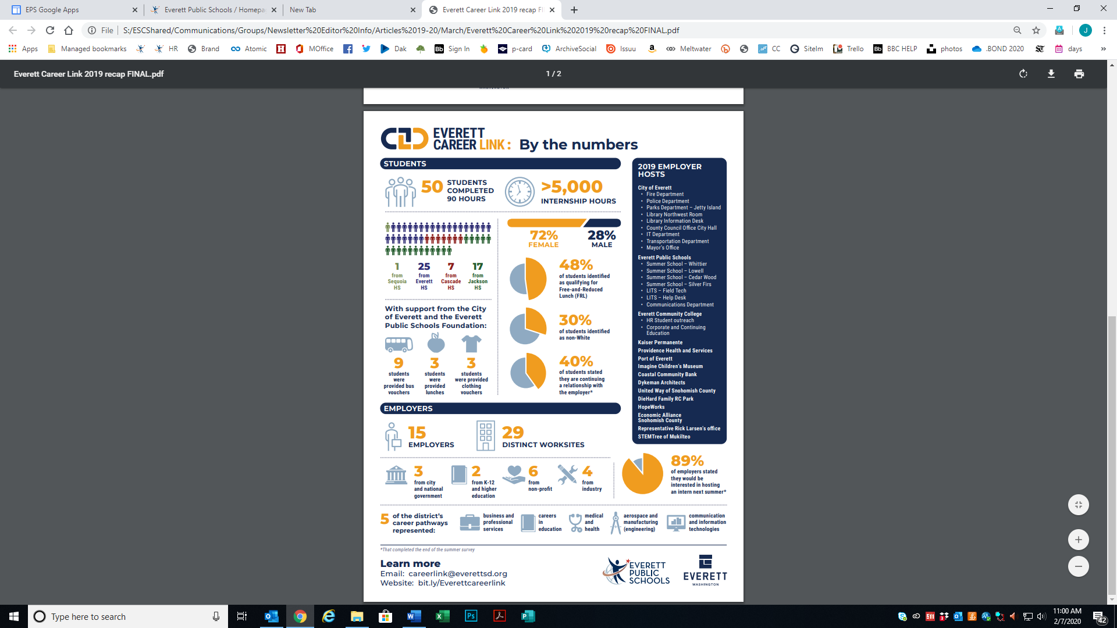

**Calendar update**

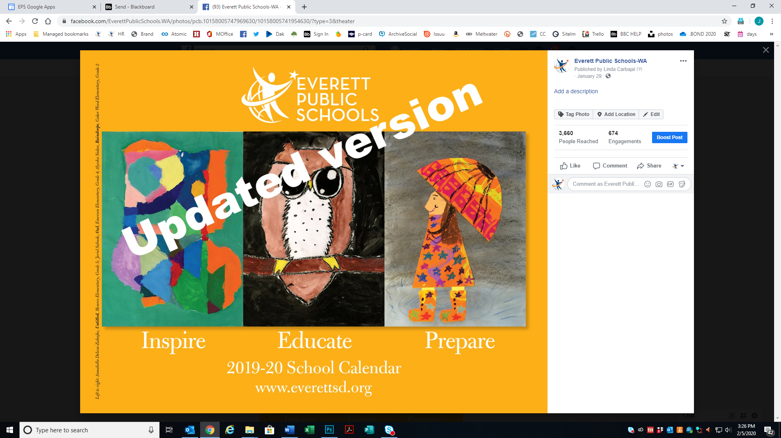On January 28, 2020 the school board approved the 2019-20 school calendar update. We've had three snow days, so the last day of school has changed. As of today, the last day of school is June 18 (keeping in mind this date is subject to change).

Go to [www.everettsd.org](http://www.everettsd.org) for updated At-a-glance and student art calendars, English and Spanish versions.

**Harvest of the month**

This month, the Food and Nutrition Department brings you broccoli grown in the PNW! Be sure to give it a try this month by choosing our broccoli salad or roasted broccoli menu option.

Did you know that broccoli is an excellent source of so many vitamins and minerals like Vitamin A, K and folate? Find out more by checking out the Harvest of the Month flyer on our website at <https://www.everettsd.org>

Brocc and Roll!

**Remember to register to vote**

By registering to vote, either in person or online, you are able to exercise a basic democratic right.

1. In person -- You may register to vote or change your registration at Snohomish County Elections, 3000 Rockefeller Ave, Everett, 1st Floor, Admin Bldg West.

2. Online -- If you have a valid Washington state driver's license, you may register with the [Secretary of State](https://www.sos.wa.gov/elections/register.aspx) quickly and easily online. You may also download a voter registration form in several languages from that site.  
3. Online – Visit the district’s bond 2020 page at www.everettsd.org/bond2020 and click on “register to vote” on the left hand side.

To learn details about elections, visit the [Snohomish County Elections](http://www.snohomishcountywa.gov/224/Elections-Voter-Registration) website.

**Daylight savings time begins March 8**

Sunrise and sunset will be about 1 hour later on Mar 8, 2020 than the day before. There will be more light in the evening.

Also called Spring Forward, Summer Time and Daylight Savings Time.

**Do not miss out!**

Our school is using Peachjar to send flyers home electronically.

Just go to the front page of our school website and click on the Peachjar Eflyer button to check it out. You do not need to login to receive or view school eflyers.

No action is required on your part. You should have already received a welcome email from Peachjar that includes a username and password. This is provided to give you the opportunity to manage your account and flyer delivery preferences. Don’t worry if you’ve forgotten your password, you can reset it at any time.

This system is used exclusively for distribution of school-approved flyers. Your email address will not be shared or used for any other purpose.

**Update emergency contacts**

Please call your school if your phone number or emergency contact information changes at any time during the school year. This is the contact information used by the Everett Public Schools automated phone system in emergencies and to share important school information with families.

