From the Principal

Tambark Creek News
TAMBARK CREEK ELEMENTARY SCHOOL NEWSLETTER

VOLUME 1, ISSUE 8

December 2019

Happy December! Tambark Creek has been open for almost four months. Thank you to all who attended the Tambark Creek Elementary dedication ceremony on Novemeber 14th. During the dedication, we honored an Everett Public School Board President Carol Andrews, who will be retiring this month after serving on the school board for twelve years. We also announced the winner of the TCE student logo contest. Congratualations to Anushree who was the winner and Sophia who received second place. Both students are in the 5th grade. Ms. Strong’s second graders did a great job demonstrating their 21st century skill by presenting their research papers about mountain lions-well done! The student logo will be printed on TCE spirit wear which is available for purchase. Please locate that information in the Tambark Creek PTSA newsletter sent out via e-mail last week.
Celia O’Connor-Weaver
Principal
Monique Beane
Assistant Principal

Tambark Creek Elementary School
4419 180th St. SE,
Bothell, WA 98012
425-302-9200
www.everettsd.org/tambarkcreek

Dec. 6
Learning Improvement Friday
2:15 Dismissal

Dec. 13
Learning Improvement Friday
2:15 Dismissal

Dec. 20
Winter Wonderland Dress Up Day for students

Learning Improvement Friday
2:15 Dismissal

Dec. 21-Jan. 5
No school-Winter Break

We are working with Dykeman graphic designers for our school logo design and brand. We will have our brand and logos out to families in the new year. PTSA will provide clothing order forms with our newest logos.
Beginning in January 2020, Tambark Creek STEM (science, technology, engineering and math) advisory group will meet every fourth Tuesday from 5:30-7:30PM, through April 2020 (January 28, February 25, March 24 & April 28). The first committee meeting will be held on December 17th, to introduce the project objectives and design thinking processes. Please e-mail Mrs. O’Connor-Weaver or Mrs. Beane if you are interested in being on this team.

From the Counselor

Our Second Step work by grade level is below. If you are interested in seeing this curricullum please let me know! Here are some of the focus areas we have explored this month:
Kindergarten – Identify and understand their own and other’s feelings; Learning about Empathy and understanding that others have feelings too.
1st Grade – Empathy; taking other’s perspective; showing compassion for others.
2nd Grade – Empathy; Identify and understand their own and other’s feelings; Learning “How to Calm Down” 1. Stop – Use your signal 2. Name your Felling 3. Calm down – Breathe – Count – Use positive self-talk.
3rd Grade – Identify and understand their own and other’s feelings; See other’s perspective; Show compassion for others; Develop friendship skills to get along better with other.
4th Grade – Identify components of a successful conversation; Giving and receiving a compliment; Recognize how strong feelings affect our brains and bodies; Using calming down steps; Manage strong feelings.
5th Grade – Disagreeing respectfully using assertiveness skills to avoid misunderstandings and prevent aggressive conflicts; Learning to calm down emotions that are getting out of control; Thinking clearly to avoid negative consequences; Using our “Calm Down” skills.

Our “Zen Kids” lunch groups are continuing for some of our students as we develop our skills to be calm and focused.

Please ask your student(s) what they are learning about in Second Step. Let me know if you have any questions!

Ms. Hehn & Mango

From the Office
If your student is absent or will be leaving early for an appointment and you email the teacher please remember to also include the attendance email at tceattendance@everettsd.org This provides a written response for your childs absence and ensures the office gets this important information.
From the PTSA
Join us on December 12th for our Winter Pajama Party at 6:30 in the cafeteria! Free admission! There will be complimentary hot cocoa and a wintry movie, along with cookie decorating and snow-themed craft kits ($1-$3) and snacks available for purchase! Contact us at tcptsaec@gmail.com with questions.

Spirit Wear is now available! Order forms and payments are due by December 18th and can be found at our website tambarkcreekptsa.org. You can also order online for an additional fee at https://my.cheddarup.com/c/spirit-wear-28905
From the Kitchen
KALE EM WITH KINDNESS!
“KALE” is our December harvest of the month. Kale is high in fiber and iron! Both of which are especially important for this age group. Iron is necessary for growing cells, which their little bodies are doing a lot of! Kale has MORE vitamin C than oranges and MORE calcium than milk! Look for kale on the salad bar, in the caesar salad and the cabbage patch soup.

The gift of attendance
Absences spike in the weeks before and after the winter holiday as families squeeze in a few more vacation days. Just a few missed days here and there, even excused absences, can add up to too much lost learning time and put your child behind in school. This is as true in kindergarten as it is in high school. Put simply, too many absences at any age can affect a student’s chances for academic success and eventually for graduation. This holiday season give your children the gift of an education and the habit of attendance.

Graduation rates jump to 95.9%
Our graduation rate jumped even higher for the 12th year in a row. Now 95.9 percent of our students graduate on time, the highest rate on record. The increase in graduation rates can be attributed to the strategically aligned work of district and school staff. It is a focus for everyone, no matter their role in our school district, to ensure each one of our students graduates ready for college and career.

Bond 2020
The Everett School District’s board of directors on Tuesday, October 8, 2019, approved placing a $317.4 million capital bond on the April 28, 2020 ballot to fund STEM career-connected learning pathways for students, ensure equitable access and opportunities for all students, increase safety and security and ensure students have enough room to learn by adding 21st century learning classroom space.

The 2020 capital projects bond prepares our students for the future by:
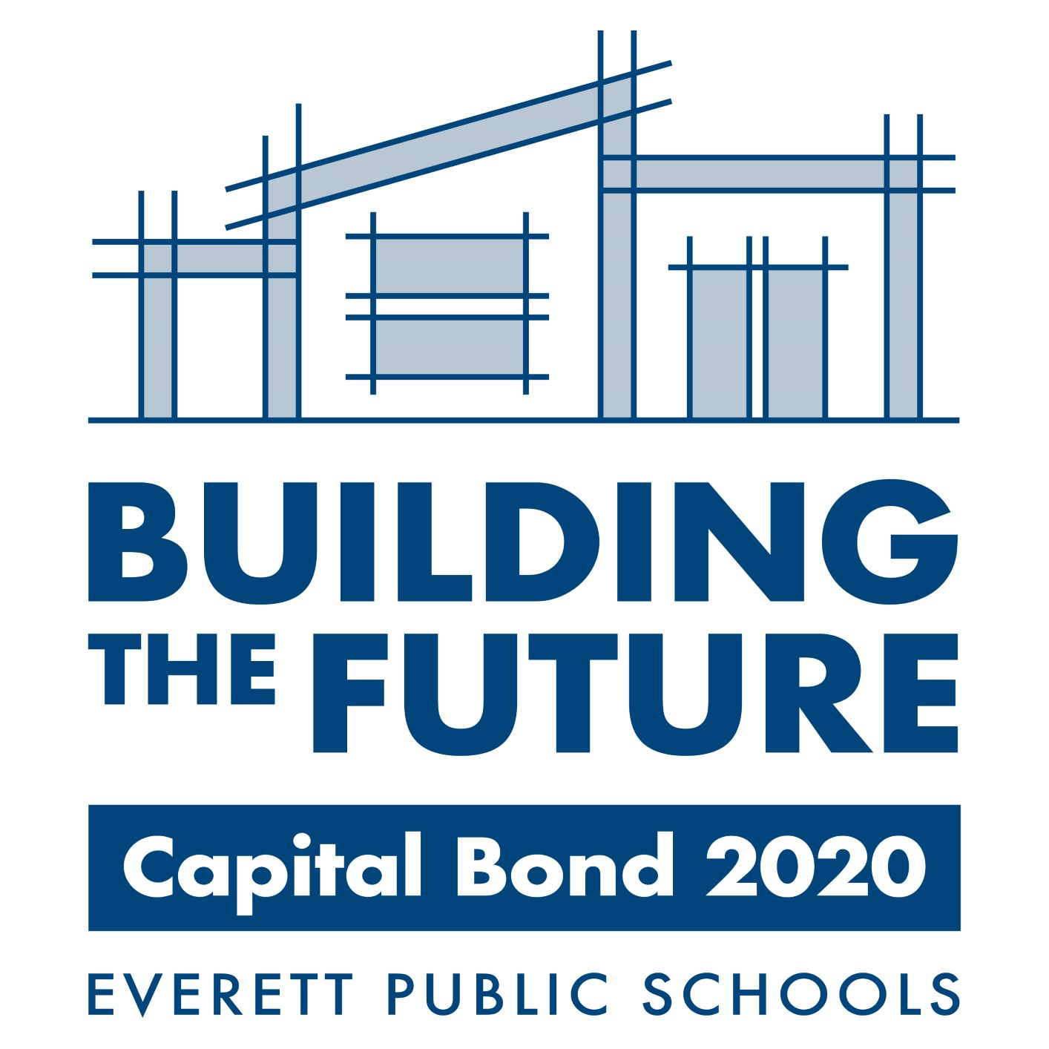
- Giving our students facilities and tools necessary for STEM career pathways
  - The bond funds modernization and upgrades to high school classrooms to support the Science, Technology, Engineering, Math (STEM) career pathway programs and new science standards.

- Increasing safety and security for students and schools
- Secure locks and keying systems will be added districtwide.
- Access control systems at two high schools
- Upgrades to fire alarm systems, security systems and fencing

- Ensuring students have enough room to learn by adding 21st century classroom space, modernizing and repairing building systems
  - Adds new elementary school classrooms throughout the district to reduce overcrowding, keep class sizes low and keep more kids at their neighborhood schools
  - Repairs aging school systems in our schools like HVAC, roofing and flooring replacements, that extends the longevity of schools

- Providing equitable access and opportunities for students by funding capital projects at all schools throughout our district, while reducing the overall school district tax rate

More information is available on the Capital Bond 2020 district webpage.

2020 Census
The 2020 Census is closer than you think! Here is a quick refresher of what it is and why it is essential that everyone is counted.
- Everyone counts. The census counts every person living in the U.S. once, only once, and in the right place.
- It’s about fair representation. Every 10 years, the results of the census are used to reapportion the House of Representatives, determining how many seats each state gets.
- It’s in the constitution. The U.S. Constitution mandates that everyone in the country be counted every 10 years. The first census was in 1790.
- It’s about $675 billion. The distribution of more than $675 billion in federal funds, grants and support to states, counties and communities are based on census data. That money is spent on schools, hospitals, roads, public works and other vital programs.

- It’s about redistricting. After each decade’s census, state officials redraw the boundaries of the congressional and state legislative districts in their states to account for population shifts.
- Taking part is your civic duty. Completing the census is mandatory: it’s a way to participate in our democracy and say, “I COUNT!”

Every household will have the option of responding online, by mail or by phone. Nearly every household will receive an invitation to participate in the 2020 Census from either a postal worker or a census worker.

Look for your invitation to respond starting in mid-March.
Snow routes are online
School drop off and pick up locations may change in an emergency situation. If your child rides a bus to school, please become familiar with the snow route information on the district transportation department’s webpage.

New Transitional Kindergarten Program
Everett Public Schools is offering a Transitional Kindergarten program this winter for children scheduled to enter kindergarten in the upcoming fall. The program will focus on basic academic, social and self-help skills to jumpstart qualifying students toward success in school. Students will be screened in early January and may qualify based on ability and/or need. This program is located at several of the elementary schools in our district; sites will be determined based on enrollment. The anticipated start date is January 28, 2020. Transitional Kindergarten will run through the last day of school, which is currently June 15, 2020.
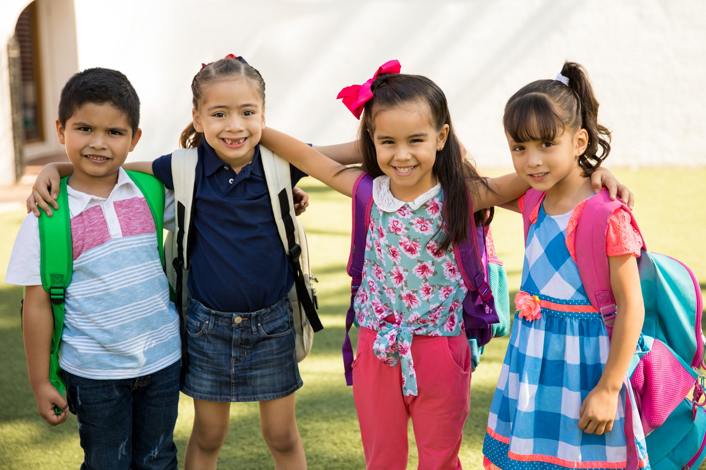
To qualify for screening, children must:
- be 5 years old by August 31, 2020
- live within the boundaries of Everett Public Schools
- not be currently enrolled in an early learning program
- demonstrate academic and/or social-emotional needs

If you are interested and believe your child qualifies for this program, please visit our website at https://www.everettsd.org/earlylearning and submit the Transitional Kindergarten form by December 6, 2019. For assistance, contact Helen Cooley at 425-385-4088 or Early Learning at 425-385-4024.

Family resources
Could you or a family you know use some help? Find information and links to helpful resources on the district’s Parent Tools webpage:
- Washington State Library – local and regional information about services and agencies offering help to families in a variety of ways including food, shelter, clothing, childcare, legal services, employment opportunities, and counseling
- Everett Public Schools Kids In Transition (KIT) program – supports homeless children and youth to continue their education
- Snohomish Health District for Snohomish County community dental resources for children and adults
- United Way of Snohomish County – 2-1-1 is a free telephone number that is your best "first call" to quickly find the right source of help. The information line is staffed by trained operators from Volunteers of America Western Washington who can connect you to a wide range of community services.

Delayed start or closed schools
If we must cancel school or delay the start of school, we will use our parent communication system to call in the morning, typically around 5:30 a.m., with a brief message about the reason for closure or delay. We will also use local media and post the message on our website. If there is no announcement about Everett Public Schools, school is on the regular schedule. More information and resources for school closures or delays is on the district website under the Parents tab.

In cases of inclement weather or other emergencies, please:
- check your email or phone for district messages
- listen for media announcements
- view the district’s website at https://www.everettsd.org/
- watch district Facebook, Twitter or Instagram accounts

Accepting Highly Capable nominations until Dec. 18
Find forms, information and evening events on the Highly Capable website. Referrals are for students currently in grades one through four for winter testing, which will take place on February 1, 2020.

Food and Nutrition
This month, the Food and Nutrition Department brings you kale grown in the PNW! Be sure to give it a try this month in our Kale Caesar salad and on the salad bar!

Did you know that just one serving of kale has more vitamin C than an orange? Find out more by checking out the Harvest of the Month flyer on our website at https://www.everettsd.org. It’s not easy being green! Don’t kale my vibe!
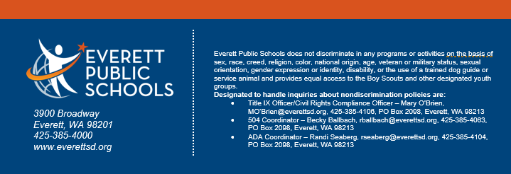

Attached are some wonderful pictures from our dedication ceremony last month!

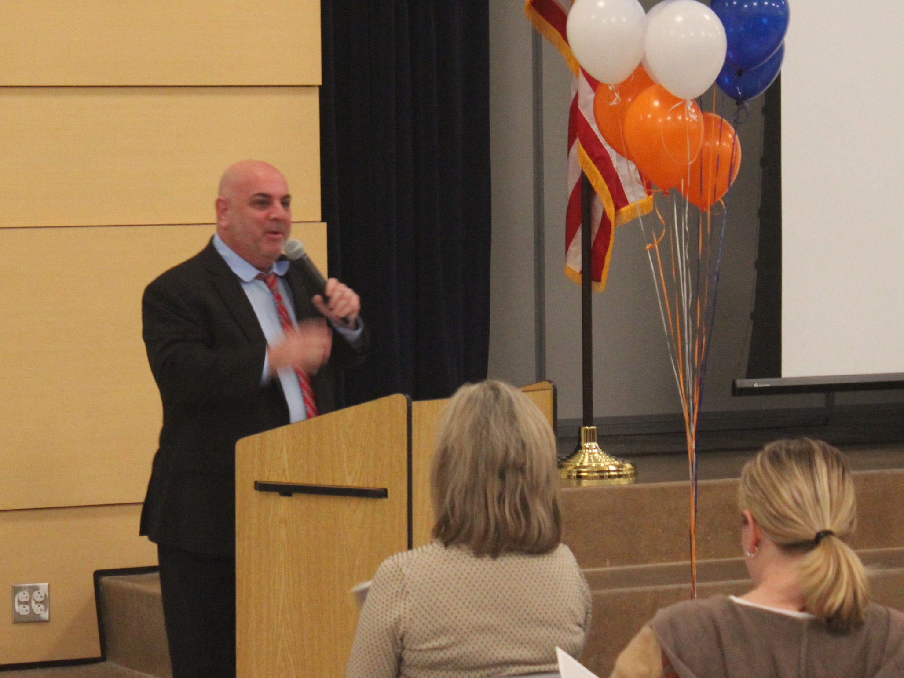

Dr. Saltzman speaking to the crowd.

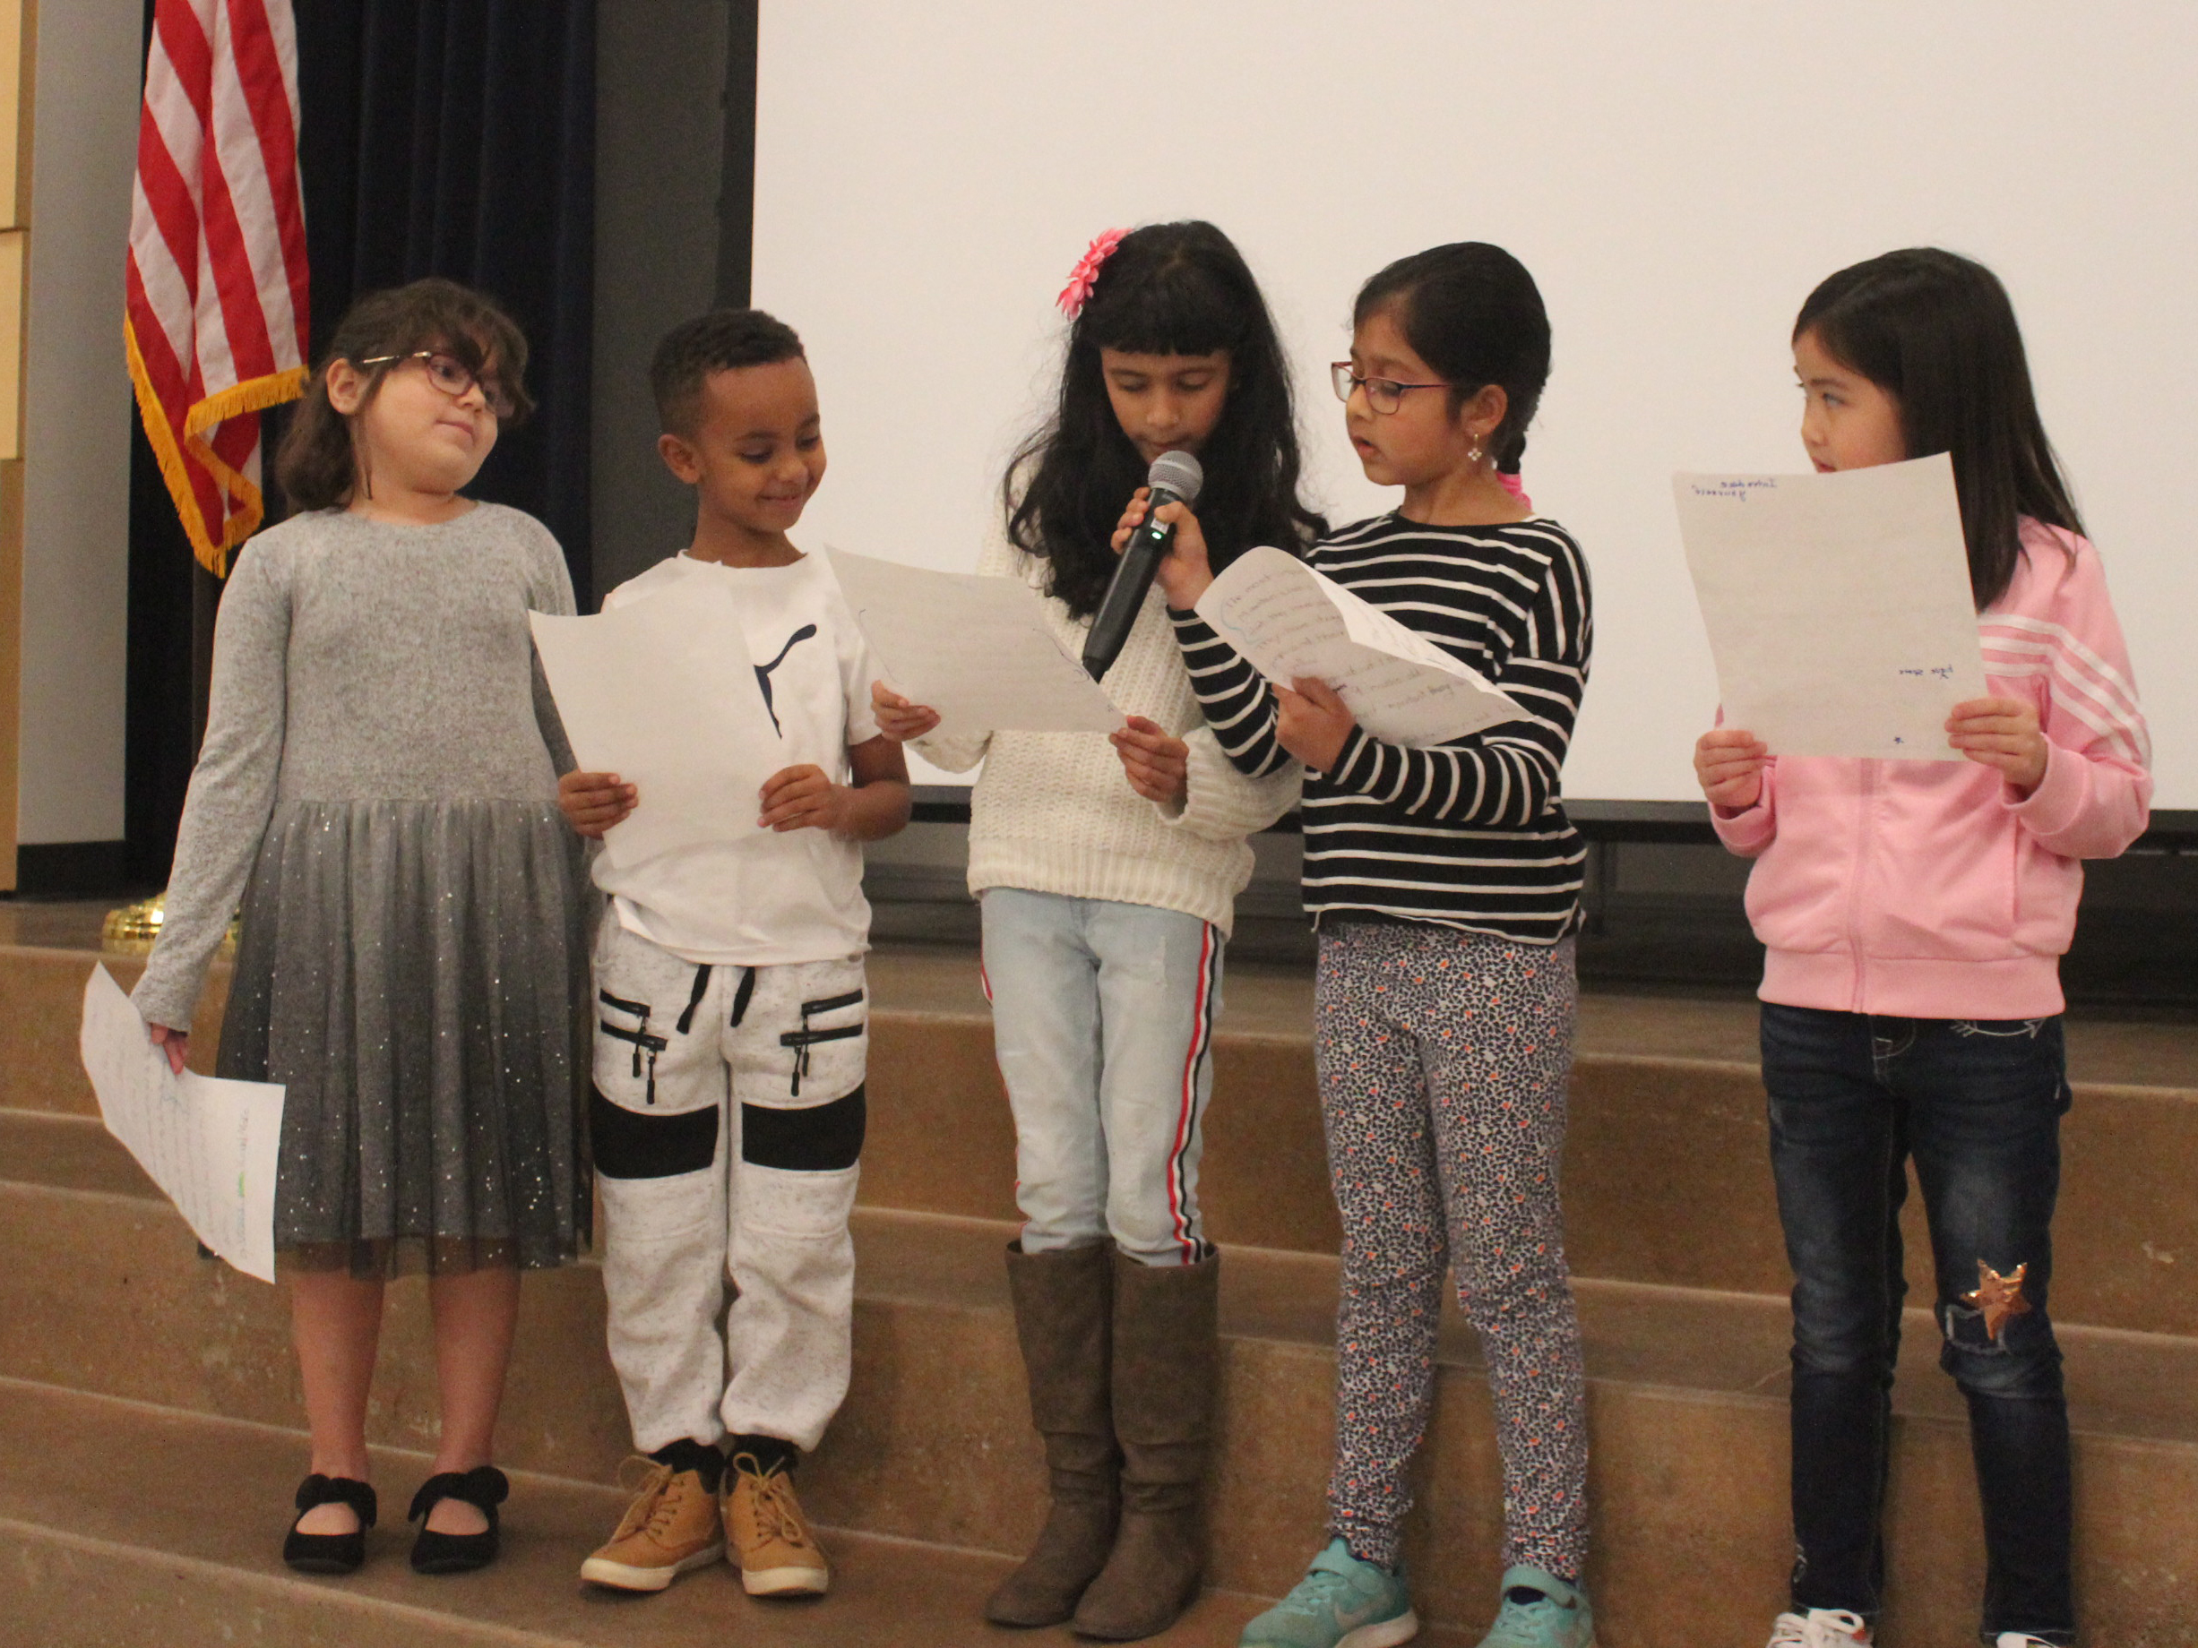
2nd grade students from Ms. Strong’s class sharing their mountain lion research papers.
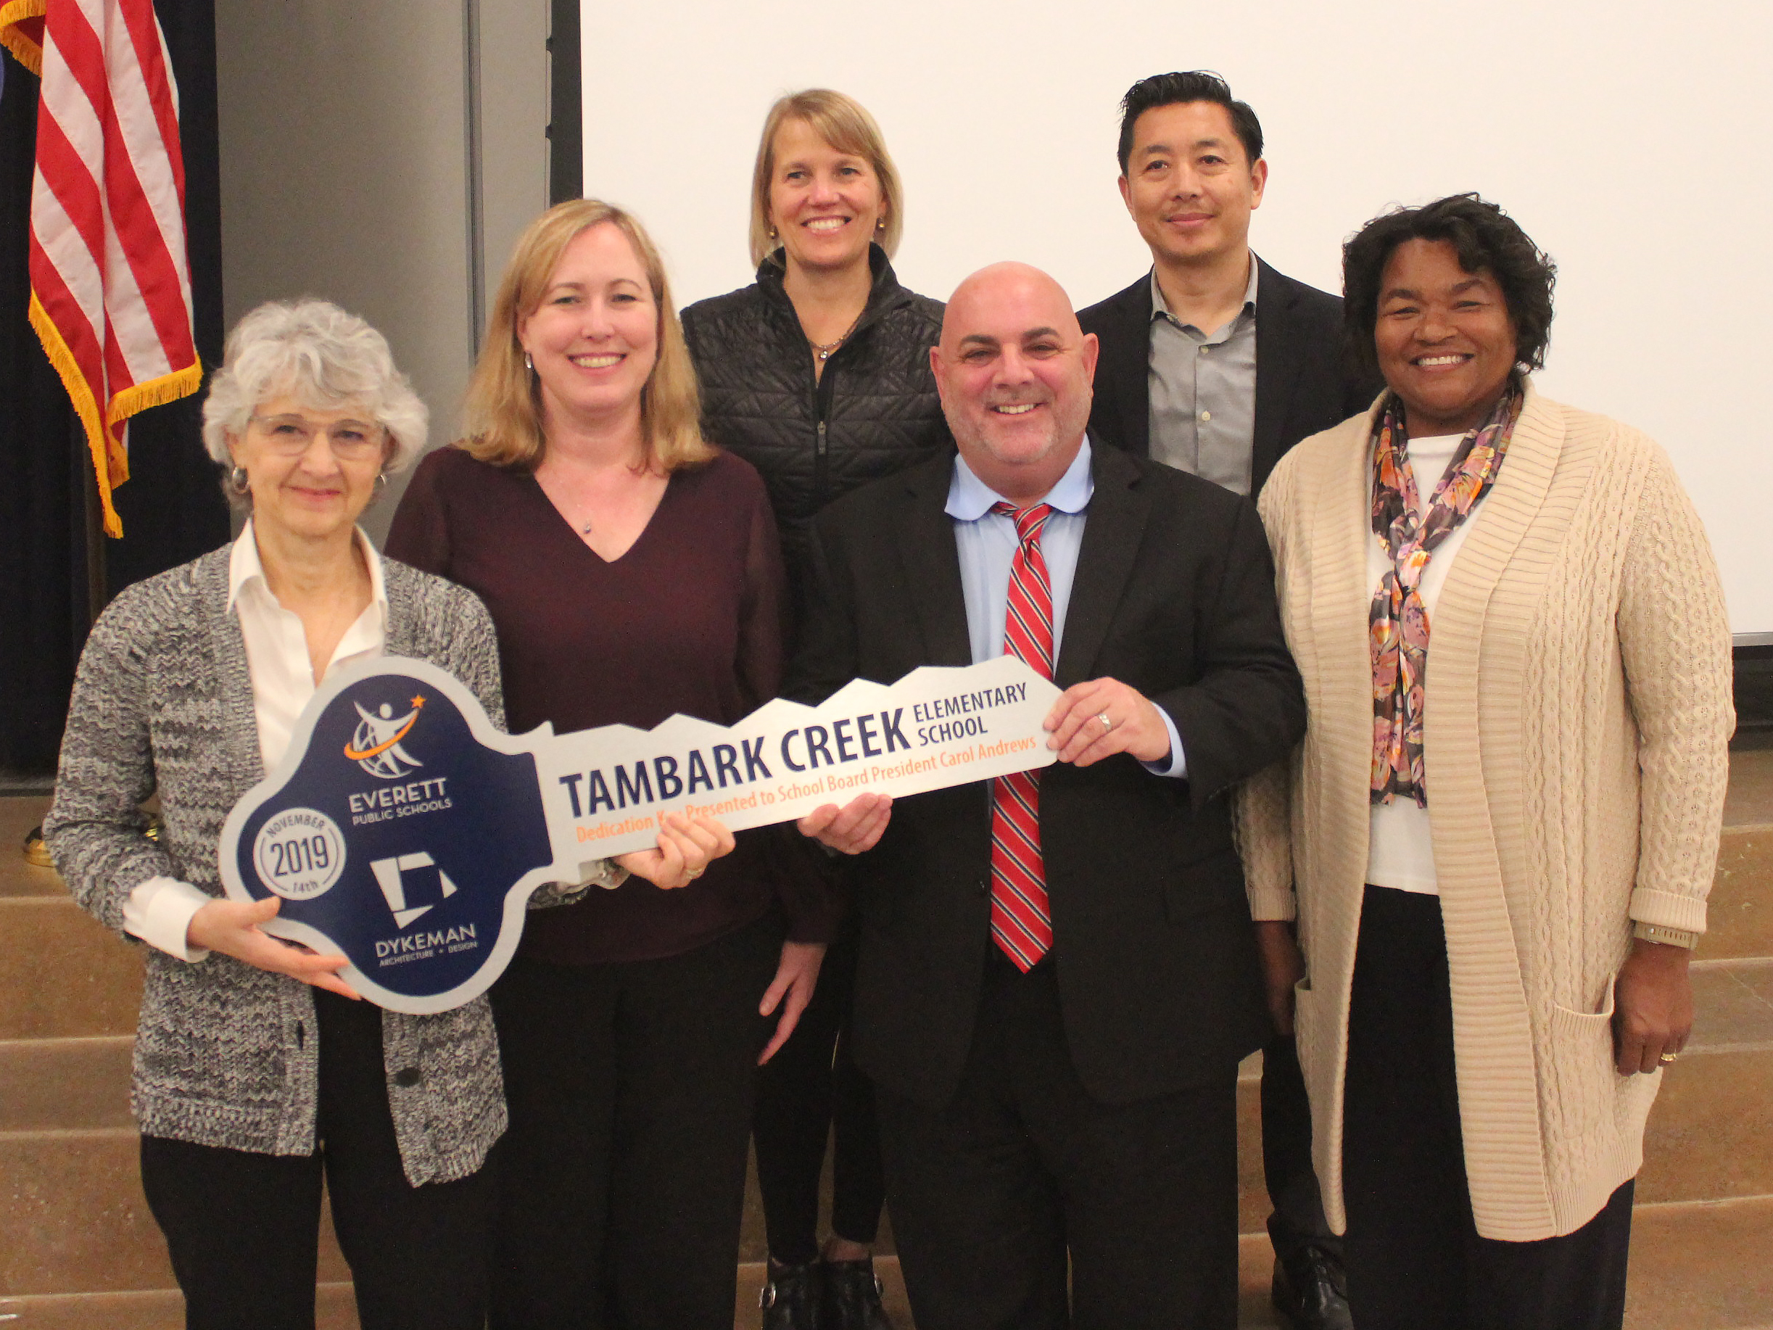
The school board and Dr. Saltzman.

