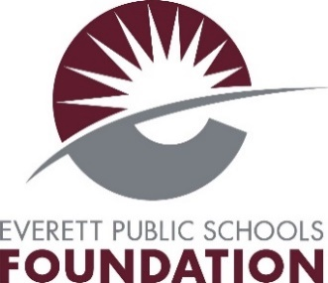

APPLICATION DEADLINE - ON OR BEFORE April 28, 2023
The Reed Baldwin Redfellowship
Applicant winners will be notified by May 24, 2023
INSTRUCTIONS: Please fill in this form: email, print or type the application information. Attach your official transcript with the completed application. (Ask Mr. Dahlke in the Career Center for transcript.) Submit electronically your application and all other materials (transcript and any additional pages) to Mr. Dahlke in the Career Center, ddahlke@everettsd.org, who will send it to the EPS Foundation.

Click or tap here to enter text.
School:
Click or tap here to enter text.
Full Name:
First Middle Last
Click or tap here to enter text.
Address:
Street City State Zip
Click or tap here to enter text.
Click or tap here to enter text.
Phone #: Email

College-University-Junior College-Trade School-Technical School
Preference (if applicable)
Click or tap here to enter text.
First Choice:
Second Choice:
Click or tap here to enter text.

Post High School Goals
Click or tap here to enter text.

Education
Please list courses taken to support goals.
Click or tap here to enter text.

Activities
Please list activities, accomplishments, hobbies, honors, and awards that support your application.
Click or tap here to enter text.

Written Essay
The Reed Baldwin Redfellowship is a scholarship for students who make their band or robotics community a better experience for all, through their infectious and inclusive energy, creative perspectives, and intuitive musical or mechanical skills. These scholarships are intended to recognize students who demonstrate the group’s success is more important than their individual spotlight. How have you helped others feel welcome to the group or asked the group to look at things in a new way, and why are you a good candidate to receive The Reed Baldwin Redfellowship? (Please limit to 500 words.)
Click or tap here to enter text.

