# From the Principal

**Tambark Creek News**

TAMBARK CREEK ELEMENTARY SCHOOL NEWSLETTER

VOLUME 1, ISSUE 13

May 2020

Hello Tambark Creek Families! I hope you and your family are well and settling into a daily schedule. I realize how hard it may be to support your child with learning from home as you continue to work. We are all in this together, and we will support one another. The Tambark Creek teachers are working hard to plan lessons, manage their teaching platforms, and communicate with families. Mrs. Beane and I have been attending their grade level Zoom meetings and student check in meetings. Although, it is tough to stay on top off work and your child’s learning on-line, it is so important that you encourage your child to engage daily with lessons, assigments and participate in the weekly Zoom meetings. I appreciate all the students who have been responding to my Flipgrid videos and answering my questions. If you need support with technology, assigments or anything, we are here for you. <https://www.everettsd.org/Page/32723>

**Celia O’Connor-Weaver**Principal

**Monique Beane**

Assistant Principal

**Tambark Creek Elementary School**   
4419 180th St. SE,   
Bothell, WA 98012

425-302-9200

*www.everettsd.org/tambarkcreek*

**May 1-29**No School

The Tambark Creek staff created a video for our students “We miss you”. The link is on our website and Facebook page. [https://youtu.be/PrVUi4f8JQQ](https://youtu.be/PrVUi4f8JQQ?fbclid=IwAR2Xnq4znTcL0Rhm3oB4UEjQqCxORilDvMaS1rboOBogMQJG0z8lcRz_Tik)

By now, many of you have come to school via car to pick up a Chromebook. We have had four deployments at Tambark Creek. We are working with district officials on a timeline for returning the Chromebooks to school sometime in June. Specific information regarding dropping off your child’s Chromebooks and picking up their personal belongings will be provided soon.

If your child is interested in participating in the 5th grade violin program next year, please register. The link is below. Registration is opened now until May 31, 2020. If you have any questions, please contact Pam VanHorne.

[https://docs.google.com/presentation/d/1fddJiKrNY3hQ17OJGJUbQForkxifmxJeKg2qDUafsYg/edit#slide=id.p](https://nam01.safelinks.protection.outlook.com/?url=https%3A%2F%2Fdocs.google.com%2Fpresentation%2Fd%2F1fddJiKrNY3hQ17OJGJUbQForkxifmxJeKg2qDUafsYg%2Fedit%23slide%3Did.p&data=02%7C01%7Ccoconnor%40everettsd.org%7Ce6bfe67dc27e48caeb7208d7eb03f20a%7Ca6158ef04f854b0da599925097f77b3d%7C0%7C0%7C637236274489119963&sdata=WaUSVOhA8uRAPzEkMorbchy%2FVAkyuFyQIX9FOXHMIAg%3D&reserved=0)

Pam VanHorne

Forest View Elementary

4th Grade Highly Capable

5th Grade Violin

pvanhorne@everettsd.org

425-385-7986

Take care and stay safe.

Mrs. O’Connor-Weaver

**From the Counselor**

Dear Tambark Creek Families,

I’m hoping that you are all doing well as we continue this journey together. There are so many unknowns at this time and with that can come stress and worry. Be kind to yourself, take things slowly, take breaks as things become overwhelming, and give yourself grace. We are all moving through uncharted territory and need time to acclimate and find our footing.

So many of you have taken on a new role of coach/teacher to your child(ren). This can be challenging! Take this role with the same grace and understanding you would give another, it’s not just a new role to you but also for your child. You both will need breaks and will have days you can’t do all you thought you could or should do. That is OK! Make positive memories for your children during this time, enjoy the extra time you have with them – Bake cookies (measuring ingredients – that’s math), take walks and collect leaves (do some research at home to find the names of the trees – that’s science), Share your favorite or hardest memories about school and have your child do the same (that’s public speaking). The list goes on . . .

I wanted to share a video that is very touching. It shares that there is hope and things will get better.

[https://www.image.ie/life/watch-this-emotive-irish-video-shows-how-important-it-is-to-stayhome-190143](https://nam01.safelinks.protection.outlook.com/?url=https%3A%2F%2Fwww.image.ie%2Flife%2Fwatch-this-emotive-irish-video-shows-how-important-it-is-to-stayhome-190143&data=02%7C01%7Cjhehn%40everettsd.org%7C31ac3c99c3c14702afd208d7e869e640%7Ca6158ef04f854b0da599925097f77b3d%7C0%7C0%7C637233413841255383&sdata=5FRmJWXq5YpX1jjcOkpncYf4PUxHC3kyOMNMjAz2%2FMc%3D&reserved=0)

Please refer to the links on my website to help you with connections to helpful websites. You will also find a link on my website that says – “Messages from Mango the Service Dog”. This gives a new message from Mango each week to students and families about things that can be done around the house that might be fun. It is a light-hearted way to help us through all we are dealing with during this difficult time. Here is one from Mango on “Music and Singing”: <https://youtu.be/Gnnr8sdlMF8>

Be kind to yourself and those around you,

Namaste,

Julia Hehn, Tambark Creek School Counselor

& Mango – who misses you all very much!

[jhehn@everettsd.org](mailto:jhehn@everettsd.org)

(425)-302-9010

**From the Office**

If you need to reach the office staff for any reason you may email Mrs. Patty the office manager at [ttetrault@everettsd.org](mailto:ttetrault@everettsd.org) or Mrs. Angie the office assistant at [ajames2@everettsd.org](mailto:ajames2@everettsd.org) We miss all of our TCE students very much!

**From the PTSA**

Hello Tambark Creek families! Thank you to everyone who attended our first virtual membership meeting on April 23rd where we voted in our nominating committee! Please join us for our next virtual membership meeting via Zoom on **May 28th at 7pm** when we will vote in our executive committee!

All PTSA members will get a link to the May 28th meeting. If you are not yet a PTSA member, you can join the PTSA online at [my.cheddarup.com/c/membership-57906](https://my.cheddarup.com/c/membership-57906)

If you are interested in being part of next year's executive committee, please fill out this form: <http://tambarkcreek.my-ptsa.org/Content/22_807/DocumentStore/4/NomForm.pdf>

If you are interested in finding out more about how you can get involved in the PTSA next year, please email us at [president@tambarkcreekptsa.org](mailto:president@tambarkcreekptsa.org)!

If you have ordered dress code wear, please know that the items are ready and we are just waiting for the vendor to be able to deliver them to us (they are considered non-essential at this time). Once we have the items, we will work with the school in order to get the items to you safely. Please contact us at [president@tambarkcreekptsa.org](mailto:president@tambarkcreekptsa.org) with any questions.

Remember that you can get the most up-to-date information about Tambark Creek PTSA events and programs on the PTSA Facebook page ([facebook.com/TambarkCreekPTSA](https://www.facebook.com/TambarkCreekPTSA)) and the PTSA website ([tambarkcreekptsa.org](http://tambarkcreek.my-ptsa.org)). And feel free to get in touch with us by sending an email to [president@tambarkcreekptsa.org](mailto:president@tambarkcreekptsa.org).

We hope everyone stays safe and healthy!

Alisha Crawley-Davis & Heather Morgan

co-Presidents, Tambark Creek PTSA 7.3.12

**School closure resources**

Watch for all Coronavirus updates at [www.everettsd.org/COVID-19](http://www.everettsd.org/COVID-19).

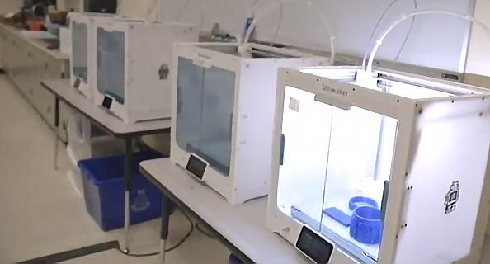**3-D printers loaned to help support local health care systems**

Everett Public Schools is grateful to be able to loan ten 3-D printers, through an agreement with Ignition Partners, to support manufacturing N95 masks, visors and other critical medical and safety equipment for our local health care systems. [Click for full article](https://nam01.safelinks.protection.outlook.com/?url=http%3A%2F%2Fr20.rs6.net%2Ftn.jsp%3Ft%3Dtobbwiabb.0.0.nrvauneab.0%26id%3Dpreview%26r%3D3%26p%3Dhttps%253A%252F%252Fwww.geekwire.com%252F2020%252Fmaker-mask-launches-seattle-using-3d-printing-technology-produce-protective-gear%252F&data=02%7C01%7CJGoodhart%40everettsd.org%7Cb4306e861a414b1bbf7508d7dd96ba18%7Ca6158ef04f854b0da599925097f77b3d%7C0%7C0%7C637221511755199038&sdata=0rzCmcAAuXB9l%2FQhgNt%2FRjZyE3bx0TcHuneTMEBtJh4%3D&reserved=0).

**Frequently Asked Questions**

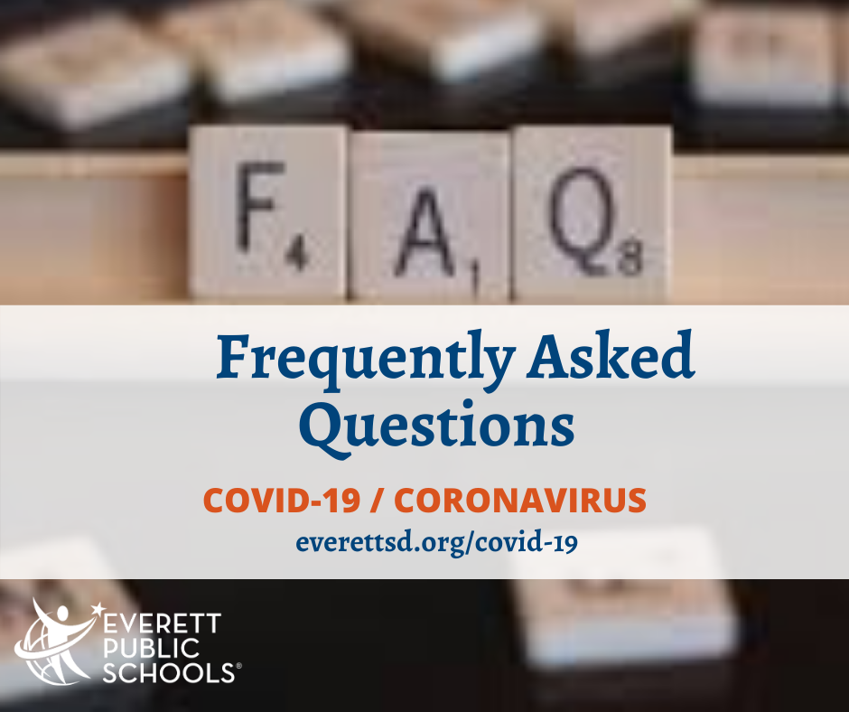

Did you know we have an [FAQ page](https://nam01.safelinks.protection.outlook.com/?url=http%3A%2F%2Fr20.rs6.net%2Ftn.jsp%3Ft%3Dtobbwiabb.0.0.nrvauneab.0%26id%3Dpreview%26r%3D3%26p%3Dhttps%253A%252F%252Fwww.everettsd.org%252FPage%252F31155&data=02%7C01%7CJGoodhart%40everettsd.org%7Cb4306e861a414b1bbf7508d7dd96ba18%7Ca6158ef04f854b0da599925097f77b3d%7C0%7C0%7C637221511755199038&sdata=qwhotCX5GSNEb39Zgu0X7aygtmdF3pu0JWIHwmMPONA%3D&reserved=0) on our district website? We actively add content as we develop answers that apply to our students, staff and community. If you do not see your question answered, there is also an '[Ask a Question](https://nam01.safelinks.protection.outlook.com/?url=http%3A%2F%2Fr20.rs6.net%2Ftn.jsp%3Ft%3Dtobbwiabb.0.0.nrvauneab.0%26id%3Dpreview%26r%3D3%26p%3Dhttps%253A%252F%252Fwww.everettsd.org%252FPage%252F33828&data=02%7C01%7CJGoodhart%40everettsd.org%7Cb4306e861a414b1bbf7508d7dd96ba18%7Ca6158ef04f854b0da599925097f77b3d%7C0%7C0%7C637221511755209031&sdata=oMgR3UIC8rRnmNe0JeE%2FrZSM9T8nW299GUKYUh9%2BnCY%3D&reserved=0)' form where you may submit your question. Hoping this is a helpful resource for all!

**Emergency meal schedule update**

Go to <https://bit.ly/EPS_EmergencyMeals> for schedule of locations and times.

Due to physical distancing standards, and for the safety of our staff, meals will no longer be delivered directly to homes.

How families can help:

• Please take advantage of curbside pickup and stay in your car

• Avoid socializing with other families

• Leave the school property immediately after receiving your meals

• If you do walk-up, stand six feet behind the family in front of you, only stand in line with people you live with

• Pick up your meals at a later time in the meal service

• Pick the meal option for your child

• Follow directions provided by Everett Public Schools staff

Thank you for your understanding as we make these necessary changes to keep everyone safe.

**Social & Emotional Health during school closure**

The outbreak of coronavirus disease 2019 (COVID-19) may be stressful for people and communities. Fear and anxiety about a disease can be overwhelming and cause strong emotions in adults and children.

Everyone reacts differently to stressful situations.  The emotional impact of an emergency on a person can depend on the person’s characteristics and experiences, the social and economic circumstances of the person and their community, and the availability of local resources. People can become more distressed if they see repeated images or hear repeated reports about the outbreak in the media.

Children react, in part, on what they see from the adults around them. When parents and caregivers deal with the COVID-19 calmly and confidently, they can provide the best support for their children. Parents can be more reassuring to others around them, especially children, if they are better prepared.

Please visit the district’s website for [links and resources](https://www.everettsd.org/Page/34884) for social & emotional health.

**Kindergarten registration**

During the current school closure, you can register for kindergarten online. Please visit the [registration page](https://www.everettsd.org/Page/31077) on the district’s website. If you have questions, please email the Early Learning Department at [EarlyLearning@everettsd.org](mailto:EarlyLearning@everettsd.org). Thank you!



**Teacher Appreciation Week**

Since 1984, National PTA has designated one week in May as a special time to honor the men and women who lend their passion and skills to educating our children. This year, Teacher Appreciation Week is May 4 – 8, 2020.

**National School Nurse Day**

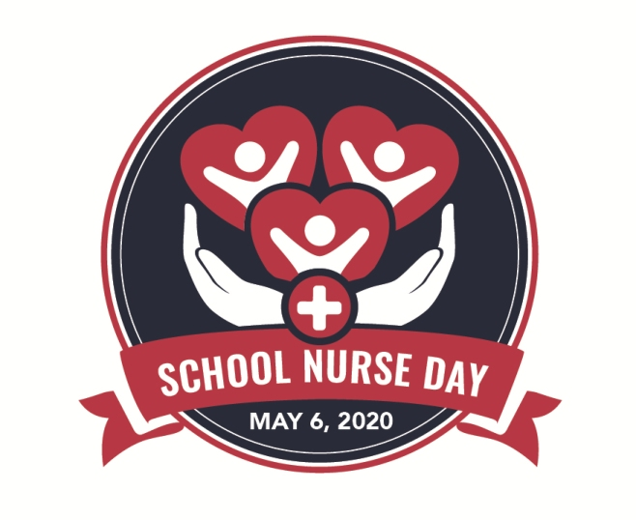National School Nurse Day, May 6, 2020, is a time to celebrate the specialty practice of school nursing. In 1972, the National Association of School Nurses (NASN) created National School Nurse Day to recognize school nurses and acknowledge their role in the educational setting. NASN applauds the contributions school nurses make every day to improve the health, safety, and academic success of all students.

The theme this year – School Nurses: Supporting Students in Times of Crisis – reinforces the changing times of 2020. This year, more than ever, all members of our school communities, school nurses included, have been required to take on unprecedented roles and adapt quickly to changes in their jobs. It is reflective of the significant roles school nurses have in the health care of their school communities to help make a healthier place for children and families to learn and grow during this crisis.

