# From the Principal

**Tambark Creek News**

TAMBARK CREEK ELEMENTARY SCHOOL NEWSLETTER

VOLUME 1, ISSUE 14

June 2020

Hello Tambark Creek Families! It was great seeing many of you this week during the student belongings deployment. We miss our students more than we can say.

**Celia O’Connor-Weaver**Principal

**Monique Beane**

Assistant Principal

**Tambark Creek Elementary School**   
4419 180th St. SE,   
Bothell, WA 98012

425-302-9200

*www.everettsd.org/tambarkcreek*

**June 1-19**

No School

If you were unable to get your child’s belongings during the two-day deployement, you can pick them up when you return the chromebooks. This date has yet to be determined. Once we have a date, I will provide a connect ed message to all families.

The 2020 end of the school year does not look the same in many ways and it leaves us feeling sad and unsettled. Please know that we would love to have closure and say good-bye in person, but unfortunately this is not feasible. The teachers are setting up special end of the year Zoom meeting for this reason.

I am so excited about TCE’s iReady usage for math and reading. The students are doing a great job of getting their iReady minutes in. This means they are maintaining their skills which will prevent lose of skills. The iReady diagnostic test is lauching on June 1st. Please have your child take the diagnostic. The data we receive from the iReady diagnostic assessment will help us prepare for necessary academic supports in the fall. The teachers are willing to help with any questions you may have regarding how to launch the diagnostic and ways you can support your child. It is a test, so please be sure that you are not providing answers. Support your child by being close by them, saying encouraging words and providing breaks as needed. The district assessment department has also provided parents with additional information and supports.

This newsletter contains district information about end of year information, summer school, on-line continued learning and much more. Please read it closely.

If your child is interested in participating in the 5th grade violin program next year, please register. The link is below. Registration is opened now until May 31, 2020. If you have any questions, please contact Pam VanHorne.

[https://docs.google.com/presentation/d/1fddJiKrNY3hQ17OJGJUbQForkxifmxJeKg2qDUafsYg/edit#slide=id.p](https://nam01.safelinks.protection.outlook.com/?url=https%3A%2F%2Fdocs.google.com%2Fpresentation%2Fd%2F1fddJiKrNY3hQ17OJGJUbQForkxifmxJeKg2qDUafsYg%2Fedit%23slide%3Did.p&data=02%7C01%7Ccoconnor%40everettsd.org%7Ce6bfe67dc27e48caeb7208d7eb03f20a%7Ca6158ef04f854b0da599925097f77b3d%7C0%7C0%7C637236274489119963&sdata=WaUSVOhA8uRAPzEkMorbchy%2FVAkyuFyQIX9FOXHMIAg%3D&reserved=0)

Pam VanHorne

Forest View Elementary

4th Grade Highly Capable

5th Grade Violin

pvanhorne@everettsd.org

425-385-7986

Take care and stay safe.

Mrs. O’Connor-Weaver

**From the Counselor**

Dear Tambark Creek Families,

As I write the last “Words from Tambark Creek’s Counselor” for the year I am struck by what a year it has been. No one could have imagined we would be ending the year working with students online. We are living in a place of questions and changes. Through all of this we have not lost our direction or the importance of our work - to educate our students at Tambark Creek.

Summer is upon us and with that comes the weather we all love, the belief that our community is going to open up soon and with that we will be able to do more of the things we miss. Know that when school starts Tambark Creek will be here to help each student settle into school and be successful.

Here are a few ideas to think about when planning your summer fun with your child(ren). It nourishes our lives to open up our creative side.

1. **Ask Questions:** Creativity is all about questioning - How can I? Why should it? What would happen if? How can I make this, or change that?
2. **Keep Everything:** Keep a bag of all the egg boxes and toilet rolls in a corner, because that’s going to be a gold mine of incredible craft-making materials.
3. **Set Challenges:** What kind of musical instruments can you make today from what’s in the bag over there?
4. **Find Online Resources:** YouTube how-to-videos abound for anything from learning a new hobby to touring a museum. Plan a family “trip” to a museum and then pick your favorite art form to make one yourself.
5. **Think Outside the Box:** Creativity is not just about arts and crafts, it flows into all areas of our lives, cooking, gardening, games . . . the list is endless. Enjoy these moments with your child!

Please refer to the links on my website to help you with connections to helpful websites. You will also find a link on my website that says – “Messages from Mango the Service Dog”. This gives a new message from Mango each week to students and families about things that can be done around the house that might be fun. It is a light-hearted way to help us through all we are dealing with during this difficult time. Here is one from Mango on “Going on a Walk”: <https://youtu.be/p19WkRGf6oo>

Be kind to yourself and those around you,

Namaste,

Julia Hehn, Tambark Creek School Counselor

& Mango – who misses you all very much!

[jhehn@everettsd.org](mailto:jhehn@everettsd.org)

(425)-302-9010

The most accurate and up-to-date source of information with regards to school is the Everett Public Schools Home Page – <http://www.everettsd.org>

**From the Office**

If you need to reach the office staff for any reason you may email Mrs. Patty the office manager at [ttetrault@everettsd.org](mailto:ttetrault@everettsd.org) or Mrs. Angie the office assistant at [ajames2@everettsd.org](mailto:ajames2@everettsd.org) We miss all of our TCE students very much! If you need to register your child for kindergarten please go to <https://www.everettsd.org/domain/1469>

**From the PTSA**

We wanted to thank everyone for their participation in the PTSA this year – whether becoming a member, attending a meeting, volunteering for and/or attending one of our events or programs, participating in our fall Fun Run, or just supporting us!

We invite the entire Tambark Creek Elementary community to fill out a survey to let us know what you thought worked and what you thought did not work this year! We will use the feedback in our 2020-2021 school year planning. The link is [survey.tambarkcreeptsa.org](http://survey.tambarkcreekptsa.org/)

Please join us for our last PTSA meeting on June 11th at 7pm via Zoom, where we will celebrate our volunteers and vote in our 2020-2021 budget. Members will be emailed a link close to the date of the meeting. If you are not a member and would like to attend, please email us at [president@tambarkcreekptsa.org](mailto:president@tambarkcreekptsa.org)

Please note that due to COVID-19, yearbooks will not be delivered in time for the last day of school. We will work with the school to figure out how to get them to you once we have a delivery date. Please let us know if you have moved or are moving out of the area so we can be sure to get them to you. Thank you!

Thank you so much for making our first year successful!

Remember that you can always get the most up-to-date information about Tambark Creek PTSA on the PTSA Facebook page ([facebook.com/TambarkCreekPTSA](https://facebook.com/tambarkcreekptsa)) and the PTSA website ([tambarkcreekptsa.org](http://www.tambarkcreekptsa.org)). And feel free to get in touch with us by sending an email to [president@tambarkcreekptsa.org](mailto:president@tambarkcreekptsa.org)

Have a great summer and we so hope to see you in the fall!

Alisha Crawley-Davis & Heather Morgan  
co-Presidents, Tambark Creek PTSA 7.3.12

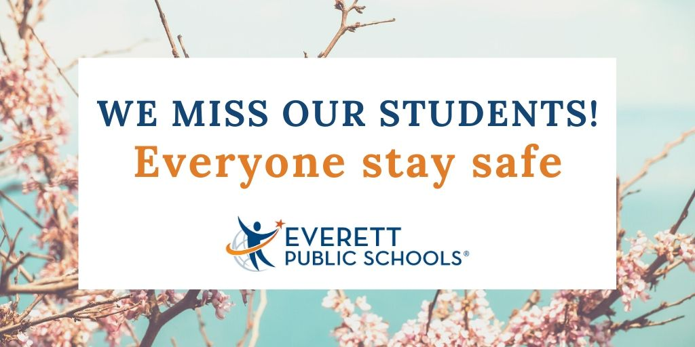**COVID-19 Coronavirus webpage**

Stay informed by visiting the COVID-19 Coronavirus webpage [www.everettsd.org/COVID-19](http://www.everettsd.org/COVID-19). Here, you will find messaging to families, information on family tech support, learning engagement, Class of 2020 support, helpful resources, FAQ’s and more related to school building closure.

**What will the 2020-21 school year look like?**

Thank you for understanding the complexity of decisions for the fall. Right now, we are focused on finishing the school year well, and are following the guidance of OSPI and the state for developing plans for the fall. Realistically, with the current unknowns, we won’t be able to finalize a plan until early August.

**Essential item pick-up**

We understand your student may still have personal items at their school which are essential to continue their learning from home, such as calculators, books or medications. Schools will be conducting personal item pick-up days in late-May for families to collect your student’s essential items, which will be pre-bagged and labeled by staff. You will receive more specific information on pick-up times from your school next week, but the dates are: elementary schools, May 26 and 27; middle and high schools, May 28 and 29.

There will be a second parent pick-up event at our schools on select dates between June 12-19 for families to collect any remaining student items and to return library books, textbooks, musical instruments, etc. More information about the June pick-up events will be shared with parents in the coming weeks.

**When does school end this year?**

June 5 is not an early release day but will follow the current modified structure.

Learning Improvement Fridays (LIF) are suspended through June 19 to follow the current modified structure.

June 19 is the new last day of school. June 12 is the last day for seniors.

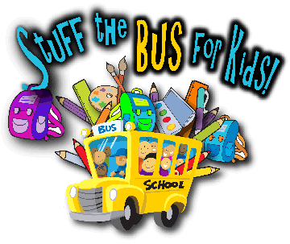

**Stuff the Bus is coming!**

With the support of our generous community, the Everett Public Schools Foundation is hosting its 11th annual Stuff the Bus for Kids school supply drive. Last year the Foundation delivered over 1,900 backpacks to students and hope to deliver the same number this year. Look for collection bins at local businesses during the month of August and look for big yellow Durham school buses parked outside Fred Meyer in Mill Creek and QFC on Evergreen Way Aug. 14-16.  For questions, please contact Kirsten Hansen at [khansen@everettsd.org](mailto:khansen@everettsd.org).

**Kindergarten Registration (Class of 2033)**

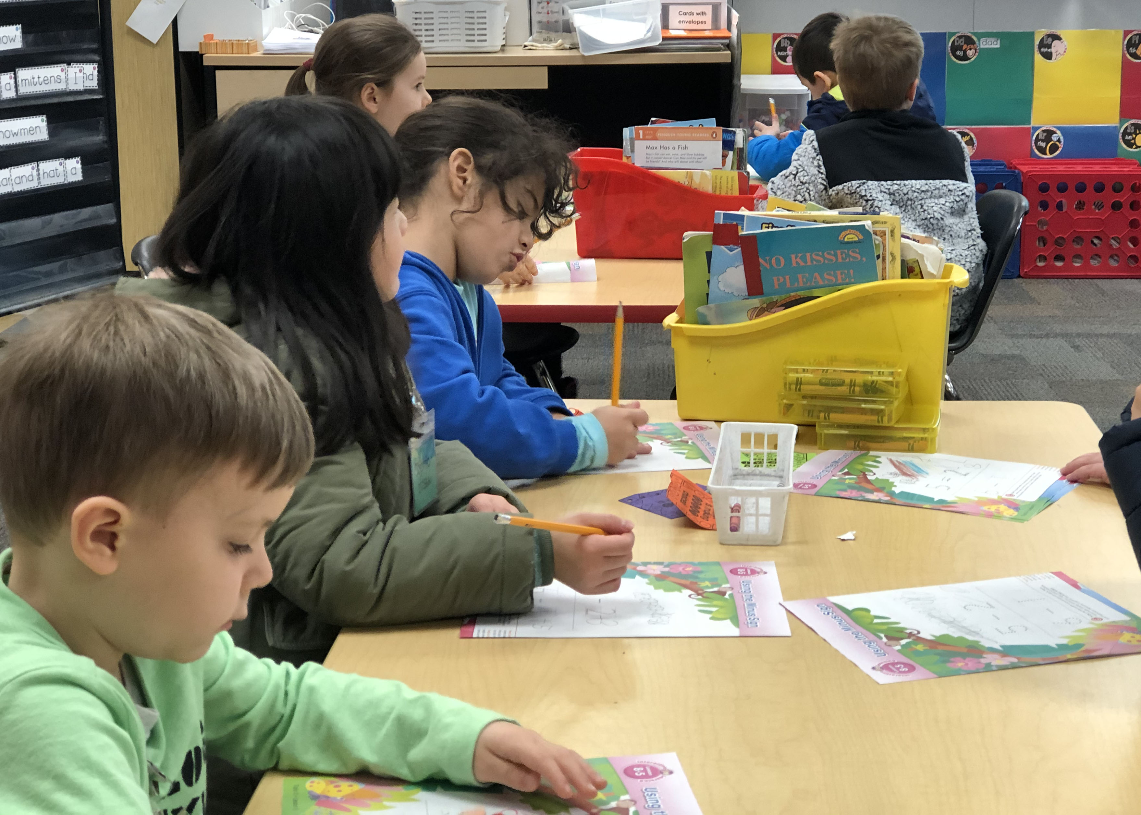If your child will be five years old by August 31, 2020, it’s time to register for kindergarten! Online registration is available at [www.everettsd.org](http://www.everettsd.org). Register now to access information about your school’s kindergarten program and receive a parent resource and children’s book “Kindergarten, Here I Come!” Registration also reserves your child’s spot in *Everett Ready,* our transition-into-kindergarten program scheduled for August 17-21, at our elementary schools. Contact [EarlyLearning@everettsd.org](mailto:EarlyLearning@everettsd.org) with any questions.

To find out which school your kindergartener will attend, click on Path Finder on the district’s transportation webpage or call the transportation office at 425-385-4144.

**Vaccinations for next year**

Now is the time to plan for the vaccinations your child will need before he or she enrolls next fall. We encourage you to obtain these vaccinations this school year and report them to the school nurse or office staff at your child’s school. We’ll track that information in the school database, which will help you avoid getting calls and overdue letters in the fall. More information can be found on the district’s [immunizations webpage](https://www.everettsd.org/domain/1473).

**Summer school**

Everett Public Schools offers a variety of summer learning opportunitites. Summer programs for high school students include opportunities to strengthen the skills and knowledge required for the district core expectations, repeat courses, extend their interests in academic areas, and take new courses. Tuition-based summer programs are offered for students through Online High School. Elementary and middle school summer programs are available for specific students who need academic support.



**Summer Reading Program**

Everett Public Schools looks forward to another successful year of its summer reading program. Please watch your school’s website for details about this summer’s reading program.

**School supply lists**

Looking to get a jump start on next year’s school supplies this summer? You can find the school supply list on your school’s website under *Our School* around the last week of school.

**Summer meals**

Did you know that all children ages 1-18 can participate in the summer meal program? Summer meals will start on June 22nd at select locations and times. Find more details on the [Food and Nutrition Department website](https://www.everettsd.org/Page/4827).

**The 2020 capital projects bond**

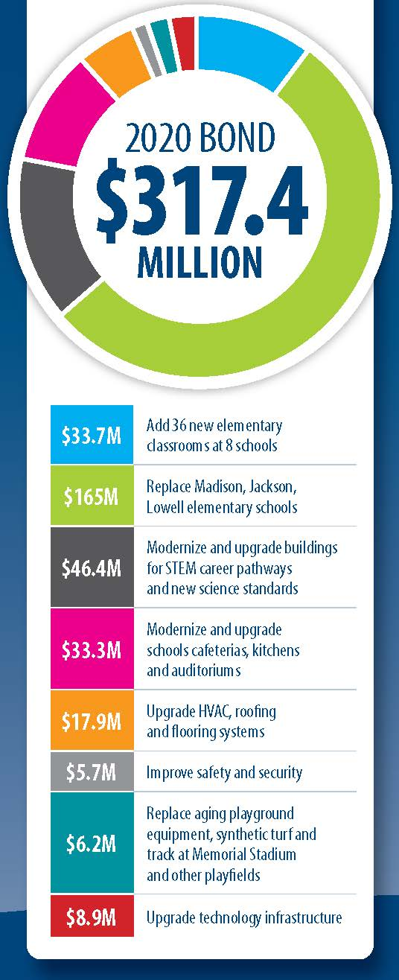Now, more than ever, schools are the heart of our community. Investing in our schools continues our focus on not only academics, but the well-being of every student in our district. Schools are a community resource and they need to be invested in.

Due to impacts of the COVID-19 pandemic, on March 24, 2020 the school board approved Resolution 1228 postponing the April 28 bond proposition until a future time to be determined by the board.

On May 5, the school board approved Resolution 1230 to place the unchanged $317.4 million bond proposition on the August 4, 2020 special election ballot.

The 2020 bond focuses on STEM, Safety, Equity and Space.

To find out more details on all of the bond 2020 projects, visit [www.everettsd.org/bond2020](http://www.everettsd.org/bond2020).

**Please remember to vote on August 4, 2020**

