# From the Principal

**Celia O’Connor-Weaver**Principal

**Monique Beane**

Assistant Principal

**Tambark Creek Elementary School**   
4419 180th St. SE,   
Bothell, WA 98012

425-302-9200

*www.everettsd.org/tambarkcreek*

**April 1-24**No School

**Tambark Creek News**

TAMBARK CREEK ELEMENTARY SCHOOL NEWSLETTER

VOLUME 1, ISSUE 12

**April 2020**

Hello Tambark Creek Families! I hope this newsletter finds you well and safe. We are in a unique and daunting time with the Corona Virus, which has currently resulted in a shelter in place for all of us. During this time, I wish you all the best and will continue to have the teachers collaborating with all families using the Google Classroom platform. Teachers have been sending home a weekly newsletter with specific academic tasks for that week as well as updating their Google Classrooms. Please encourage your student to respond to their teachers Google Classroom discussions etc.

**Celia O’Connor-Weaver**Principal

**Monique Beane**

Assistant Principal

**Tambark Creek Elementary School**   
4419 180th St. SE,   
Bothell, WA 98012

425-302-9200

*www.everettsd.org/tambarkcreek*

**April 1-24**No School

Teachers are available Monday through Friday from 9:10-3:30 via e-mail. Please feel free to contact me anytime via e-mail. I am here to help answer questions and provide support. I have included some fun and create activities that you can partake in with your children while at home.

All state-wide testing has been cancelled. Therefore, our students will not be taking the Smarter Balanced Assessment (SBA) this school year. The Everett Public Schools Communication Department will continue to send out updates regarding Covid-19 and how the distict will proceed moving forward. [https://www.everettsd.org/Page/31233](https://nam01.safelinks.protection.outlook.com/?url=https%3A%2F%2Fwww.everettsd.org%2FPage%2F31233&data=02%7C01%7CPScott%40everettsd.org%7Cd35c65896e454fef091708d7c9f9c9ea%7Ca6158ef04f854b0da599925097f77b3d%7C0%7C0%7C637199946987027373&sdata=SUUVNZaukVn0Rvw%2FzvmfYFww5%2FUyQnRFRs31ps0tR00%3D&reserved=0)

The Educational Effectiveness Survey (EES) is given each year to parents, students in grades 3-5 and staff members across the district. The survey is currently available <https://www.research.net/r/eps-parent> through April 3. It will be available online and we will post the link on our website. The information we receive from the survey provides the district with feedback and suggestions on ways in which we can improve our practices. Thank you for taking the time to complete the survey.

Here are some fun, meaningful, and generally tech-free learning opportunities for you.

* Interview a family member.
* Measure the area and perimeter of each room in your home.
* Graph the types of birds that frequent your yard or windows.
* Be completely silent for 60 minutes, then write about the experience.
* Write and mail a [real] letter to your teacher or principal or classroom penpal.  Address the envelope yourself.
* Build a "fable fort" out of blankets and chairs.  Camp in it all day while you create stories to tell your family over dinner.
* Learn Morse code and use it to communicate with your siblings through walls and floors.
* Alphabetize the spices in your kitchen.
* Stay up late and stargaze.
* Call a grandparent or older relative.  Ask them to teach you the words to a song from their childhood days.
* Using household materials, build a working rain gauge, barometer, and wind vane.
* Determine and chart the times that different liquids require to turn solid in the freezer.
* Design and build puppets that perform a show about multiplication.
* Construct a family tree.
* Learn ten new big words.  Write them in marker on your bathroom mirror.
* Draw a map of your home.
* Sit silently for 15 minutes while you write down every sound you hear.   When you are done, classify the sounds (high/low pitch, high/low volume, manmade v. naturally occurring, etc.).
* Create a Venn Diagram that compares and contrasts two people in your family, your neighborhood, or your church, mosque, or temple.
* Learn, practice, and perform a magic trick.
* Learn, practice, and tell three new jokes.
* Use household materials to make and play stringed, percussion, and wind instruments.
* Learn to shine a pair of shoes.
* Collect leaves from ten different (non-harmful) plants.  Sort them by size, color, and texture.
* Put your favorite book, toy, and keepsake on a small table in sunlight.  Draw or paint a full color still life.
* Find, pick, and dissect a flower.
* If you have stairs, walk up and count them.  Walk down and count by twos.  Walk up and count by threes.  Continue through tens.
* Determine the volumes of ten containers, them display them in order on your porch.
* Write a poem on your sidewalk using chalk.
* Classify twenty everyday objects by shape, size, color, height, mass, and material.
* Measure the length of your bed using five different nonstandard units.
* Call a person who speaks a language you do not.  Ask them to teach you five common words or phrases.
* Create and use a secret code.
* Using one type of paper (constant), build three different paper airplanes (independent variable) and test to see how far they fly (dependent variable).
* Set a clock three hours and seven minutes ahead.  Whenever someone needs to know the time, help them figure it out by subtracting.
* Write down every adjective you say for one full day.
* Learn three new jokes.  Tell them to an aunt or uncle.
* Design a map of every state ever visited by people in your family.
* Write or tell a story titled "What if humans had to leave the Earth and no one remembered to turn off the last robot?"
* Find ten rocks smaller than a dime.
* Using paper, tape, and string, design, build, and test a device that warns you when someone opens the kitchen cabinet.

Imagine, create, and fly a full-size flag that tells the world about you.

Mrs. O’Conner-Weaver

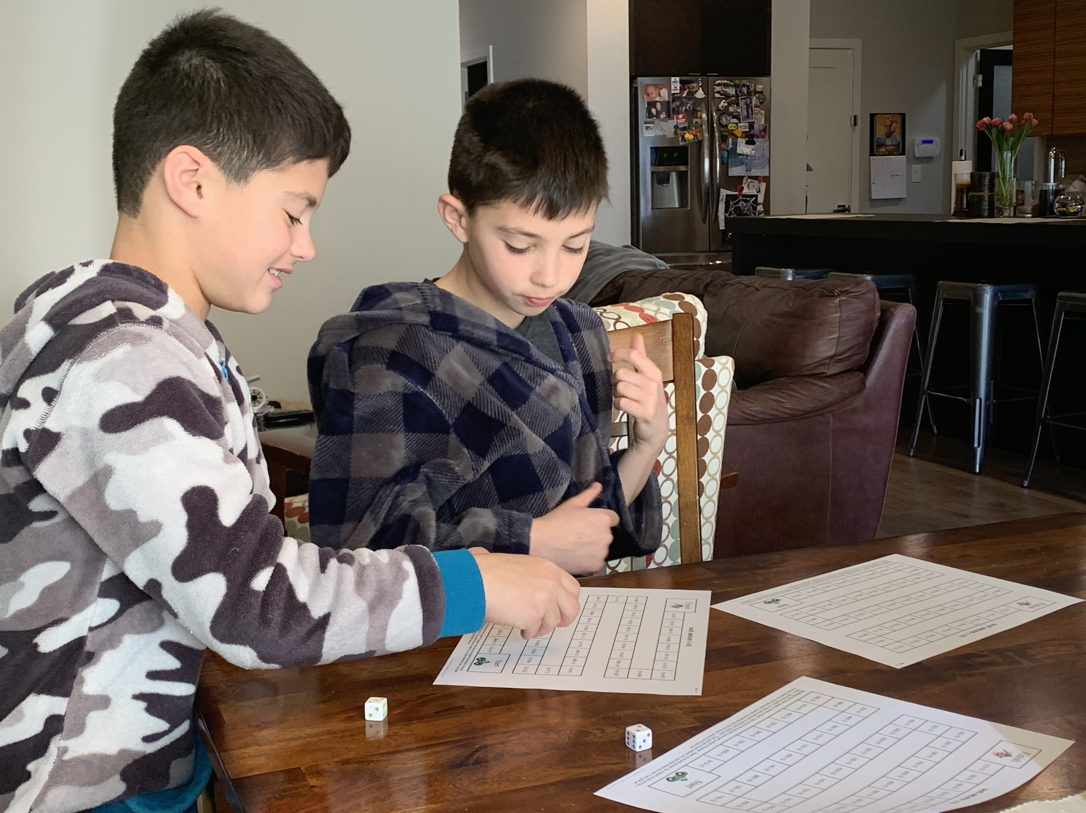

Tambark students playing a math game that was posted on their teacher’s Google Classroom. Please, continue to send me pictures of your child (ren) learning from home

**From the Counselor**

Dear Tambark Creek Families,

I want to reach out to you all during this difficult time to let you know that I am here to support your student and your family. Please refer to the links on my website to help you with connections to helpful websites. The most accurate and up-to-date source of information with regards to school is the Everett Public Schools Home Page – <http://www.everettsd.org> The best way to communicate with teachers and other staff is through email. If that isn’t possible for you, you may leave a phone message.

I am sure you are all doing your best to work with your student and support their learning during this time. This is a time of crisis, we need to care for each other. Make sure you take fun breaks! Make this time as stress free as you can. I know the teachers have sent you out many different website links that give students brain breaks and ways to move their bodies to reduce stress. You can find many free ones yourselves doing web searches. Do these activities with them. Stressed adults cannot teach stressed children well. It is neuro-biologically difficult. Focus on connections and support feelings of calm and safety.

I am attaching to this newsletter a wonderful flyer that shares ways to support your family during this time. I believe it will be helpful to you all as we work through this unprecedented time together. Please know that I miss working with all the students at Tambark Creek Elementary and look forward to seeing them soon.

Be kind to yourself and those around you,

Julia Hehn, Tambark Creek School Counselor

& Mango – who misses you all very much!

[jhehn@everettsd.org](mailto:jhehn@everettsd.org)

(425)-302-9010

**From the Office**

If your student is absent or will be leaving early for an appointment and you email the teacher please remember to also include the attendance email at [tceattendance@everettsd.org](mailto:tceattendance@everettsd.org) This provides a written response for your childs absence and ensures the office gets this important information.

**From the PTSA**

Hello Tambark Creek families! We want to remind you that our Tambark Creek PTSA mission is to **support our entire school community**, and we will strive to do that in any way we can over the coming weeks.

All PTSA events and programs that were scheduled between now and April 24th are canceled or postponed while school is closed. We will figure out how to proceed with the programs and events for the rest of the school year when we get closer to the date of school re-opening. We will follow any district and health department guidelines that are in place at that time.  
  
We may have an online membership meeting at some point during the school closure - we will send notice of the date at least 10 days before the meeting to our PTSA members. If you are not yet a PTSA member, you can join the PTSA online at [https://my.cheddarup.com/c/membership-57906](https://nam01.safelinks.protection.outlook.com/?url=https%3A%2F%2Fmy.cheddarup.com%2Fc%2Fmembership-57906&data=02%7C01%7CAJames2%40everettsd.org%7C3a706778b4874b68ae9808d7cadec82c%7Ca6158ef04f854b0da599925097f77b3d%7C0%7C0%7C637200930500017659&sdata=m4wykAFvE%2BdDv5uBjIWsG%2BiQUaQliZSIf%2F5pvEcnGys%3D&reserved=0)  
  
Remember that you can get the most up-to-date information about Tambark Creek PTSA events and programs on the PTSA Facebook page ([facebook.com/TambarkCreekPTSA/](https://nam01.safelinks.protection.outlook.com/?url=https%3A%2F%2Fwww.facebook.com%2FTambarkCreekPTSA%2F&data=02%7C01%7CAJames2%40everettsd.org%7C3a706778b4874b68ae9808d7cadec82c%7Ca6158ef04f854b0da599925097f77b3d%7C0%7C0%7C637200930500027613&sdata=2krdes4DmY6h9MDzoBFegK4vlxLE%2F5W4GLMjkIYj3ow%3D&reserved=0)) and the PTSA website (tambarkcreekptsa.org). And feel free to get in touch with us by sending an email to [president@tambarkcreekptsa.org](mailto:president@tambarkcreekptsa.org).

We hope everyone stays safe and healthy!

Alisha Crawley-Davis & Heather Morgan  
co-Presidents, Tambark Creek PTSA 7.3.12

**Meals for emergency school closure**

We are committed to providing access to the nutrition Everett Public School students need during an extended emergency district wide closure. We will be offering meals for pick up at a total of 23 school sites and at least 5 apartment complexes.

**Meal pick-up and order process**

* Meals will be available for pick up at 28 sites (times listed on form for each site as they may differ)
* Lunch orders must be placed before 7:00 a.m. each day. Orders placed after 10:00 a.m will be for the following day.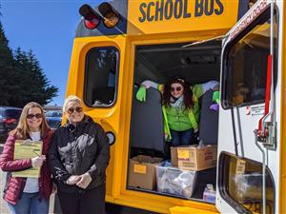
* [**Preorder**](https://forms.gle/BzhRhif4a8UNuiY66) is encouraged each day
  + Additional meals will be available for students that drop in but availability will be limited
* Meals will be free for all children 1-18 years of age (they do not need to be a student)
* Students must be present to receive their meal
* Adult meals are not available for purchase
* Breakfast for the next morning will be given out with lunch
* Meals will be available for pick up based on the delivery location selected on the pre-order form
* Pick-up site does not need to be the students home school, you can select the most convenient site for your family
* School pick up sites include: Cedar Wood, Forest View, Garfield, Hawthorne, Jackson Elementary, Jefferson, Lowell, Madison, Mill Creek, Monroe, Penny Creek, Silver Lake, Silver Firs, Tambark Creek, View Ridge, Whittier, Woodside,Eisenhower, Evergreen, Heatherwood, North, Cascade High School & Sequoia
* Apartment complex pick up sites are: The District Apartments, Family Tree Apartments, Gateway Apartments, Heatherwood Apartments, Mirabella Apartments, Shoreside Village, and The Lakehouse

Here is the link to pre-order a meal: <https://docs.google.com/forms/d/e/1FAIpQLScDKtD8YgVrb1nZ4Oc0aIuGbyoof5gthnT4VFx-ukUzYDsK0g/viewform>

We are so proud of Mrs. Deb and Ms. Nakena for preparing and delivering lunches during our long school closure! Thank you!

**School closure resources**

Watch for all Coronavirus updates at [www.everettsd.org/COVID-19](http://www.everettsd.org/COVID-19).

**Kindergarten registration happening now**

During the current school closure, you can register for kindergarten in 3 ways:

1. Online! Scroll down and register online in the language of your choice.
2. [Download and print the paper forms](https://nam01.safelinks.protection.outlook.com/?url=https%3A%2F%2Fdocushare.everett.k12.wa.us%2Fdocushare%2Fdsweb%2FGet%2FDocument-105245%2FEPS%2520Kindergarten%2520Registration%2520Packet%25202019-20.pdf&data=02%7C01%7CLCarbajal%40everettsd.org%7Cbfb8e2ffc1c94602275508d7cac0db4e%7Ca6158ef04f854b0da599925097f77b3d%7C0%7C0%7C637200801966004710&sdata=2TVbGLcBPmoH8scSVobwqaQtiTqR2zle%2Fo66EHvFsrw%3D&reserved=0).*
3. Pick up a pre-printed registration packet from the reception desk at the Community Resource Center, located at 3900 Broadway in Everett, during business hours.* (The CRC will be closed March 19, 20 and 23).

*For options 2 and 3, please complete the paper registration materials and gather the required documents listed [here](https://nam01.safelinks.protection.outlook.com/?url=https%3A%2F%2Fwww.everettsd.org%2FPage%2F31077&data=02%7C01%7CLCarbajal%40everettsd.org%7Cbfb8e2ffc1c94602275508d7cac0db4e%7Ca6158ef04f854b0da599925097f77b3d%7C0%7C0%7C637200801966014706&sdata=7xMYvPc2jEfJtUkL2U6u6txRThV2mtfjrt%2FevWwU7bI%3D&reserved=0). Once school reopens, please take the completed forms and required documents to your neighborhood elementary school to complete your student’s enrollment.

If you have questions, please email the Early Learning Department at [EarlyLearning@everettsd.org](mailto:EarlyLearning@everettsd.org). Thank you!

**Easy access with district app**

Download and log into the district app to quickly and easily access your student's info. Pay lunch balances, see books checked out from the library, and find the staff directory, school websites, calendars and more.

The free mobile app is available in the online iTunes® and Google Play® app stores. Search for “Everett Public Schools.”

Once you’ve downloaded the app, log in to “student info” with your LMS password to see student-specific information for each of your children. Choose to read content in one of many languages in the settings.

**Thank you, volunteers!**

April 20-24 is Public Schools Volunteer Appreciation Week. We are grateful for the many volunteers who support students and staff, many of them each and every school day. With activities ranging from reading with students, to playground supervision support, Watch D.O.G.S., and chaperoning field trips, your help matters. Our volunteers contribute to making school the best part of a student’s day. Thank you!

**ECEAP preschool accepting applications for 2020-21**

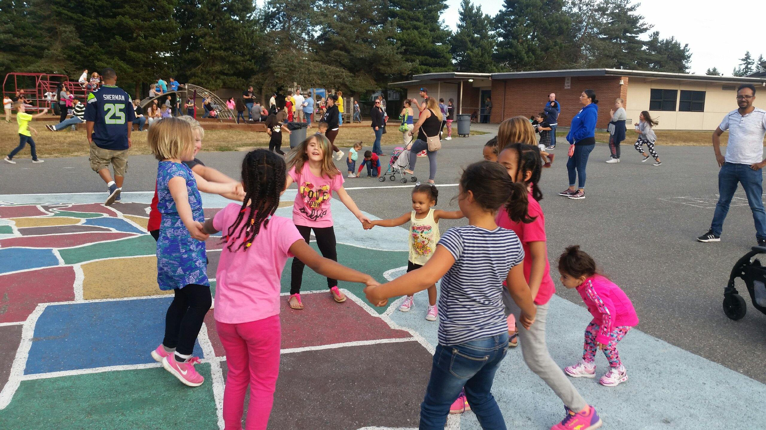Everett Public Schools Early Childhood Education & Assistance Program (ECEAP) is a FREE preschool program for three- and four-year-old children from families with limited income. ECEAP prepares children for kindergarten and provides family support and health and nutrition services. It is funded by the Washington State Department of Early Learning.

The five ECEAP sites within our school district are Garfield, Hawthorne, Lowell, Madison and Silver Lake elementary schools. Space is limited – apply early! For an application or more information, please call 425-385-4628 or visit the [district ECEAP website](http://www.everettsd.org/Page/5962).

