**How to go on Google Classroom from home:**

1.       Go to: [www.everettsd.org](http://www.everettsd.org/)

2.       In the **search engine** type: EPS Google Apps

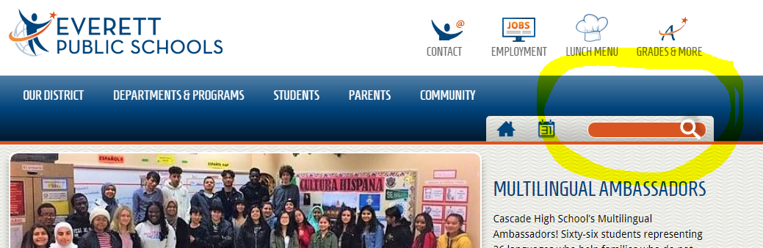

3.       Click on: [**EPS Google Apps** - Everett Public Schools](https://www.everettsd.org/site/default.aspx?PageType=3&ModuleInstanceID=108732&ViewID=5C8B25C6-C8F8-4BD5-923B-8A7C70A93DDA&RenderLoc=0&FlexDataID=82186&PageID=20975)

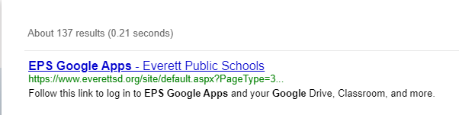

4. Click on the link displayed:

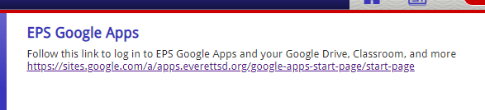

5. Sign in through Everett Public Schools:

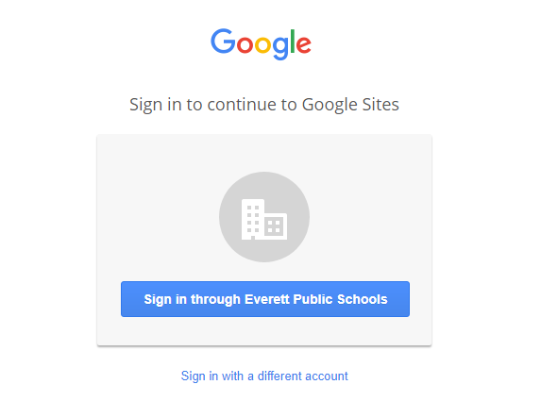

6. Type the student username and password.

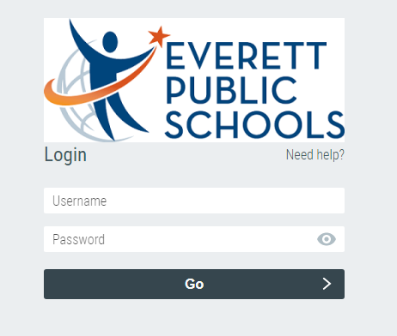

Here is **your school email** in case you need it!

____­Your lunch number_________@apps.everettsd.org

7.   Go to our **Google Classroom** and input your work in the **“Homework”** section.