Google Classroom Assignments

Making Sure they are Turned In 😊

As your student finishes their Google Classroom (GC) Assignments, it is very important to make sure that they are “turned in/marked as done/submitted”. Due to the “glitch” that has been found within the GC platform, here is how we will work around it:

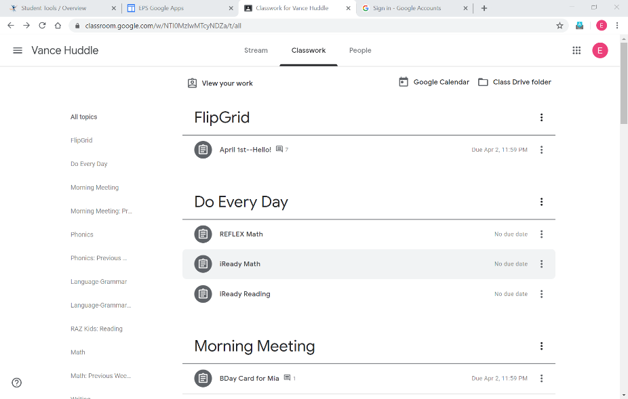Once your student logs in to our GC:

* click on the “Classwork” tab at the top of the page
* click on the “View Your Work” icon

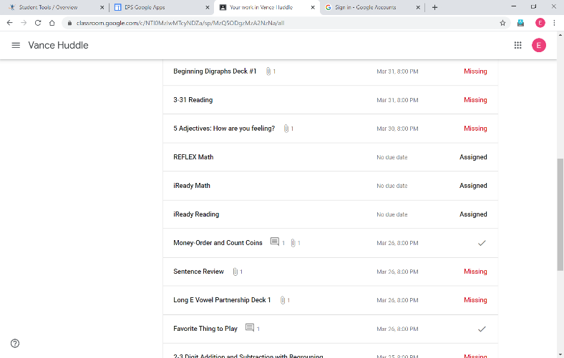

A list of your students’ assignments will open:

*You will see one of the following

--missing

--Assigned

--Turned In

--a “check mark”

**click on the assignment that says “missing/not submitted”

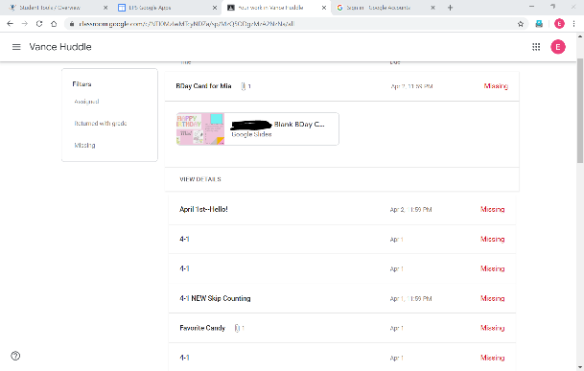

An assignment specific window will expand

*click on “View Details”

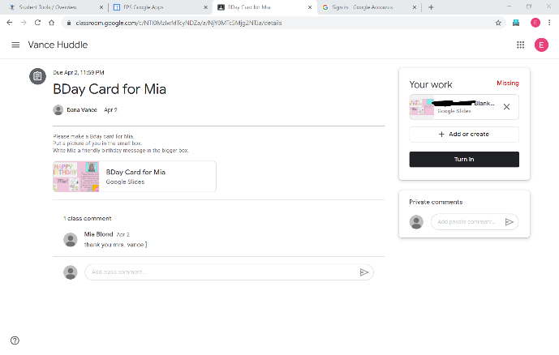*Click on the assignment in the “YOUR WORK” box that now appears on the right

*if it is a google slide deck activity—click on the assignment and check to be sure it is complete

*then click on “turn in” in the black bar

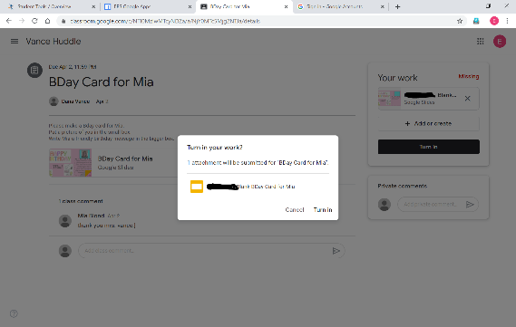*A white box will appear, while the rest of the background goes gray

*Click on “turn in” in the white box

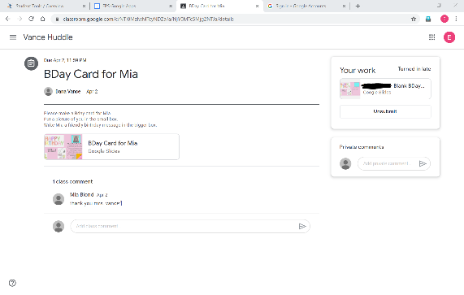*It will process your “turn in” command and then you will see that the assignment now says “Turned in” (Do not worry if it shows “late”. I am not worried about that. 😊)

*You will need to do this for each assignment that shows “missing

*Click the back arrow at the top above “Vance Huddle” to go back to your list

*Once you are back to your list of assignments you can collapse that assignment box by clicking in the white area by the title of the assignment and then go to the next one. This will keep your list neat and tidy. 😊

You will need to do this each assignment that shows “missing”. Crazy—I know!

Now, for iReady Reading/Math, REFLEX Math, RAZ Kids: it is a little bit different (of course—right?)

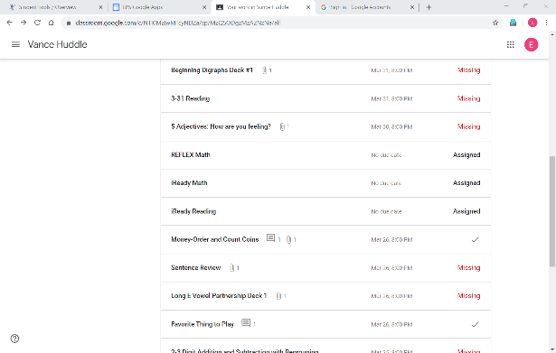*click on REFELX Math

*iReady Reading

*iReady Math

*RAZ Kids

*Education.com (if I ever get around to that one again)

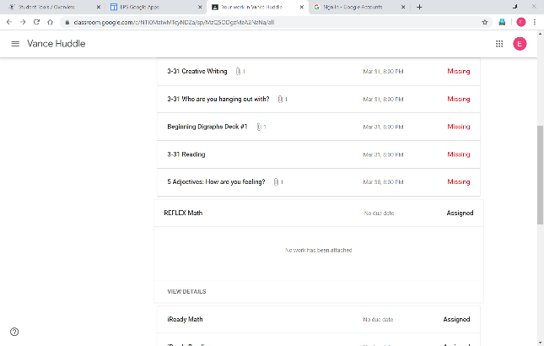*The assignment window will expand

*click on “View Details”

*the window will look *blank* in the middle until you click the “view details”

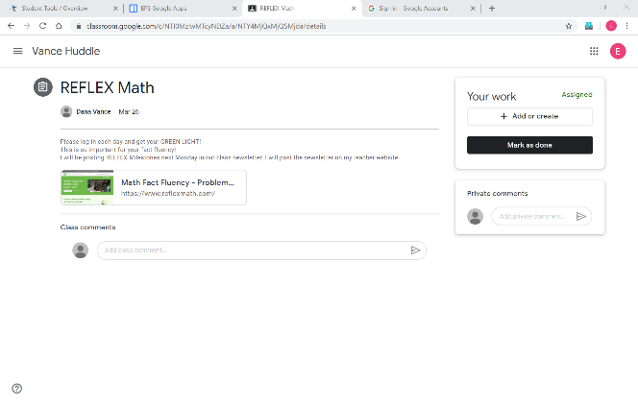

If you have achieved your “GREEN LIGHT” for that day

*click on “Mark as Done”

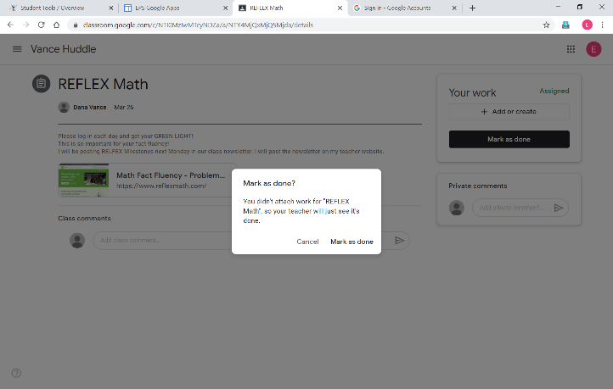*The background will *gray out* and the little white window opens

*Click “Mark as Done”

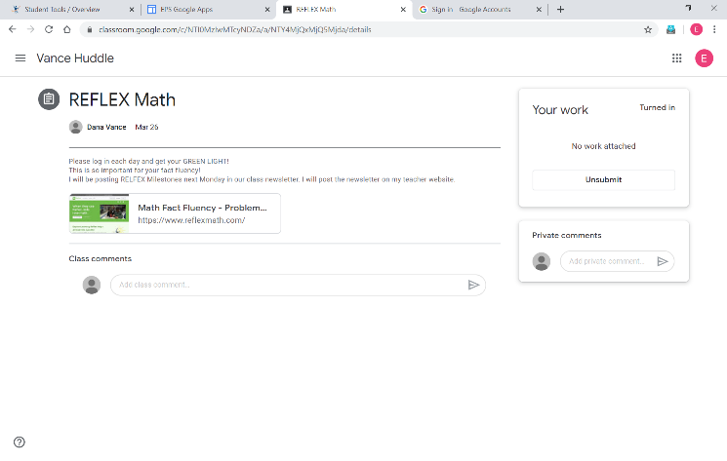*It will process and then you will see it is now marked as “turned in”

*\*Do this same procedure for iReady Reading and Math*

*ONLY IF YOU HAVE REACHED YOUR iReady GOALS OF 2 LESSONS EACH WEEK WITH 75% or HIGHER!*\*Click the back arrow at the top over “Vance Huddle” to get back to your list

*Click in the white area by the assignment title so that the assignment detail window collapses—neat and tidy! 😊

RAZ Kids/Reading:

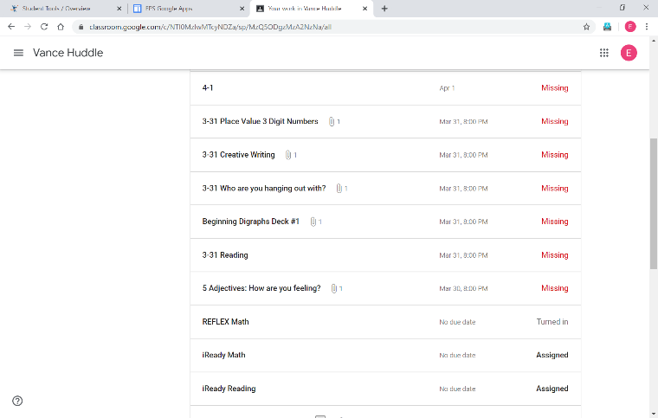*You will not see “RAZ Kids” in the assignment title

*You will see Reading and the date

*Click on the reading assignment that shows “missing”

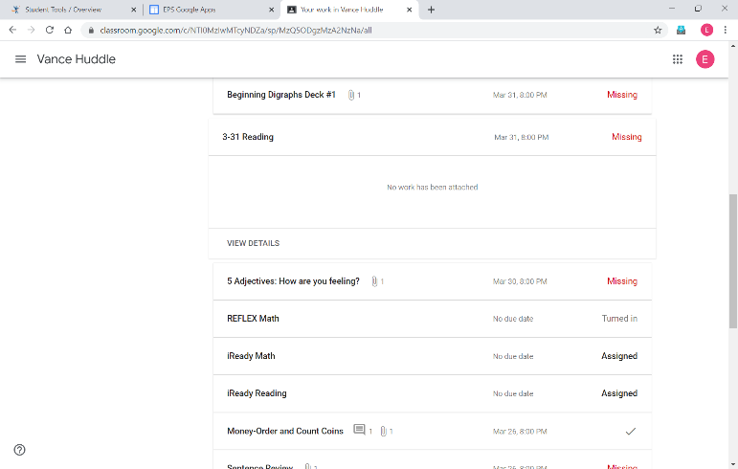*it will expand and will be *blank* in the middle

*click on “View Details”

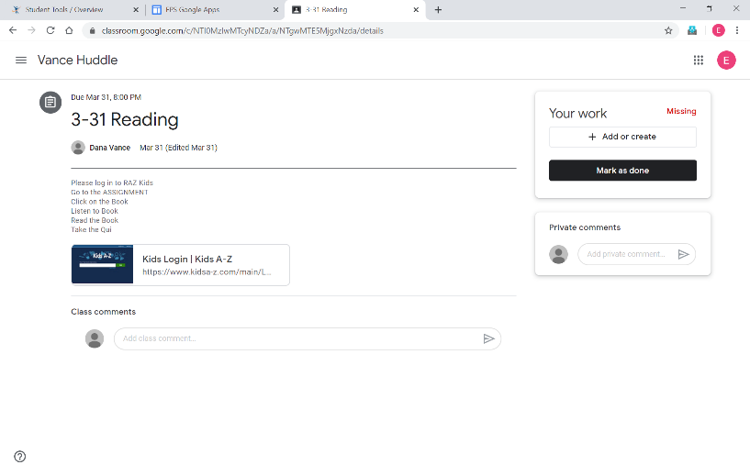If you have completed the assignment:

*Listened to the story

*Read the story

*Took the quiz—if missing more than 2 questions on the quiz take the quiz again (you will get different questions)

*If after two attempts on the quiz and on the second try you do miss more than 2—do not do it again! You are done with that story.

*Click on “Mark as Done” in the black bar  
*It will process and then you will see the *grayed out* screen with little white box in the middle.

*Click on “mark as done”

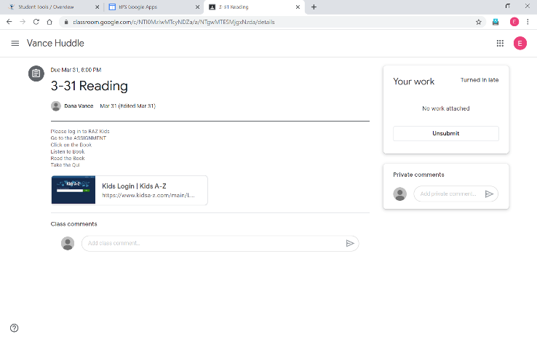You will see that it is “turned in”

**Do not worry about the “late” issue—I am not! 😊

*Click the *back arrow* at the top above the VANCE HUDDLE to go back to your “View Your Work” list

*For iReady Reading, iReady Math, REFLEX Math, and RAZ Kids: I will be going into each of the programs and checking your work there.*

**iReady Reading and iReady Math**

***I will be going into this program looking for the following:***

*2 iReady Reading Lessons each week

*2 iReady Math lessons each week

---You must get a 75% or higher on the quiz portion of each lesson

If you do not, you may have Domains “turned off” and I will be adjusting your lesson pathways.

**REFLEX Math:**

***I will be going into this program to look for the following:***

*Check your Fluency growth-did you hit a MILESTONE

*Did your fact fluency increase

*Did you achieve your GREEN Light for each day.

I will post MILESTONES on our weekly class newsletter that will go up on my teacher page on the PCE website.

If you Master addition/subtraction I will move you to multiplication/division 0-10.

If you Master multiplication/division 0-10, I will move you to multiplication/division thru the 12’s.😊

**RAZ Kids:**

***I will be going into this program to check your assigned readings. Your assigned readings are based on your reading level and comprehension skills that you need to work on.***

***I will be looking for:***

*You listened to the book

*You read the book

*You took the quiz-not missing more than 2 questions on the quiz.

*I will note the comprehension type questions that you answered incorrectly and assign the next lessons accordingly

As you go throughout the week—PLEASE check your list in the “View Your Work” view and check on your assignments. If it says “turned in”—GREAT!!! If it says “missing” please go in and complete it or check to make sure it is complete and then turn it in. 😊

Thank you!

Mrs. Vance